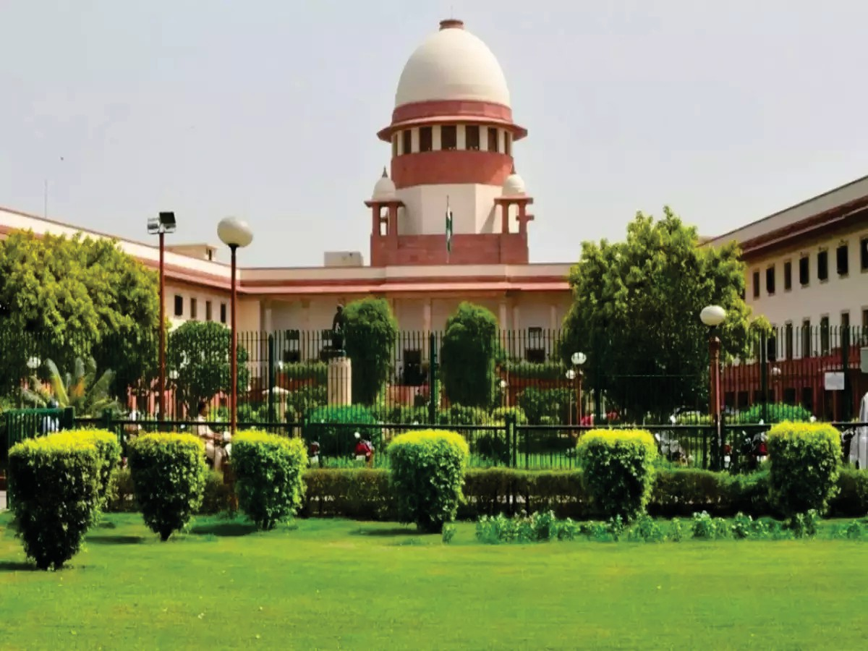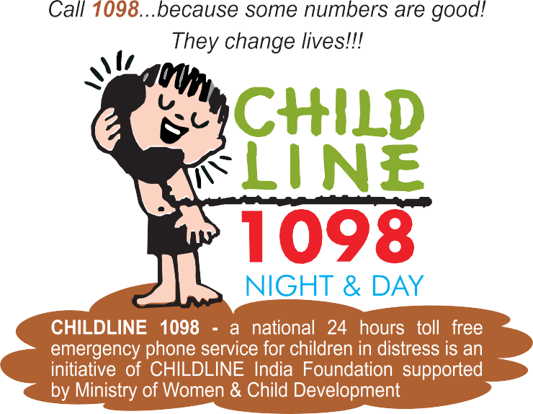

LEGAL STUDIES

Class 11



**Central Board of Secondary Education**

**Shiksha Sadan, 17, Rouse Avenue, New Delhi - 110002**





**PRICE**



**:** Unpriced Edition

**:** First Edition 2013

Second Edition 2022

**This book or part thereof may not be reproduced by any person or agency in any manner.**

**LEGAL STUDIES FOR CLASS XI**

**Edition**

**Published by :** Director (Academics) Central Board of Secondary Education

Shiksha Sadan,17, Institutional Area,17, Rouse Avenue, Delhi-110002

**Design & Layout : LAXMI PRINT INDIA**

556, GT Road, Shahdara, Delhi-110032



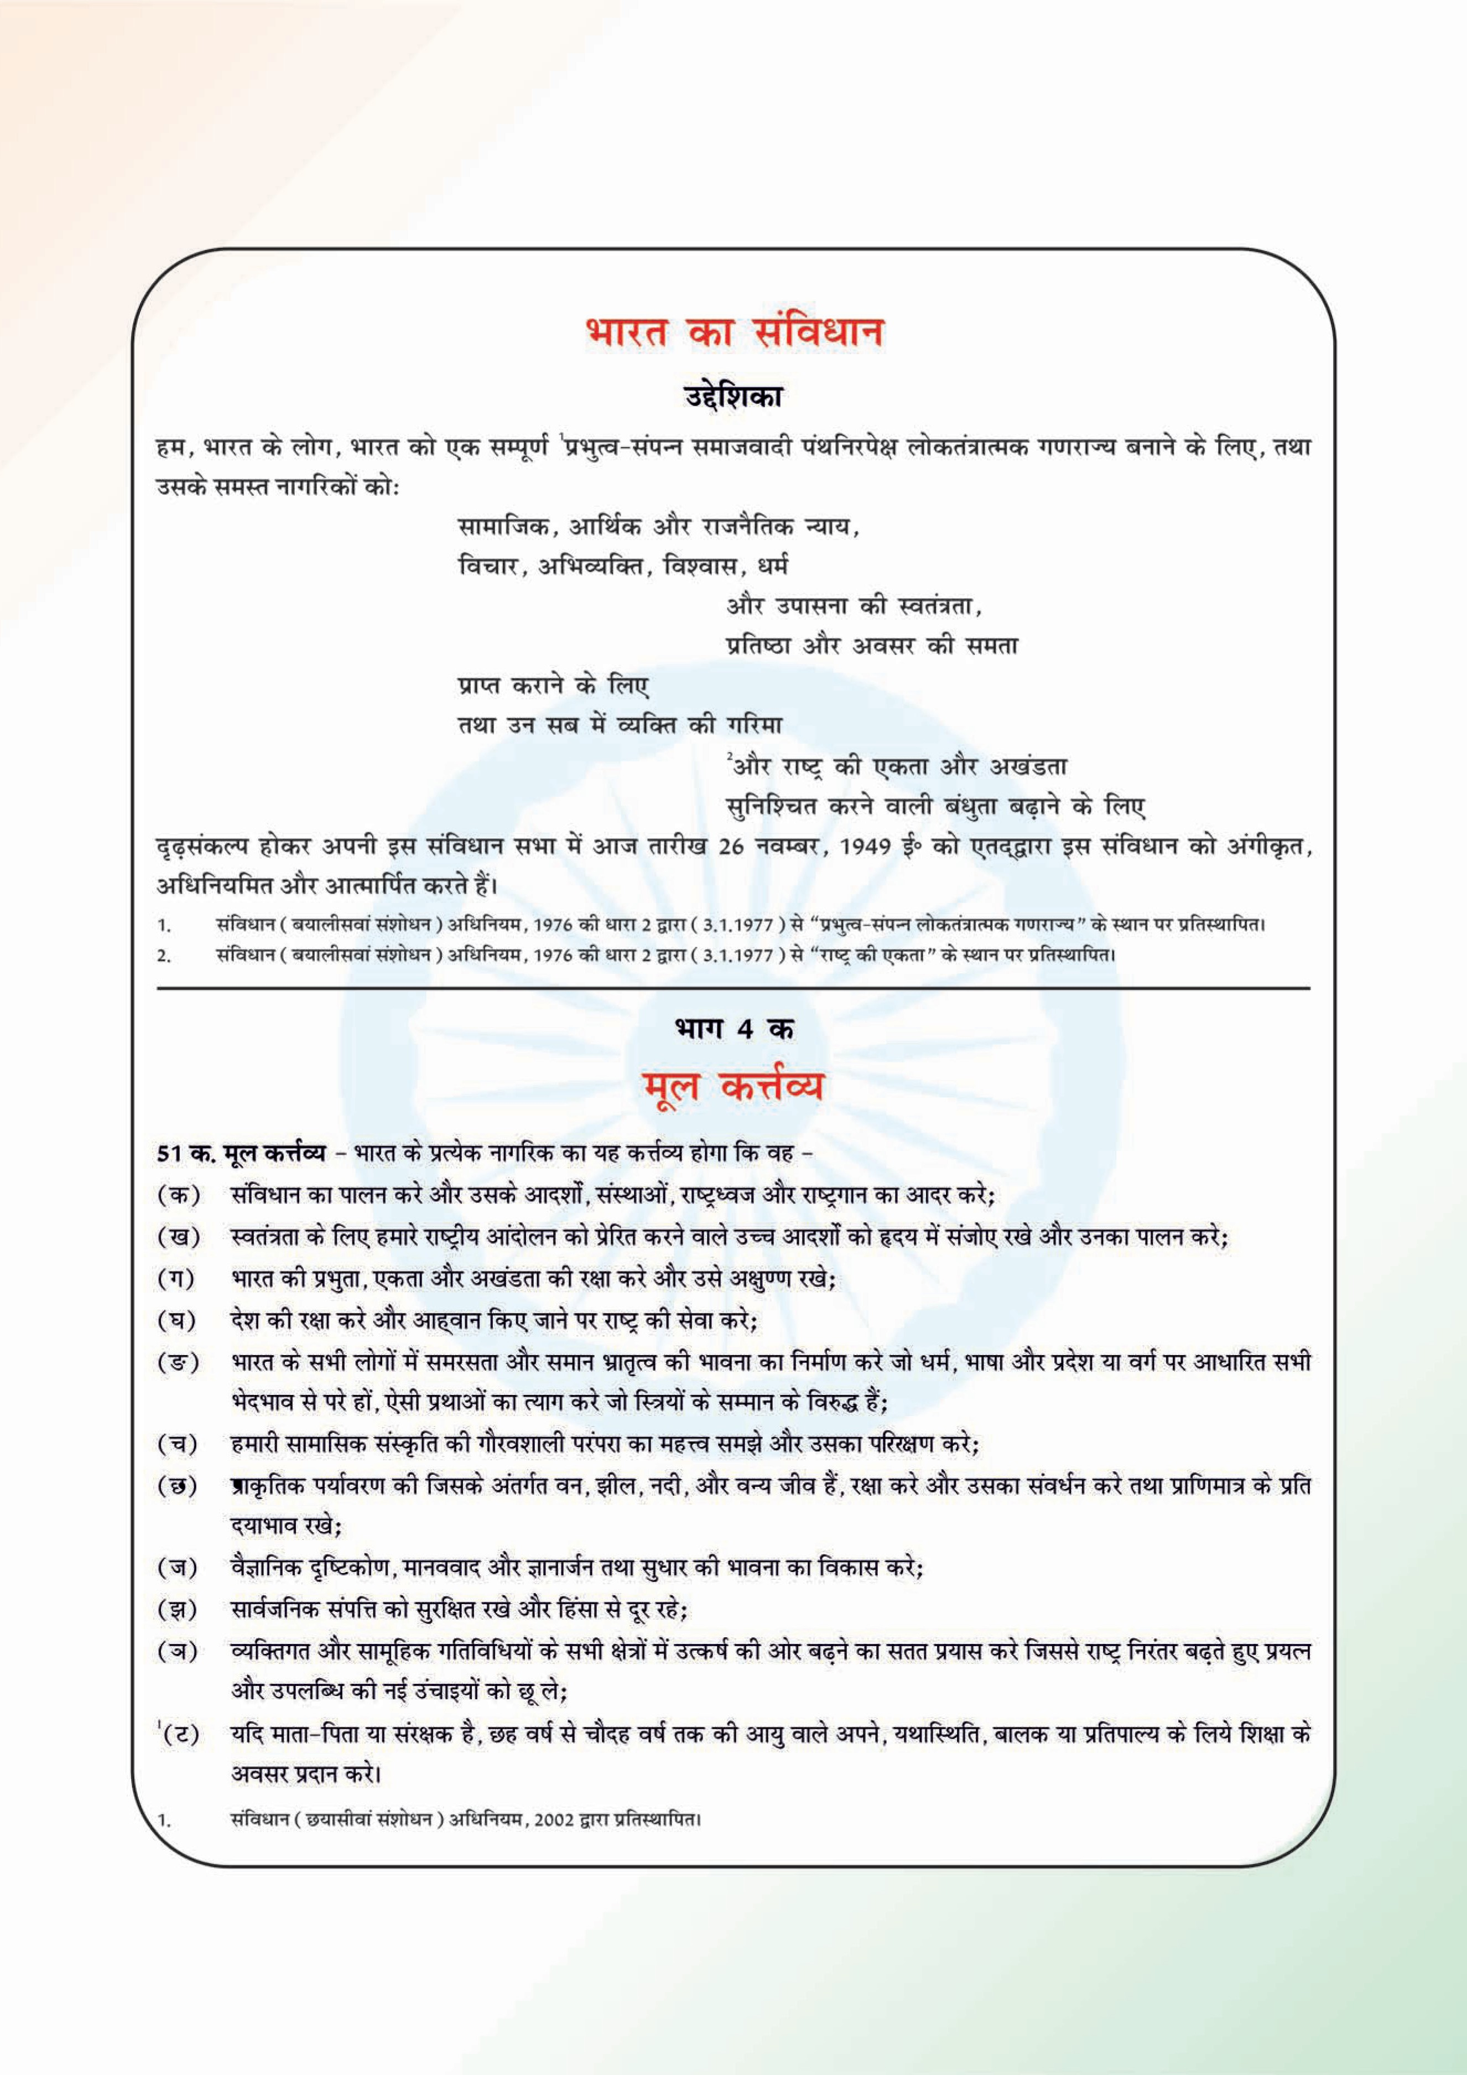



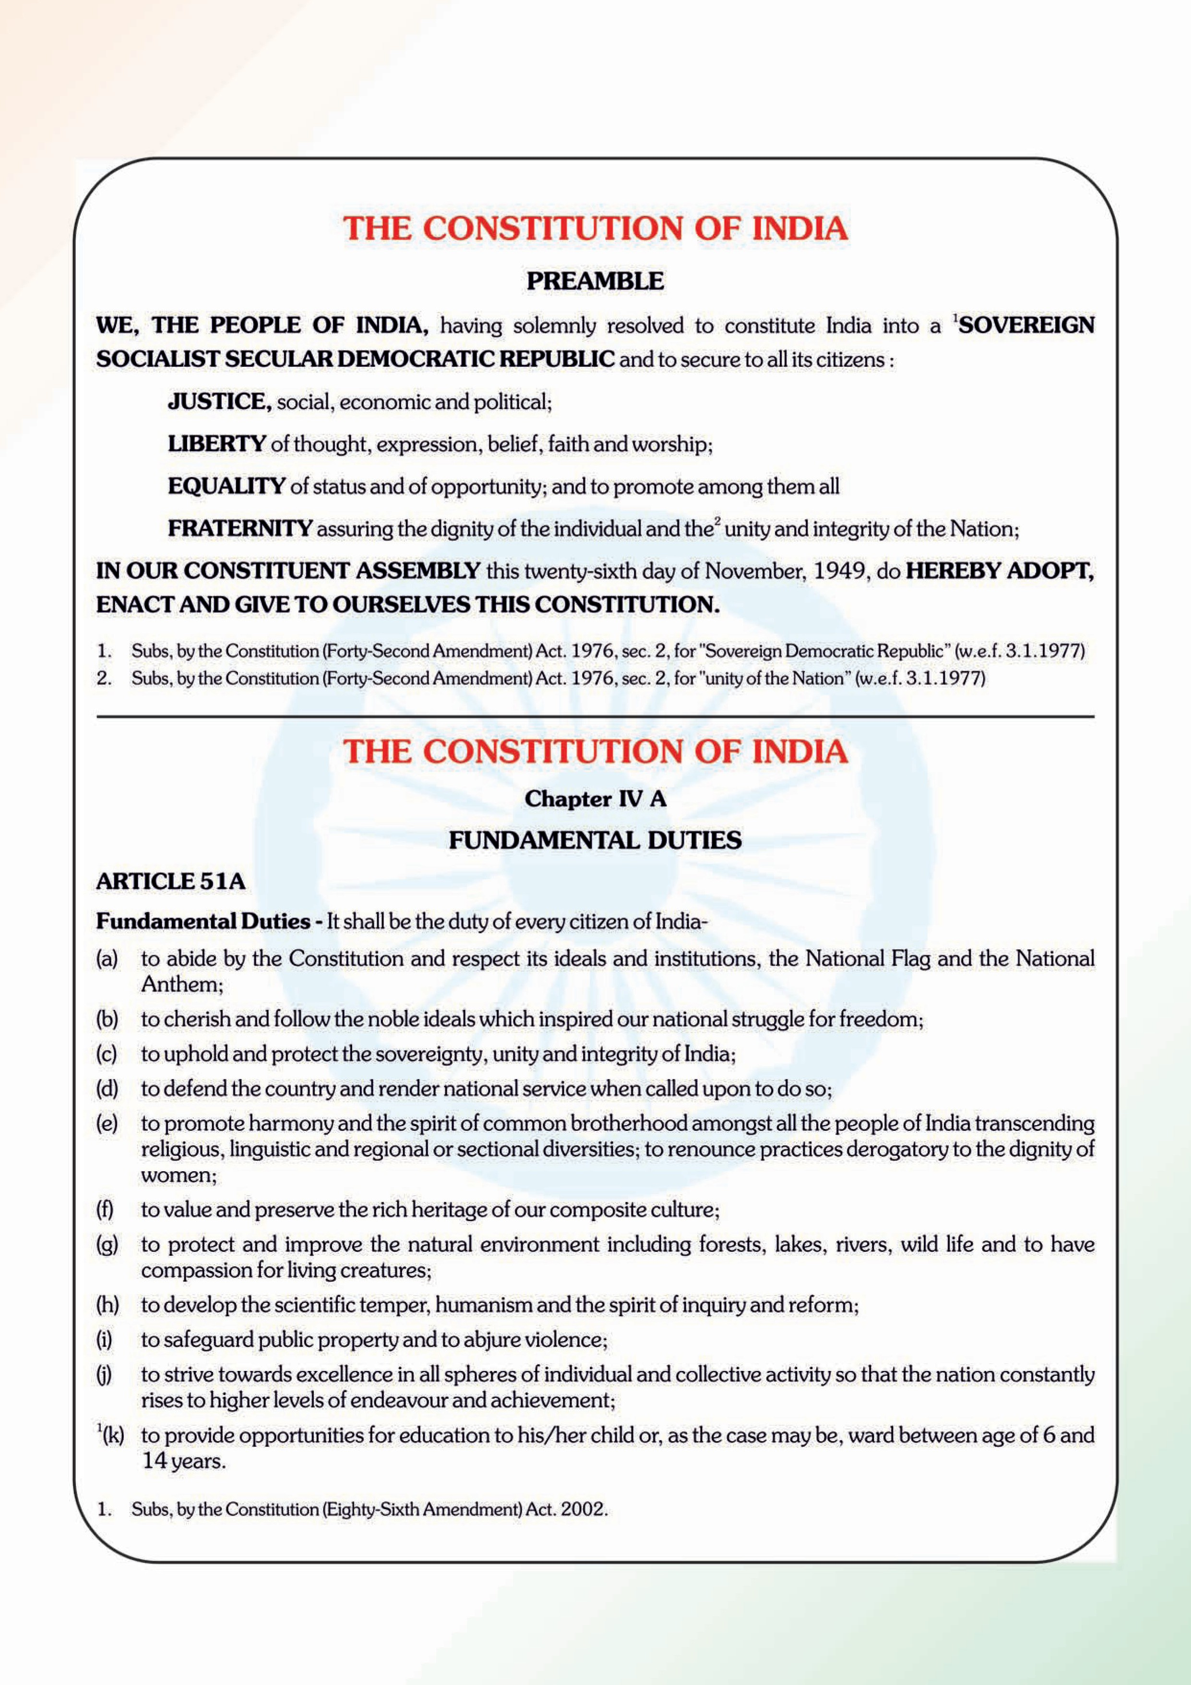

**Preface**

egal Studies was introduced in the year 2013 not only to allow flexibility in the choice of electives but to foster the interest of students in legal concepts, functioning of legal institutions, modes of legal reasoning as well as to provide them with the opportunity to examine a range of legal issues in their socio-economic contexts. As an introductory textbook of legal studies, the goal of this book is to engender an understanding of the effect that law has on different facets of social life. Students are expected to gain desirable levels of competencies by becoming familiar with not only how, but also why the law has become such a crucial part of our lives and learning about how law provides order and stability while also adapting to changing needs of Indian society. The suggestions and the opinion of experts in the field about the first edition have also been taken into account for revising it. The second edition have updated Acts and Laws such as Consumer

L

protection act, RTI, POSH Act 2013 alongwith updated court cases.

The units guide the student from an overview of the rationale behind the structure of the Indian legal system to a discussion of some major areas of the legal system. In each unit, a student will learn about fundamental legal concepts and principles and the scope of their application. Unit 1 and 2 provide an introduction to Political Institutions and Basic Features of the Constitution of India, detailing the manner in which law is created and administered, need and relevance of fundamental rights and duties and writ jurisdictions of different courts. Unit 3 and 4, concentrate on different areas of Jurisprudence and Nature and Sources of Laws by exploring basic principles and terminology. A complete chapter on Cyber Laws has been incorporated in view of the massive increase in cyber transactions and related issues during the last few years. Unit 4 addressing the structure and roles of Constitutional, Civil, and Criminal Courts, has been updated by adding content on Criminal law. Unit 5 deals with another important branch of the Legal system concerning with the Family Justice System providing information on various avenues to seek help and resolve issues swiftly and with the minimum of pain caused to those involved.

The revised textbook offers newer practical strategies to guide the teachers in planning effective teaching-learning tasks for their students. I record my sincere gratitude to the experts associated with revision and vetting work.

I sincerely hope that with the availability of the revised edition, teachers will be able to impart an understanding of legal concepts in a more up-to-date manner. Comments for further improvement of the textbook are always welcome.

**Dr Vineet Joshi**

*Chairman CBSE*

**Acknowledgement**

**Guidance and Support**

* Dr. Vineet Joshi, IAS, Chairman, Central Board of Secondary Education.
* Dr. Joseph Emmanuel, Director (Academics), Central Board of Secondary Education.

**Material Production for the First Edition**

* Prof. James J. Nedumpara, Professor, Jindal Global Law School, OP Jindal Global University, Sonepat, Delhi
* Mr. Sandeep Kindo, University of Wisconsin - Madison, USA
* Mr. Vinay Kumar Singh, Indian Society of International Law, New Delhi
* Dr. Anil Kumar Thakur, Panjab University, Chandigarh
* Ms Anjali Bansal, Panjab University, Chandigarh
* Mr. Ram Shankar, Assistant Professor & Joint Director (GA&E), CBSE.

**Content Updation Group (Second Edition)**

* Ms. Disha Grover, Delhi Public School, Mathura Road, New Delhi
* Ms. Neelu Sofat Whig, Suncity School, Gurugram
* Ms. Charu Tiwari, Sanskriti School, New Delhi
* Ms Sanah Batta, Bloom Public School, New Delhi
* Ms. Piyush Vardhini, Amity International School, Mayur Vihar, New Delhi
* Ms. Mansi Nangia, Modern School, Barakhamba Road, New Delhi

**Legal Inputs and Book Review**

* Dr. Pooja Singh, Advocate, Delhi High Court

**CBSE Coordinator**

* Mr. Al Hilal Ahmed (Joint Secretary)

**Contents**

**4**

**1-34**

**Introduction to Political Institutions**

**Unit 1**

**1**

**Chapter 1 :** Concept of State 3

**Chapter 2 :** Forms and Organs of Government 13

**Chapter 3 :** Separation of Powers 24

###### Unit 2 Basic Features of the Constitution of India 35-64



**Chapter 1 :** Salient Features of the Constitution of India 37

**Chapter 2 :** Administrative Law 57

###### Unit 3 Jurisprudence, Nature and Sources of Law 65-104

**Chapter 1 :** Jurisprudence, Nature and Meaning of Law 67

**Chapter 2 :** Classification of Laws 78

**Chapter 3 :** Sources of Laws 83

**Chapter 4 :** Law Reforms 94

**Chapter 5 :** Cyber Laws, Safety and Security in India 98

###### Unit 4 Judiciary : Constitutional, Civil and Criminal Courts

###### and Processes 105-130

**Chapter 1 :** Judiciary : Constitutional, Civil and

Criminal Courts and Processes 107

**131-172**

**Family Justice System**

**Unit 5**

**5**

|  |  |  |
| --- | --- | --- |
| **Chapter** | **1 :** Institutional Framework - Marriage and Divorce | 133 |
| **Chapter** | **2 :** Child Rights | 149 |
| **Chapter** | **3 :** Adoption | 155 |
| **Chapter** | **4 :** Property, Succession and Inheritance | 159 |
| **Chapter** | **5 :** Prevention of Violence against Women | 168 |





Unit 1

# Introduction to Political Institutions

UNIT V

UNIT IV

UNIT III

UNIT II

**UNIT I**



**Concept of State**

CHAPTER

1

## Contents

1. What is a State?
2. The concept of State and Article 12 of the Constitution of India
3. What is Government?
4. Emergence of the State from Society
5. Definition of State
6. Theories on the origin of State
7. Elements of a State
8. Role of a State
9. Exercises

## Learning Outcomes

Students will be able to:

* + Define the term “State” in legal and political context especially international law
  + Identify and explain the elements that are required by any political institution to be recognized as a State
  + Define, identify and illustrate the various roles played by states in the context of the governmental control being exercised on the citizens
  + Evaluate the relevance of Modern Welfare States in today’s global scenario

## What is a State?

Black’s Law dictionary defines ‘State’ as “*the political system of a body of people who are politically organised; the system of rules by which jurisdiction and authority are exercised over such a body of people*.”

## The concept of State and Article 12 of the Indian Constitution

Article 12 of the Constitution of India states that, *“in this part, unless the context otherwise requires, the State includes the Government and Parliament of India and the Government and the Legislature of each of the States and all local or other authorities within the territory of India or under the control of the Government of India.”*

As per the definition provided above, State includes the following:

UNIT V

UNIT IV

UNIT III

UNIT II

**UNIT I**

* 1. The Government and Parliament of India, i.e., Executive and Legislature of the Union
  2. The Government and Legislature of each State, i.e., Executive and Legislature of the State
  3. All local and other authorities within the territory of India
  4. All local and other authorities under the control of the Government of India

## Quick Facts about Article 12

|  |  |
| --- | --- |
| **Facts about Article 12** | |
| **What is Article 12 of the Constitution?** | It defines the term ‘State’ which is used in Part-III of the Constitution while mentioning the application of the provisions of Fundamental Rights of the Indian Citizen. |
| **Is Article 12 a Fundamental Right?** | Article 12 in itself is not a Fundamental Right technically, but it defines the term ‘State’ for the Fundamental Rights that are entailed in Articles 14 to 35. |
| **Is judiciary a State under Article 12?** | There is no explicit mention of judiciary (Supreme Courts, High Court, or Lower Courts) as a ‘State’ in Article 12. However, judiciary cannot make rules that are in itself violative of Fundamental Rights. |

1. **What is Government?**

Black’s Law dictionary defines ‘Government’ as “*the structure of principles and rules determining how a state or organization is regulated.*”

What is the difference between State and Government?

Some of the main differences between state and government are as follows:

|  |  |
| --- | --- |
| **STATE** | **GOVERNMENT** |
| A State has four essential elements— Population, Territory, Government and Sovereignty. | Government is only one element of the State. |
| Sovereignty is the hallmark of the State. It belongs to the State. | The government exercises power on behalf of the State. |
| The State has sovereign ownership and jurisdiction over its territory. State is a territorial entity and territory belongs to it. | The government has the responsibility to preserve, protect and defend the territory of the State. |

## Emergence of the State from Society

UNIT V

UNIT IV

UNIT III

UNIT II

**UNIT I**

The State is usually described as ‘society politically organized’. Society is an association of human beings, who live a collective life and form social relations to fulfil their needs of life. These may be physical, emotional, intellectual or spiritual. The presence of the societal institutions like family, clans, tribes, villages, religious institutions, educational institutions, work place associations etc. in a society is a fact, which cannot be denied. Society is the whole web of social relationship based on kinship, affinity, language affinity, religious affinity, common conscience of individuals and territorial affinity. Social relationships are governed by necessity, custom, courtesy, morality, mutual understanding, agreement or even contract.

When a society is governed by common set of laws, rules, regulations, and obey a supreme authority, it qualifies for being a State. The State fulfils the need of political organization of society to realize the purpose of collective living. This is what we understand from the famous phrases used by Aristotle (384-322 BCE) in his treatise Politics, where he observed that ‘Man is a social animal; Man is a political animal’.

Thus, the State is formed out of society. The society is the primary association. A State is formed to regulate the political activity of individuals for social order. The State depends on society for its existence, and not vice versa.

R.M. MacIver (1882-1970) in his famous work ‘The Modern State’ has thus observed, ‘There are social forms like the family or church or the club, which owe neither their origin nor their inspiration to the state; and social forces, like custom or competition, which the state may protect or modify, but certainly does not create; and social motives like friendship or jealousy, which establishes relationships too intimate and personal to be controlled by the great engine of the state… The State in a word

regulates the outstanding external relationships of men in society’.

## Definition of State

According to J. W. Garner, ‘state is a community of persons more or less numerous, permanently occupying a definite portion of territory, independent or nearly so, of external control and possessing an organised Government to which the great body of inhabitants render habitual obedience’. The definition given by Garner contains all the elements of the state. The state must possess four elements, namely, population, territory, government and sovereignty.

## Theories on the origin of State

Political philosophers have given different theories on the origin of the state.

#### Theory of Kinship

The theory of kinship on the origin of State is based on sociological facts. The earliest advocate of this theory is Aristotle (384-322 BCE). In his treatise, ‘Politics’ Aristotle states, ‘Society of many families is called a village and a village is most naturally composed of the descendants of one family, the children and the children’s children…, for every family is governed by the elder, as are the branches thereof, on account of their relation, there unto…. and when many villages so entirely join themselves together as in every respect to form but one society, that society is state and contains in itself that perfection of government’.

In other words, family was the unit of society at the beginning. The blood relationship and kinship brought the members of the family together and they all accepted the authority of the head of the family. The name of the common ancestor was the symbol of kinship. Kinship created society and

society in turn created the State. With the expansion of family arose new families and multiplication of families led to the formation of clans. With the expansion of clans, tribes came into existence and ultimately the state came into existence. Family, discipline, command and obedience are supposed to represent the origin of government. This view finds support from the writings of R.M. MacIver (1882- 1970) according to which curbs and controls that constitute the essence of government is first seen in the family. There is a difference of opinion among the scholars regarding the nature of kinship.

#### Patriarchal Theory

According to Patriarchal Theory, in the origin and development of State, the eldest male descendant of the family had an important role to play. The Patriarchal theory finds its support from Sir Henry Maine (1822-1888). In his book ‘The Spirit of Laws’ (1861), Maine explained that the state developed out of the family as legitimate legal system developed out of the unrestrained autocracy of the family head (patria potestas). Under patria potestas, the eldest male parent of the family had the final and unqualified authority over the family and the household. He expanded the family ties by polygamy and thus created the bondage among the individuals on the basis of kinship to form a state. The congregation of families formed villages, and extension of villages formed tribes or a clan, ultimately to form State.



#### Matriarchal Theory

Matriarchal Theory finds support from political thinkers like McLennan (1827-1881), and Edward Jenks (1861-1939). According to them, patriarchal families were non-existent in the primitive ages. Polyandry (where a woman had many husbands) was the highest authority of the household. McLennan described mater familias (mother as the head of family) as the martia potestas (mother as the final authority) in matters of possession and disposal of property of the family.

Edward Jenks illustrates this process from his studies of primitive tribes in Australia. The Australian tribes were organized in some sort of tribes known as totem group. The totem groups were not organized on the basis of blood relationship but they were united by a common symbol like a tree or an animal. Men of one totem group would marry all the women of their generation belonging to another totem group. Thus, the system of marriage included polygamy as also polyandry. Kinship and paternity in such cases could not be determined

but maternity was a fact.

Edward Jenks points out that with the passage of time and beginning of pastoral stage in human civilization, the matriarchal society evolved into the patriarchal one.

Patriarchal and matriarchal theories have been criticized on the ground that the authority of a state as a political institution over its individuals is not by nature but by the choice of individuals.

The purpose of forming a state also differs to a great extent from that of a family. The authority to run a state is conferred on the ruler not because of his seniority, but on account of his status and competence.

UNIT V

UNIT IV

UNIT III

UNIT II

**UNIT I**

The Minangkabau is the largest matriarchal society in the world. They are the indigenous tribe of the Sumatra region of Indonesia which

is made up of 4.2 million members. Ownership of land, as well as the family name, is passed from mother to daughter whereas men are involved in political matters.

#### Divine Theory

According to the Divine Theory, state is established and governed by God or some super human power or the King as his agent and the religious scriptures. As God created the animals, plants, trees, rivers, hills and other inanimate objects, the God also created the state for a particular end in view, that is, peace, protection and preservation of creatures on this earth. This theory found support from political thinkers such as James I (1566-1625) and Sir Robert Filmer (1588-1653). This theory implies individuals to obey and support some definite ruler with a high moral status equivalent to God. This theory adds moral character to state functions. Laws backed by religious sanctions appealed more to the primitive man to live under the authority of the king.

Hindus, Christians, Muslims, Jews, and many other faiths of this world hold a similar view, that the origin of political authority had divine sanction. Hinduism considered King Rama and King Krishna as divine incarnations on this world. The Islamic states also seek to uphold the reign of God (Allah) on earth. Christianity also traced the origin of political theory to the will of God.

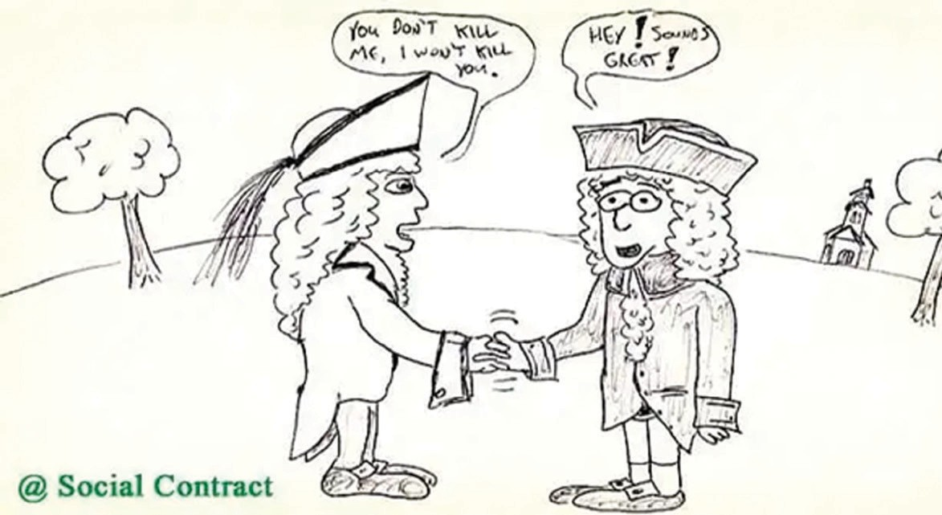

#### Social Contract Theory

The Social Contract Theory traces the existence of the State to the mutual agreement and mutual consent of the people, to form a State. Thomas Hobbes and John Locke, both from England, and Jeans Jacques Rousseau from France, are the three political philosophers who propounded this theory. They assumed that, to escape from the pre-political condition of society, individuals entered into a social contract. These theories served as the basis for modern democracy. This theory established the obedience to political authority and that ultimate political authority rested with the consent of the people. The pre-political condition of mankind was described as the state of nature.

**Thomas Hobbes** (1588-1679), an English political philosopher, in his literary work Leviathan explains the origin of the state. He explains that prior to the emergence of a civil state, human beings were in the state of nature. Hobbes began his thesis with the concept of a state of nature,which he characterised as the pre-social phase of human nature. Their lives were under constant struggle with nature. The state of nature was a

condition of unmitigated selfishness and capacity. It was a condition of

[https://www.politicalscienceview.com/the-theory-of-social-contract/](http://www.politicalscienceview.com/the-theory-of-social-contract/)

perpetual war ‘where every man was enemy to every other man’. The life of a human being was ‘solitary, poor, nasty, brutish and short’.

UNIT V

UNIT IV

UNIT III

UNIT II

**UNIT I**

To evade the state of nature, and for securing their natural rights of life, liberty and property as civil rights, individuals entered into a social contract to establish a state. The people authorized their right of governing themselves to the sovereign, which came into being as a result of the contract. The person or assembly of persons to whom the rights were surrendered became the sovereign and the individuals who agreed to submit to the authority become subjects. Sovereign here meant the King. The ruler was not a party to the contract, and was not bound by any terms of social contract and free to rule as per his whims. The commands of the sovereign were laws for the governed and the sovereign was not accountable to people. People gave their ruler unquestioned obedience.

In the words of R.G Gettle, Hobbes created the all powerful sovereign on account of his belief that without such sovereign power, law, order, peace and security could not be maintained in society.

Hobbes deprived the people of their right to revolt against the sovereign. Hobbes allowed individuals to disobey the commands only when the sovereign deprived them of their right to self-preservation or the ruler got conquered and submitted authority to a new emperor.

UNIT V

UNIT IV

UNIT III

UNIT II

**UNIT I**

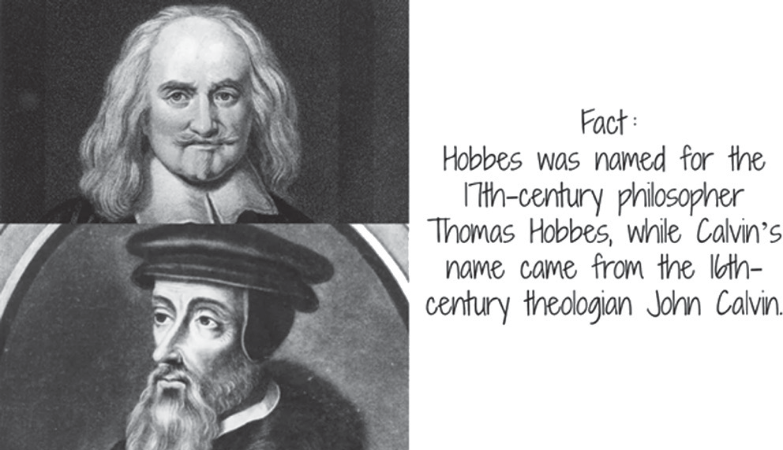According to Hobbes, a change in the government meant the dissolution of the State. Thus, he did not maintain the difference between state and government as a political institution.

**John Locke** (1632-1704) in his book ‘Two Treatises of Government’ explained that the state of nature was not a state of war, but a state of peace, natural rights, preservation, goodwill and mutual assistance.

Locke’s state of nature was pre-political. The people were social and had rights and liberties. The state of nature ensured three rights to individuals relating to life, liberty and property. The state of nature was one of inconvenience. Life was inconvenient because each individual had to interpret the law of nature for himself and had also to enforce it without the help of any other authority. The state of nature did not have the machinery to enforce the natural rights of individuals. To preserve such state of affairs two contracts were made: social and governmental.

Social contract led to the formation of civil society and governmental contract to the establishment of government. Social contract was among the individuals to surrender their natural rights in exchange of civil rights. Governmental contract was between the individuals and the ruler, to establish a system of law and justice in the form of a State. The ruler was the party to the contract and was bound by its terms. Unlike Hobbes, Locke traces the source of government’s authority to the consent of the community.

Locke introduced the concept of limited government, in terms of the rulers, their powers, functions and tenure. He believed in limited monarchy. The King was the trustee of the people. If the ruler abused his powers and breached the popular trust, he may be changed by revolt by the people.

According to **Jean Jaques Rousseau** (1712-1778) ‘the general will of the people’ led to the creation of the institution called the State. Rousseau in his literary work, ‘The Social Contract’ described the state of nature as a state of bliss and happiness. With the passage of time, increase in population and disparity of wealth and power, life became intolerable. Simplicity and happiness disappeared. Human beings then started to build their relations on cooperation and dependency. They entered into a ‘social contract’ to preserve their natural rights without submitting or subordinating to any ruler or authority.

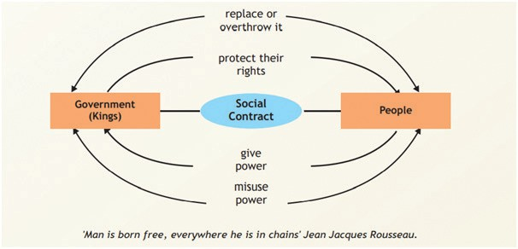Individuals surrendered their rights to the general will of which individuals themselves were part, and hence they shared rights even after transferring them. Individuals were governed by a new authority in the name of general

will (common good) of the people, in the form of direct democracy. Rousseau regarded general will of the people as sovereign. The common good depends on the prevailing circumstances of a society. According to Rousseau, the government is merely the tool to execute the popular will. Thus, popular sovereignty is in continuous

exercise and there is no scope of revolt in his theory.

UNIT V

UNIT IV

UNIT III

UNIT II

**UNIT I**

This theory is criticized on certain common counts. First, the individuals who were naive to the concept of political authority and civil rights could not, from any particular point of time, enter into an agreement and start living a collectivized civil life. Second, if the existence of state is based on agreement of the members of a society, then the old agreement may be revoked for new in accordance with the self-interests of the members. Thus, a mechanically originated state will run under the constant fear of destabilization.

## Elements of a State

#### Population

The state is a human association constituted by the people living there. Population is an essential element of a state. It is the people who make a state, without them there can be no state. The people are the ones who create the state. They also maintain the resources, live on the land, and form the Government. The population must be large enough to make a state and sustain it.

Plato (429-347 B.C.E) in his book ‘The Laws’ suggested a figure of 5040 citizens for constituting an ideal State. Aristotle (384-322 BCE) states that the population of a state should neither be so large that administration may be inconvenient nor so small that people may not lead a life of peace and security.

Stephen Leacock (1869-1944), an English political writer had stated that the population must be sufficient in number to maintain a state organization, and that it ought not to be greater than the territorial area and resources that the state is capable of supporting.

On the nature of population, it may be homogeneous or heterogeneous in respect of race, religion, language or culture. Countries such as India, United States of America, and Canada have population marked with such diversity. People’s Republic of China has a population of more than 1400 million people, whereas the smallest state in the world Vatican has a population of only 821 people.

#### Territory

A state is a territorial institution. The fixed territory and population of a state gives it a physical identity in the eyes of municipal law and international law.

The functions of a state, as a political and legal community of human beings, must first of all be exercised in a given territory. Territory is a geographical area that is owned and controlled by a government or country to exercise state sovereignty. Aristotle (384-322 BCE) favoured the State having moderate size. Montesquieu (1689-1775) said that there is a necessary connection between the size of the state and the form of government best suited to it. The fact is that the states of the world vary in terms of demographic strength. San Marino has an area of 36 sq. miles, whereas the United States of America has a territory of 37,38,395 square miles.

Territory is therefore generally described as land which belongs to the state and individuals, internal waters and territorial sea (straits) which state claims for sovereignty and the airspace above this territory (land, bodies of water, atmosphere and natural resources). Resources such as agriculture, livestock, minerals, oil, natural gas and forestry can be found on land.

Territories constitute the physical basis of the state. Nomads and gypsies can have no state because they lead a wandering life. It is important that a state should possess an undisputed territory of its own over which it should have exclusive jurisdiction. Furthermore, it should have territorial contiguity, i.e., geographically it should be one composite whole. A fixed territory is

not essential to the existence of a state provided that there is an acceptable degree of what is characterized as ‘consistency’ in the nature of the territory in question, and of its population. In fact all modern states are contained within territorial limits.

UNIT V

UNIT IV

UNIT III

UNIT II

**UNIT I**

In brief, a territory does not need to possess geographical unity, and it may even consist of territorial areas which lack connection, or are distant from one another. For instance, islands or other territories which are part of the mainland still constitute of territory of a state.

#### Government

Government is the political and administrative organ of a State. The state operates through its government. The state consists of all its citizens, and is a broader concept. The Government is the sum total of legislative, executive, and judicial activities of a state. It also includes internal bodies, sub-state governing authorities at the local and regional levels, such as the Municipal Corporations, Municipal Councils, Panchayats and Gram Sabhas in India. The government of a state makes provisions for the services of defence, foreign relations, levy of taxes, issue of currency, building of roads, bridges, transportation, communication, water supply, electricity, health education and other types of social and physical infrastructure. The government of a state shall be so organized that it enforces law to maintain order, peace and security. As the role of a state changes, so does the form of government.

#### Sovereignty

Sovereignty is the crucial factor that distinguishes the state from other associations. Without Sovereign there can be no state in the technical sense of the term. Sovereignty is the most essential ingredient and characteristic in the formation of the state. No state can exist without internal and external sovereignty. Internal sovereignty means that the people residing within the territory of the state give their unqualified obedience and support to the authority of the state, and further that the state is supreme in all its internal matters. It is by virtue of its sovereignty that the state makes its laws and decisions and issue commands which are binding on all citizens. The right to use legitimate coercion in its own right is exclusive to a state. Internal revolts or external aggressions may disturb a state, but the state continues to exist so long as it has legitimate sovereignty.

External sovereignty is understood as the freedom of state from external control and influence. The state should be treated at par with other states and should not be assigned any inferior position. The state should be free to enact its own laws as well as foreign policy without any external pressure.

Presently ‘international recognition’ is also considered as an essential element of the state. That implies the recognition of the sovereignty of the state over a given territory and population by other states.

## Role of a State

Political thinkers have different opinion regarding the role of the state. In the words of Professor MacIver, “the state has no finality, can have no perfected form. The state is an instrument of social man.” To many scholars the functions of the state are also different. Some consider state as a moral and ethical institution whereas others consider it as an evil institution. MacIver has referred to different notions of the state such as class organization, legal institution, mutual insurance agency, unnecessary evil, necessary evil, the march of God on earth, welfare system, power system, state as an organism etc.

Andrew Heywood, an English political writer in his book Politics, classifies the role of the state based on the functions or responsibilities that are fulfilled by the state and the ones that are left to private individuals. It will be instructive to examine the following classifications:

#### Minimal States

UNIT V

UNIT IV

UNIT III

UNIT II

**UNIT I**

The ideal of minimal states is a contribution of classical liberals. Names of political thinkers such as John Locke, Jeremy Bentham, J. S. Mill, Herbert Spencer, Robert Nozick, Friedrich Von Hayek and Milton Friedman are generally associated with this approach. The idea is to ensure the widest possible individual liberty. People who ascribe a minimal role to the state believe that a laissez-faire (‘let it be’ or ‘leave it alone’) approach to the economy is most likely to lead to economic prosperity. States’ role is to protect individuals from interference in their liberty and that transactions between private individuals are voluntary and free. According to John Locke’s theory, ‘state acts as a night watchman’ whose services are called upon when orderly existence is threatened. The state must exercise the basic role of providing protection from external attacks, enforcing agreements and maintaining domestic order. Minimal states play a minimum role in interfering with the social and economic life of the subjects.

#### Developmental States

A developmental state is characterized by having strong state intervention, as well as extensive regulation and planning. The term ‘developmental state’ describes the states’ essential role in harnessing national resources and directing incentives through a distinctive policy-making process. The first person to seriously conceptualize the developmental state was Chalmers Johnson (1931-2010). Johnson defined the developmental state as a state that is focused on economic development and takes necessary policy measures to accomplish that objective.

#### Social Democratic States

Social democratic states are the ideal type of states viewed by modern liberals and democratic socialists. The state functions on the principle of fairness, equality and equal distribution of wealth to achieve social, political and economic justice, equality and empowerment of its people. The state is considered necessary to promote economic growth and social well-being of its people.

#### Collectivized States

They undertake the control of economic life, by bringing common ownership of all economic resources under their own control for the welfare of all. The state makes laws to control the private property of their citizens. People’s Republic of China follows such a policy. The state takes care of the economic needs of its citizens i.e. provides food, shelter, employment and the citizens must not act against the government policies.

#### Totalitarian States

Philosophers like Hegel and dictators such as Hitler and Mussolini held that the state must have absolute powers and individuals have no right against the state. According to this view, the state can do no wrong. The whole life of an individual is within the jurisdiction of the state.

#### Modern Welfare State

Irrespective of the classification, functions of a modern welfare state include the maintenance of law and order, establishment of justice, defence, public security and foreign relations, maintenance of public health and sanitation, water supply, transport and communication system, supply of power, electricity and essential commodities,control of banking, currency and inflation, preservation of forests, checking of trading and control of prices and measurements etc. Other functions include the removal of social exploitation and establishment of social unity, provision of economic and other benefits to weaker sections, social security to old age people, widows, orphans and disabled,protection of workers by regulating minimum wages, pension, education

of the masses,encouragement of art and literature, scientific and technological research and cultural exchanges to increase the spirit of cultural unity and harmony among the masses.

UNIT V

UNIT IV

UNIT III

UNIT II

**UNIT I**

## Exercises

Based on your understanding, answer the following questions:

* 1. Write short notes on the following-
     1. Patriarchal Theory
     2. Developmental States
     3. Social Contract Theory
     4. Totalitarian States
     5. Article 12 of the Constitution of India
  2. Write one point of difference between the following-
     1. Internal and External Sovereignty
     2. Matriarchal and Patriarchal theory of State
     3. Minimal and Collectivised State
     4. Social Contract theory by Hobbes and Locke
     5. State and Government
  3. Answer the following questions briefly-
     1. List down the various theories on the origin of State.
     2. Briefly explain the elements of a State.
     3. What are the various states on the basis of its role? Q-4 Answer the following questions in about 200 words

1. Explain the comparative views on social contract theory.
2. Define State.
3. Explain the emergence of State.
   1. Hobbes stated ‘Man is born free, everywhere he is in chains’. In light of this statement, in which type of state would a man be chained the most and why? Give an example of such a State. If given a choice of residence, in which type of state would you like to reside? Give reasons.
   2. Patria, a locatable place on the world map, having a considerable territory under its control, consisted of a population of 1 million people. It was ruled by Col. George, however, the place did not gain any international political recognition as one of the major elements was missing. Identify and explain all the elements of state.
   3. How has the concept of state been defined in the Constitution of India? Why do you think it has been included in Part III of the Constitution?
   4. How would you differentiate between India as a state and the various states of India?
   5. Imagine yourself living in a state of nature. Which aspects of your life would you want to give up and what would you expect in return? What kind of social contract would you enter into and with whom?

UNIT V

UNIT IV

UNIT III

UNIT II

**UNIT I**



**Forms and Organs of Government**

CHAPTER

2

## Contents

* 1. Introduction to the Organs of Government
  2. Forms of Government
     1. Monarchy
     2. Aristocracy
     3. Dictatorship
     4. Democracy
  3. Main Organs of Government and its Functions
     1. General Functions of Legislature as Organ of Government
     2. General Functions of Executive as Organ of Government
     3. General Functions of Judiciary as Organ of Government
  4. Exercises

## Learning Outcomes

Students will be able to:

* Construct the political system which forms the foundation of our legal system
* Describe all forms of government seen globally with relevant examples
* Differentiate between all forms of government
* Recall organisation of legislature globally and their advantages
* Identify the organs of government
* Explain the functions of legislature
* Enumerate the functions of executive and link it to modern welfare state
* Explain the functions of judiciary
* Evaluate the overlap in functions of all organs

## Introduction to the Organs of Government

UNIT V

UNIT IV

UNIT III

UNIT II

**UNIT I**

In the preceding chapter, we discussed ‘Government’ as an essential element of the ‘State’. Government can be said to be a set of institutions that exercises control through legal devices and imposes penalties on those who break the law. A government normally functions by distributing its functions between its organs with each organ performing some specific functions. It primarily performs three functions: making the laws, enforcing the laws and adjudicating disputes. These three essential functions are termed legislative, executive and judicial functions.

A government achieves the purpose of a state through the performance of the above functions. These functions constitute the minimal requirements of any form of government. The legislature makes laws, the executive implements them and the judiciary interprets laws and adjudicates disputes. This system of distribution of powers among the three organs of a government is called ‘Separation of Powers’.

## Forms of Government

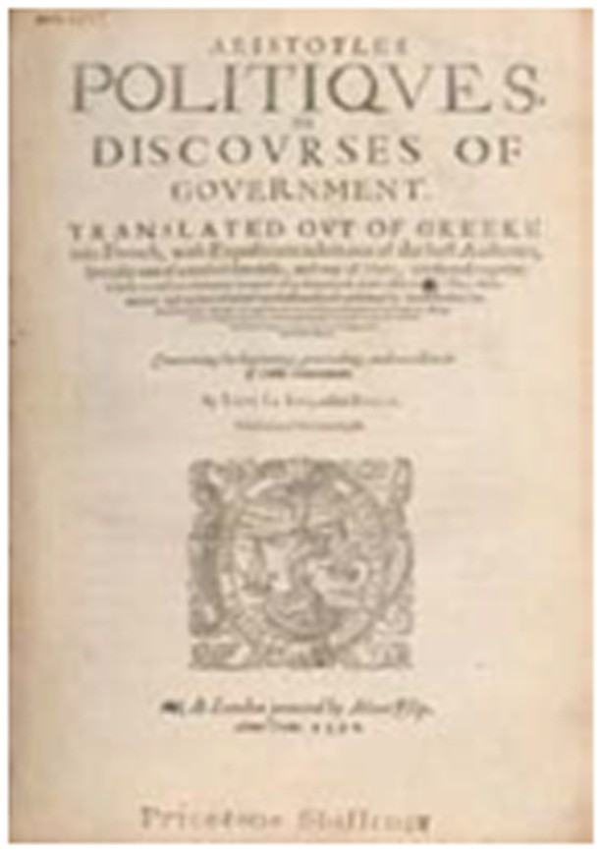

#### Monarchy

Monarchy is the oldest form of government. The state machinery worked according to the commands and rule of the monarch. Monarchy is thus a form of political regime in which the supreme and final authority is in the hands of a single person wearing a crown, irrespective of whether his office is hereditary or elective. It is the will of one person which ultimately prevails in all matters of governance.

J.W. Garner (1871-1938) stated “In its widest sense, any government in which the supreme and final authority is in the hands of a single person is a monarchy, without regard to the source of his election or the nature and duration of his tenure. In this sense, it is immaterial whether his office is conferred by election (by parliament or people) or is derived by hereditary succession, or whether he bears the title of emperor, king, czar, president or dictator. It is the fact that the will of one man ultimately prevails in all matters of government which gives it the character of monarchy.”

With the development of Republican and Democratic forms of government, monarchial form of government declined. In some cases, as in the United Kingdom, monarchs are merely retained as the ‘ceremonial’ or ‘nominal’ heads of government, devoid of key political powers. As observed by C.C Rodee, “Constitutional monarchs are loved and respected by their people as the symbols of unity of the nation or empire, but are devoid of political power.”

#### Aristocracy

UNIT V

UNIT IV

UNIT III

UNIT II

**UNIT I**

The word ‘Aristocracy’ originates from the greek word ‘aristo’ which means ‘the best’ and another greek word, ‘kratein’, which means ‘to rule’. In aristocratic form of government, political power of the state is vested in the hands of a few people. It is a form of government in which relatively small proportion of people determine the policies of the government. It can be a combination of priests, soldiers, professionals, landowners or men of wealth.

As defined by Garner, Aristocracy is the form of Government “in which relatively a small portion of citizens have a voice in choosing public officials and in determining public policies.” Those few people are chosen from among the people of the state on varied basis, such as wealth (land owning class), education (nobles), religious positions (priestly class), family, succession, physical force etc. The ruler is considered as a class separate and superior from the ruled.

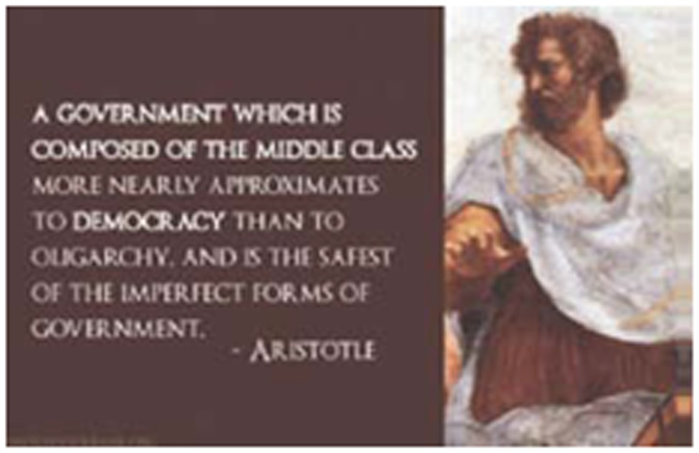

#### Dictatorship

In the words of Alfred Cobban (1901-1968), “It is the government of one man who has not obtained the position by inheritance, but either by force or consent or a combination of both. He possesses absolute sovereignty, that is all the political power emanates from his will and it is unlimited in scope. It is also exercised in an arbitrary manner by decree rather than by law. The authority of the dictator is not limited in duration, is not subject to any other authority, for such a restriction would be inconsistent with his absolute rule”.

Dictatorial form of Government is the rule by a single person or a determined set of individuals. He controls and exercises the political powers of the state. He occupies the position by force, invasion, intervention and militarism, in contrast to a monarch. His dictates are law of the country. He implements them and adjudges according to his will. He holds the absolute power. He is not accountable or answerable to the citizens of the state. Modern Dictatorship plays the role of totalitarian states.

#### Democracy

Pericles (495-429 B.C.) the Greek leader defined democracy as a form of Government in which people are powerful. Bryce defined democratic form of government as one where the ruling power of the state was vested not in a particular class or classes but in the community as a whole. Democratic form of Government is the most popular form in the modern civilized states. The word, ‘democratic’ originated from the Greek word ‘Demos’ meaning people and ‘Kratia’ meaning rule, i.e. rule by a popular vote.

Abraham Lincoln (1809-1865), a former President of the U.S., in his speech at Gettysburg defined democracy as a ‘government of the people, by the people and for the people’.

‘Government of the people’ implies equal distribution of political powers and influence among the citizens of the state, ‘government by the people’ implies participation of all citizens in forming a government, ‘government for the people’ implies the rule of government for the promotion of public welfare.

UNIT V

UNIT IV

UNIT III

UNIT II

**UNIT I**

Democracy exists in two major forms: **Direct or pure democracy and indirect or representative democracy.** As defined by Garner, ‘A pure democracy so called is one in which will of the state is formulated or expressed directly and immediately through the people in mass meeting or primary assembly, rather than through the medium of delegates or representatives chosen to act for them’. The political power is in the hand of the citizens of the state as a whole to enact legislations, to administer regulations and the citizens, by common vote, elect their public officers. This is referred to as initiative, plebiscite or referendum.

This form of democracy operated in Greek city state, Athens during 4th and 5th century BC and in Rome during the early stages of the Roman polity, as an ideal system of popular participation. This form of democracy is not possible in the states having large population and territory. In contemporary times, this form of democracy is prevalent in the provinces of Switzerland. The voters meet in open air Parliament known as Federal Assembly, to deliberate upon and decide public affairs by way of Initiative, where a specified number of voters prepare a bill for acceptance or approval by legislature or general public. If approved it becomes law. Referendum is where the bill passed by the legislature is forwarded to the voters for final ratification. The term plebiscite is used where an important issue could not be decided by the government, and is decided by the votes of people. Voters recall their elected representatives when they are not satisfied by their conduct.



The other form is Representative or Indirect Democracy, on the basis of universal suffrage. In this form, citizens of the country elect their representatives on the basis of popular votes. The will of the state is formulated and expressed through the representatives. The representatives form a law making and law-executing agency for a fixed term. On the matters of governance, the representatives are accountable and answerable to the public in general. As observed by Garner, ‘this kind of democracy resembles its pure form in the sense that political power remains vested in the people, but the two differ in respect to their exercise’. Thus all the citizens of the state have equal opportunity of participation in the political affairs of the state in contrast to monarchy or dictatorial form of Government. The political power remains in the hands of people.



#### Presidential and Parliamentary form of Government

UNIT V

UNIT IV

UNIT III

UNIT II

**UNIT I**

In Parliamentary system the legislature and the executive are related to each other, by way of membership in the two bodies and their accountability. This form of government is well prevalent in India and United Kingdom. The executive body, while implementing laws and discharging its responsibilities like health, education, food and public distribution, defence, police services etc., is responsible to the legislature.

As stated by Professor M.P. Jain, “A notable principle underlying the working of parliamentary government is the principle of collective responsibility which represents ministerial accountability to the legislature. The principle of collective responsibility means that the Council of Ministers works as a team, as a unit and is responsible as a body for the general conduct of the affairs of the government. All the Ministers stand or fall together in Parliament, and the government is carried on as a unity.”

This form of Government is also termed as Cabinet Government by Sir Ivor Jennings (1903-1965), an English lawyer and academician, and Prime Ministerial Government by Richard Crossman (1907- 1974), an English author and politician.

In the Presidential system, executive branch of the government is independent of the legislature for its tenure and actions. In the words of Garner, “Presidential government is that form in which the chief executive is independent of the legislature as to his tenure and, to a large extent, as to his policies and acts. In this system the nominal head of the state is also the real executive.”

This form of government is prevalent in United States of America and Argentina. The President is elected by the people, whether directly or indirectly, for a fixed period unless removed on impeachment by the legislature on the grounds stated in the Constitution of the country. This system works on the principle of ‘separation of powers’ and ‘checks and balances’.

#### Unitary and Federal form of Government

The Unitary form of Government is one where the whole state with all its units and provinces is organized under a single central Government. The local/provincial Governments are created by the central Government as its subordinates for better administration. The central Government delegates powers and authority to the local/ provincial Government. As remarked by Garner, “Where the whole power of Government is conferred by the constitution upon a single central organ or organs from which the local governments derive whatever authority or autonomy they may possess, and indeed their very existence, we have a system of unitary government. It is the characteristic of this form of government that there is no constitutional division or distribution of powers between central government of the state and subordinate local governments.”

As remarked by Garner, “Federal Government as distinguished from a unitary government is a system in which a totality of governmental power is divided or distributed by the national Constitution or the organic act of Parliament creating it, between a central Government and the governments of individual states or other territorial sub divisions of which the federation is composed. Local/ provincial Government is considered as part of central Government with full autonomy.” As listed in the Seventh Schedule of the Constitution of India, the matters concerning national importance like international relations, war and peace, atomic energy, etc. are dealt with by the Central Government.

The matters of regional and local importance listed in the state list can be legislated by the state governments. There are matters on which both the Central and State governments are authorized to make laws which are included in the Concurrent list. Constitution of India despite having adopted federal features does not claim to establish India into a federation of states. In the words of K.C. Wheare, India’s system of Government is federal in character and unitary in spirit.

During recent periods, the governments of most States have combined different forms stated above.

For instance the British Government combines Monarchy, Democracy, and Parliamentary forms. India is a Democratic Republic with Parliamentary form of government with Unitary and Federal features.

UNIT V

UNIT IV

UNIT III

UNIT II

**UNIT I**

## Composition of the Legislature

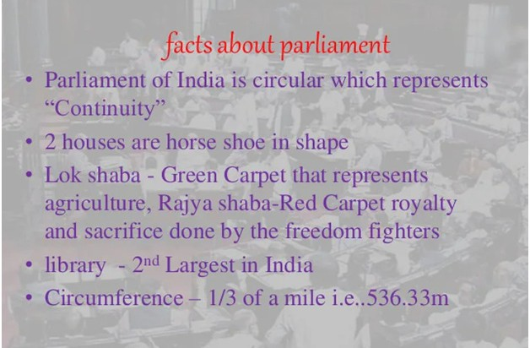

Legislature may be organized as Bicameral or Unicameral Legislature. In a Bicameral System, there are two houses or chambers. Indian Parliament is a bicameral legislature, its houses being the House of People (Lok Sabha) and Council of States (Rajya Sabha). In the States of the Indian Union, the legislature consists of the Vidhan Sabha (lower house) and Vidhan Parishad (upper house). However, certain states have only one house. The House of People (Lok Sabha) consists of the representatives of citizens of the entire country living in states and union territories. Council of States (Rajya Sabha) consists of the representatives elected by the Legislative Assemblies of the states, and other nominated members from the field of art, culture, academics, sports, literature science and social service. The purposes and functions of the second chamber are to check hasty and ill-considered pieces of legislations, with the sober advice of experts and eminent persons. Thus, it becomes possible to examine issues from different standpoints, and to safeguard the interests of states in a federal system.

Unicameral legislature implies one legislative house. This system of legislature is seen in Turkey, which is known by the name of Grand National Assembly of Turkey; in Bangladesh by the name of House of Nation, etc. This system is supported by the reason that the legislative body representing people’s interest must be one, failing which delays and conflicts may arise in the enactment of legislation.

India has 28 States and 8 Union Territories.

There are 24 states which have a unicameral structure. The list of these states are given below:

1. Arunachal Pradesh
2. Assam
3. Chhattisgarh
4. Delhi
5. Goa
6. Gujarat



7.

8.

9.

10.

11.

12.

13.

14.

15.

16.

17.

18.

19.

20.

21.

22.

23.

24.

Haryana Himachal Pradesh Jharkhand

Kerala

Madhya Pradesh Manipur Meghalaya Mizoram Nagaland Odisha Puducherry Punjab Rajasthan Sikkim

Tamil Nadu Tripura Uttarakhand

West Bengal

The names of the six states having bicameral legislature are:

1. Andhra Pradesh
2. Bihar
3. Karnataka
4. Maharashtra
5. Telangana
6. Uttar Pradesh

**Difference between Unicameral Legislature and Bicameral Legislature**

UNIT V

UNIT IV

UNIT III

UNIT II

**UNIT I**

|  |  |  |
| --- | --- | --- |
| **Difference** | **Unicameral** | **Bicameral** |
| Number of House | One | Two |
| Sharing of Power | Concentrated in one house | Shared between two houses |
| Decision-Making | Flexible and efficient as bills are introduced and passed in only a single house | Time-Consuming as both the houses have to pass the bill hence, their approval is a tedious task |
| Suitability | A unicameral legislature is best suited to smaller states. | Bicameral legislature is more suited to larger states |

## Main Organs of Government and its Functions

UNIT V

UNIT IV

UNIT III

UNIT II

**UNIT I**

Let us now try to learn about the three main organs of government (the legislature, the executive and the judiciary), their functions and various related provisions. Here we also try to explain the relationship between various organs of a government.

#### General Functions of Legislature as Organ of Government

Parliament, Assembly and Congress are the synonyms used for the term ‘Legislature’ in various countries. The word ‘Parliament’ is derived from the French word ‘parler’. Parliament means meeting for discussion. The following are some functions of this organ:

###### Expressing and formulating the will of the state and enactment of laws

The legislature formulates and expresses the ‘will of the state’. The ‘will of state’ in a representative democracy is the will, opinion and sentiments of its citizens and the public issues concerning them. In a monarchy or dictatorial Government, the ‘will of the state’ is the interest and objectives of its ruler.

Laws when enacted are called ‘Acts’. These Acts are the direct source of law to control and regulate the institutions running in a state and society. All legislations are enacted for the achievement of certain objectives and purposes. For example, the Indian legislature enacted the Consumer Protection Act, 1986 with the purpose of protecting the interest of consumers and the speedy settlement of their disputes.

###### Ensuring accountability of the executive

Article 75(3) of the Constitution of India states that the Council of Ministers shall be collectively responsible to the House of the People. Parliament exercises check and ensures executive and administrative accountability through its control over finances. Parliament assesses governmental policies and performance of administration through procedures like questions, calling attention motions etc. Motion of No-Confidence may be moved and passed against the Council of Ministers, in the Lok Sabha.

**Parliamentary procedure and enactment of laws**

A Bill is a statute in draft and cannot become law unless it has received the approval of both the Houses of Parliament and assent of the President of India. A Bill can be introduced either by a Minister, when it is called a Government Bill; or a member other than a Minister, when it is known as a ‘Private Member’s Bill’.

The legislative procedure for introduction and passing of Bills is laid down in Articles 107 to 108, in the Constitution of India, in the case of ordinary Bills; and in Articles 109-110 in the case of Money Bills. Article 111 provides details of assent to Bills by the President.

1. Ordinary Bills may originate in either House of Parliament.
2. A Money Bill contains provisions for imposition, abolition, alteration or regulation of any tax, custody of the Consolidated Fund or Contingency Fund of India, payment of money into or withdrawal of money from any such Fund and related matters. However, a Money Bill shall be introduced only in the House of People and not in the Council of States.
3. Annual Financial Statement is the annual statement of estimated receipts and expenditure of the Government for the ensuing financial year. Article 112 of the Constitution of India states that the President shall cause the statement to be laid before both the Houses of Parliament. The Members of Parliament debate on the provisions of the proposed Bill. Generally, a Bill is passed after three readings.

###### Legislature and its judicial functions

UNIT V

UNIT IV

UNIT III

UNIT II

**UNIT I**

The Legislature performs judicial functions while hearing and trying cases of impeachment (removal from office before term). The Constitution of India lays down the procedure for impeachment of President and Vice President of India, Judges of the Supreme Court and High Court and the Chief Election Commissioner. It performs judicial function while deciding on the privileges of the Members of the House.

###### Legislature and its Administrative functions

In India, the elected members of both Houses of Parliament and elected Members of the Legislative Assemblies of the States form an electoral college to elect the President. The Vice- President is elected by an electoral college comprising of Members of both Houses of Parliament. The members of the Lok Sabha elect two members as the Speaker and Deputy Speaker, while the members of the Rajya Sabha elect the Deputy Chairman of the Rajya Sabha.

#### General Functions of Executive as Organ of Government

Executive is often referred to as the ‘government’ of a state. In a representative democracy, the term ‘Executive’ has a broad meaning.

The following are the functions of the executive organ:

###### Internal and External Administration of the State

The chief function of the executive is the maintenance of internal and external administration - law and order, financial matters, infrastructure and industrial development, welfare and development of the people (health, education, labour, employment, rural and local development), environment and forests, natural resource management, trade and commerce etc., on the internal front and defence, foreign affairs, international relations etc on the external front.

###### Executive and its Legislative functions

The executive performs certain legislative functions.

###### Delegated Legislation

Delegated legislative functions are performed by the executive. Delegated legislation is an enactment made by an individual or body other than Parliament. By delegating the power to make a legislation to the Executive, the Parliament empowers different people or bodies to integrate more details to an Act of Parliament. Parliament along these lines, through essential enactment (for example an Act of Parliament), authorises the executive to make laws and guidelines through delegated legislation. It frames orders, rules, regulations, ordinances, by-laws, and circulars. They carry equal force of law if framed within the sphere and policy of the parent legislation.

###### Ordinance

Under Article 123 of the Constitution of India, the President has the power to promulgate an ordinance during the recess of the Parliament. An ordinance is a law that is promulgated by the President of India only when the Indian parliament is not in session. President promulgates an ordinance on the recommendation of the union cabinet. Using ordinances, immediate legislative actions can be taken. However, it must be noted that for an ordinance to exist, it should be approved by the Parliament within six weeks of being introduced. Parliament is required to sit within 6 weeks from when the Ordinance was introduced.

###### Executive and its financial functions

UNIT V

UNIT IV

UNIT III

UNIT II

**UNIT I**

The executive imposes and collects taxes and incurs expenditure on the various activities of the state. It prepares budget of the financial year, maintains accounts of government departments and prepares national policies. It also arranges financial grants from international entities like International Monetary Fund, World Bank etc.

###### Executive and Judicial functions

Judicial functions of the executive include power to grant pardon (Presidential), to suspend or lessen the punishment on special grounds or to exchange one form of punishment for another, on the petition of a person convicted of any offence by the court.

#### General Functions of Judiciary as Organ of Government

###### To Hear and Decide disputes

The first and the foremost function of the judiciary is to hear and decide a case, according to the substantive and procedural laws of the land. The role of the judiciary is expanding with the expanding role of the executive. Disputes may arise among citizens of a state, between citizens and state, among the federal units, between the various departments of the executive and in international relations, calling for intervention by the judiciary.

Dispute settlement and adjudication require the independent functioning of judiciary, without political influence or interference. Impartial and time-bound justice delivery are essential requirements for the judiciary.

###### Judicial Review

Judicial review is the power bestowed upon the judiciary by the constitution, by virtue of which the judiciary can examine legislative enactments and executive orders of the governments, be it state or central, and declare them null and void if they contravene the provisions of Constitution.

**Judiciary and its Jurisdiction**

Judiciary refers to the set of courts having civil and criminal jurisdiction. With the expansion and diversification of state and its agencies, and expansion of arbitration and conciliation, tribunals and various for a have also become part of the conventional judicial system, such as the Motor Accident Claims Tribunal under Redressal Forums under the Consumer Protection Act, 1986 etc.

The judiciary exercises jurisdiction on the basis of territorial limits, pecuniary/financial limits, appealable matters, matters for review and revision. The judiciary consists of Magisterial courts, District and Sub-District Courts at the lower level and the higher judiciary comprising of High Courts and the Supreme Court. Decision given by them is known as ‘judgment’, decree’, ‘order’, or ‘award’.

###### Interpretation of laws

Wherever the law is ambiguous (confusing) or not clear or silent or appears to be inconsistent with other laws of the land, the courts after proper analysis determine or interpret the intent, purpose and meaning of the provisions of law.

###### Advisor to the President

The Supreme Court has special advisory jurisdiction in matters which may specifically be referred to it by the President of India under Article 143 of the Constitution.

###### Role of Judiciary as an activist

UNIT V

UNIT IV

UNIT III

UNIT II

**UNIT I**

In India, perhaps the first instance of the activist role of the judiciary was after the Emergency, when the Supreme Court came up with public-interest litigation (PIL), a tool meant to ensure justice for the under-privileged and the marginalized.

###### Legislative and executive function of the judiciary

The judiciary has been empowered to frame rules and execute them for the smooth functioning of its own administration. This is also done to ensure independence of the judiciary.

## Exercises

Based on your understanding, answer the following questions:

* 1. Provide one point of difference between the following-
     1. Monarchy and Democracy
     2. Parliamentary and Presidential form of government
     3. Direct and Indirect democracy
     4. Lok Sabha and Rajya Sabha
     5. Unicameral and Bi-cameral legislature Q-2 Give an example for the following-

1. A country where unicameral legislature exists
2. A country where presidential form of government prevails
3. A country where the monarch enjoys the absolute power
4. A country where direct democracy exists
5. A country where constitutional monarchy exists Q-3 Write brief notes on the following-
6. Money Bill
7. Annual Financial Statement
8. Democracy
9. Unitary form of government
10. Judicial function of executive
    1. Explain the role of the following organs of Government.
       1. Legislature
       2. Executive
       3. Judiciary
    2. A country, Amerintina was governed by representatives on behalf of the citizens. Another country, Plicia was governed by the citizens themselves by various methods. Identify the above two forms of government and differentiate between their processes.

UNIT V

UNIT IV

UNIT III

UNIT II

**UNIT I**



**Separation of Powers**

CHAPTER

3

## Contents

1. Concept of Separation of Powers
2. Historical Background and Evolution of Montesquieu’s Doctrine of Separation of Powers
   1. Montesquieu’s Doctrine of Separation of Powers
   2. Basic Features of the Doctrine Separation of Powers as enunciated by Montesquieu
   3. Checks and Balances of Power
   4. Impact of the Doctrine
3. Evaluation of the Doctrine of Separation of Powers
   1. Key Benefits and Advantages of The Doctrine of Separation of Powers
   2. Defects of the Doctrine
4. Separation of Powers in Practice
   1. Separation of Powers in Britain
   2. Separation of Powers in the United States of America
   3. Separation of Powers in India
5. Exercises

## Learning Outcomes

After the completion of this chapter, the students will be able to:

* Define separation of powers
* Explain historical evolution of the Montesquieu’s doctrine of separation of powers
* Evaluate Montesquieu’s doctrine of separation of powers- it’s advantages, disadvantages, impact and defects
* Describe the concept of checks and balances of power
* Explain the relevance of Montesquieu’s doctrine in governance and comment on its limitations
* Analyse and compare the application of doctrine of separation of powers in UK, USA and India

## Concept of Separation of Powers

For the preservation of the political liberty of the individuals and democracy, it becomes necessary in a state to establish special organs for the exercise of powers. The powers of the government are

divided between its organs in accordance with the nature of powers to be exercised. Broadly, the powers of a government in a state have been classified as the power to:

UNIT V

UNIT IV

UNIT III

UNIT II

**UNIT I**

1. Enact laws i.e., powers of the Legislature.
2. Interpret laws i.e. powers of the Judiciary.
3. Enforce laws i.e. powers of the Executive.

The theory of separation of powers in its simplest form implies that all the above functions should be entrusted to three different authorities. The three organs of the government should be kept separate and distinct. One organ should be independent of the control of others.

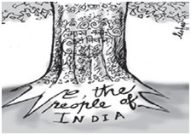

Each organ shall exercise its powers within its own sphere. This doctrine entails that each organ shall not encroach upon or interfere with the powers and independence of other organs of government. If any organ encroaches into the terrain of the other organ, it shall be checked by another organ of the government. Thus, no new organ is created over and above the existing organs of government, to check encroachment.

On the whole, separation of powers requires the existence of a written Constitution to define the formal powers of each organ. The powers shall be so defined and divided to create a system of checks and balances of powers among the organs. This view finds support from the writings of Carl

J. Friedrich (1901-1984), a German-American political theorist.

In the words of Wade and Phillips (Constitutional Law, 1960), separation of powers may mean three different things:

1. The same persons should not form part of more than one of the three organs of the Government
2. One organ of the government should not control or interfere with the exercise of its function by another organ
3. One organ of the government should not exercise the functions of another

## Historical Background and Evolution of Montesquieu’s Doctrine of Separation of Powers

#### Montesquieu’s Doctrine of Separation of Powers

The most original, systematic as well as scientific elaboration of the concept of ‘separation of powers’ has been given by the French philosopher Baron De Montesquieu (1689-1755) in the 18th century. Montesquieu’s theory on ‘separation of powers’ has become the model for governance of all democracies.

During his time, he saw the oppressive and despotic rule of French King Louis XIV (1661-1715). The ruler enjoyed the absolute powers of State, and the prevailing dictum was, ‘I am the State’. Liberty of the people was suppressed under the despotic rule of the King and his administrators.

UNIT V

UNIT IV

UNIT III

UNIT II

**UNIT I**

During his visit to England, Montesquieu experienced the sense of liberty and freedom enjoyed by the citizens of England. He was very impressed with the thoughts of Locke. He compared their system of governance with the system prevailing in his country. He examined the separation of powers of the government, and their exercise by separate organs of the government namely, the King, Parliament and the law courts in the governance structure in England.

The doctrine of the separation of powers emerged as a distinct doctrine in his famous book ‘Esprit Des Lois’ (The Spirit of Laws) published in 1748.

#### Basic Features of the Doctrine Separation of Powers as Enunciated by Montesquieu

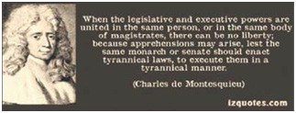

* + 1. Montesquieu proposed the theory of separation of powers. He advised that the division of powers is necessary in between the legislative, the executive and the judicial system.
    2. Different departments must exercise the three powers of the government with their respective personnel. He provided the reason for the division of powers between the three branches of the government as follows:
       1. When the legislative and executive powers are united in the same persons, there cannot be liberty. It may lead to apprehensions that the monarch may enact tyrannical laws and execute them in a tyrannical manner, as the same agency becomes the maker and executor of laws.
       2. Where judicial powers are combined with the legislative, the life and liberty of the subjects would be exposed to arbitrary control, as the Judge would be the legislator.
       3. Where the judicial power is combined with the executive power, the Judge might behave in a violent and oppressive manner. The prosecutor and the Judge would then be the same person and authority.
       4. If powers are vested in one organ, or exercised without separation, governance would not be effective.
    3. It is inherent in any authority to abuse powers unless limitations are imposed on its exercise.
    4. For safeguarding the liberty of people, each organ of the Government shall have the obligation to act within its own sphere and not beyond it. If the authority acts beyond the permitted limits, it would be checked by the other organs. This means that the executive organ shall exercise some control over legislative and judiciary, the legislative organ over executive and judiciary, and the judiciary over legislative and executive organs. The system of checking the encroachment of powers by each organ and thus balancing the division of powers is termed as the system of ‘checks and balances’.

This kind of overview is the correct meaning of the maximlepouvoirartere le pouvoir which means, power halts power. By separating the functions of the executive, legislature and judiciary, one power may operate as a balance against another and thus have a check on the power exercised by another.

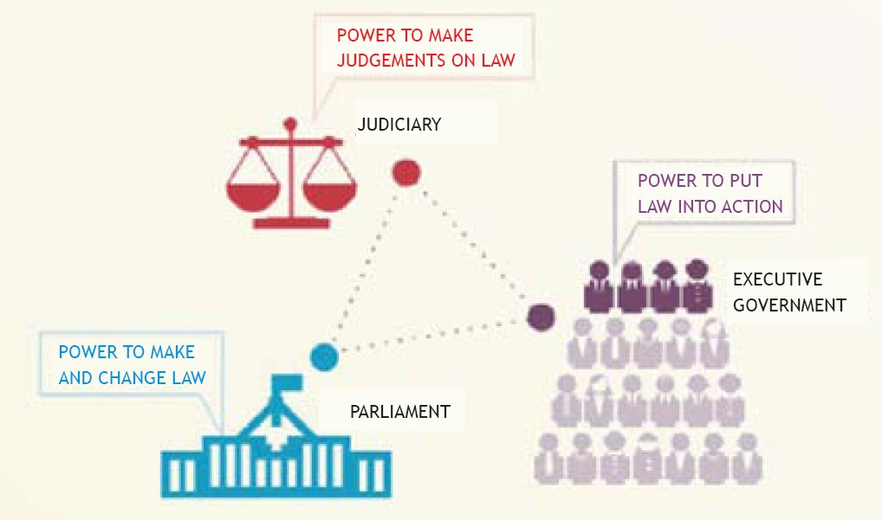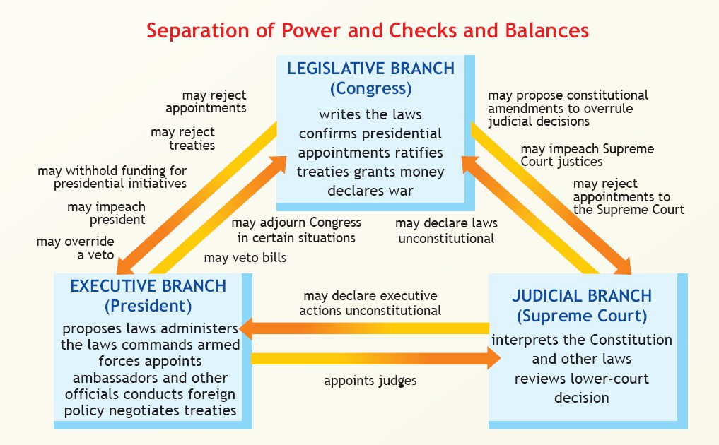

UNIT V

UNIT IV

UNIT III

UNIT II

**UNIT I**

#### Checks and Balances of Power

* The origin of the concept of check and balances is specifically credited to Montesquieu.
* This concept provides a system-based regulation that allows one branch to limit another.
* The following chart explains the operation of check and balance mechanism between

different organs of the government in the United States.

#### Impact of the Doctrine

* Montesquieu advocated the adoption of this doctrine in his own country’s political system.
* His teachings gave boost to the French Revolution and led to the adoption of the Declaration of Rights in 1789.
* The Declaration provided that: ‘Every society in which Separation of Powers is not determined has no Constitution. The French Constitution, 1791 made executive, legislative and judiciary independent of one another’.

UNIT V

UNIT IV

UNIT III

UNIT II

**UNIT I**

* James Madison (1751-1836), the 4th President of United States of America wrote in The Federalist that “The accumulation of all powers, legislative, executive, and judiciary, in the same hands, whether of one, a few, or many, and whether hereditary, self-appointed,or elective, may justly be pronounced the very definition of tyranny”.
* The doctrine of separation of powers forms the foundation on which the entire structure of the U.S. Constitution 1787 is based. Montesquieu thus became the intellectual father of the American Constitution.

## Evaluation of The Doctrine of Separation of Powers

The doctrine of separation of powers can be better understood in two forms. First, it implies that concentration of powers in the same person or same body of persons should be avoided. Secondly, it implies division of those powers which essentially and primarily belong to one organ and not the other. Then allied functions can be performed with the coordination of the other organs. Emphasis must be laid on modification of the concentration of powers.

The doctrine can be better evaluated after studying its key benefits and defects.

#### Key Benefits and Advantages of the Doctrine of Separation of Powers

* Different personnel, with respective capabilities for different organs, bring efficiency to the performance of functions and administration. This indeed serves the purpose of the State and its people. Each organ must do its job to the best of its efficiency, and with due regard to its responsibility.
* The doctrine of separation of powers, safeguards the liberty and freedom of individuals. The doctrine requires that each organ must act within the sphere of law. Thus, it establishes the government of law rather than of official will. It aims at protecting freedom of individual from the tyrannical rule of absolute monarchy. Montesquieu developed the theory as a means of limiting the absolute powers of the ruler in France.
* One important aspect of this doctrine is to establish an independent judiciary that is free from administrative discretion. Montesquieu was interested in setting the judicial power as a check on and as arbiter between the other two organs.
* The system of check and balances within the organs of the government provides stability to the government by protecting the sovereignty of the state. It promotes harmonious exercise of powers and functions within the three organs.

#### Defects of the Doctrine

* Historically speaking, there was no separation of powers under the British Constitution, as construed by Montesquieu. A. V. Dicey had observed that the British constitution had “a weak Separation of Powers”. As remarked by Barnett in Constitutional and Administrative Law (2005), “Britain has an uncodified or unwritten Constitution. Much of the British constitution is embodied in written documents, within statutes, court judgments and treaties as the supreme and final sources of law. The statutes of Parliament can change the Constitution by passing new legislations. The Constitution has other unwritten sources, including Parliamentary constitutional conventions”.
* The three organs of government and their functions cannot be divided into water- tight compartments. It would be wrong to say that they are not interconnected, though their mode of action may differ. The legislature deliberates; the executive takes rapid actions and gives effect to legislative enactments and judicial decisions. The Judiciary critically analyses the laws and actions of the executive, and may even declare them invalid.

UNIT V

UNIT IV

UNIT III

UNIT II

**UNIT I**

* Extreme separation of powers prevents the unity and coordination needed to administer the legally expressed will of the State; extreme checks and balances create frictions and dead-locks that prevent smooth and efficient government. The functions performed by each organ are not unique. A Judge makes law in the form of precedents.The Executive legislates in the form of framing subordinate legislation, such as rules, bye-laws, regulations, policies, schemes etc. The Legislature acts judicially in deciding the breach of its privileges. Absolute separation of powers may even prove hazardous in the smooth functioning of the government.
* “Power tends to corrupt, and absolute power corrupts absolutely” arose as a part of a quotation by John Emerich Edward Dalberg (1834-1902), a historian, politician and writer, who is popularly known as Lord Acton, who expressed this opinion in a letter to Bishop Mandell Creighton in 1887.
* Separation of powers is in itself a protest against power. Its meaning can be better analyzed if the use of the word powers of the organs is substituted by functions. The word ‘functions’ implies the attitude of service, while the word ‘powers’ implies force. The government performs activities to serve the purpose of the State and its individuals through its classified functions for which the different organs are created.
* The theory of separation in its strict sense cannot apply to the countries having Parliamentary form of Government where the legislative and executive organs are combined.

**Growth of executive organ in welfare state:** Montesquieu had envisaged that all the three organs of the government would be given equal and independent position in the political organization of the country. But in fact it is not so in reality. The concept of Welfare State demands more and more action and services from the government such as health, education, food and public distribution, public transport and supply of electricity. It tends to increase the powers of the executive, and develop the executive as a multifunctional organ. Today, the executive legislates, exercises judicial jurisdiction and plans the future activities of the government. As remarked by Barker: “If the growth of legislative organ, in consequence of cabinet system, was the notable feature of 18th century, it may be said that growth of executive organ in consequence of the extension of rights and the corresponding extension of services which mostly fall to the lot of executives, is the notable feature of the 20th century”.

## Separation of Powers in Practice

Depending on the form of Government in a State, there is overlapping of powers among the organs. This can be better explained by studying the functions performed by different organs in a State.

#### Separation of Powers in Britain

The British governing system follows a Parliamentary form of Government. The British Constitutional system has adopted a fusion of powers rather than separation of powers.

In Britain, the three organs of Government are the Executive Head (the British monarch), Legislature comprised of House of Commons and House of Lords, and the Judiciary.

##### EXECUTIVE

UNIT V

UNIT IV

UNIT III

UNIT II

**UNIT I**

The British Queen acts as the nominal executive head devoid of political powers. She holds the office by virtue of hereditary succession. The real executive powers vests with the Prime Minister and the Council of Ministers. The Queen exercises powers on the advice of the Council of Ministers.

##### LEGISLATURE

The United Kingdom Parliament consists of two Houses: the **House of Commons** and the **House of Lords**. Their work is similar: making laws (legislation), checking the work of the government (scrutiny), and debating on current issues.

The Prime Minister and his Council of Ministers are part of the legislature. They are collectively responsible to it and play important role in legislative activities. They remain in office so long as they enjoy the confidence of the House of Commons. They make subordinate legislation. They perform judicial functions by being the members of Administrative Boards and Tribunals. The House of Commons performs judicial function in case of breach of its own privileges.

##### JUDICIARY

The highest judicial court in the UK is the Supreme Court and is relatively new. It was established in October 2009 after the Constitutional Reform Act, 2005. The judges of the Supreme Court are known as Justices of the Supreme Court or Privy Counsellors. Justices of the Supreme Court are granted the courtesy title *Lord* or *Lady* for life.

Prior to the creation of the Supreme Court, the highest court of appeal was the House of Lords Appellate Committee made up of Law Lords. Formerly, Law Lords, who were the final arbiters of judicial disputes in Britain sat simultaneously in the House of Lords, the upper house of the legislature. This arrangement ceased in October 2009 when the Supreme Court of the United Kingdom came into existence.

Until the Constitutional Reform Act, 2005 the Lord Chancellor was the head of the Judiciary in Britain. He fused the Legislature, Executive and Judiciary, as he was the ex - officio Speaker of the House of Lords, a Government Minister who sat in Cabinet and was head of the Lord Chancellor’s Department, which administered the courts, the justice system and appointed judges . He sat as a judge on the Judicial Committee of the House of Lords, the highest domestic court in the entire United Kingdom, and the Judicial Committee of the Privy Council, the senior tribunal court for parts of the Commonwealth.

The Constitutional Reform Act, 2005 separated the powers. The Lord Chancellor ceased to be the Speaker of the Lords, and was replaced by the Lord Speaker. Also, the Lord Chief Justice is now head of the judiciary, and the Lord Chancellor may no longer sit as a judge. Therefore, legislative functions are now vested with an elected Lord Speaker and the judicial functions are vested with the Lord Chief Justice. The Lord Chancellor’s Department was replaced with a Ministry of Justice and the Lord Chancellor currently serves in the position of Secretary of State for Justice.

#### Separation of Powers in the United States of America

The U.S. Constitution has adopted a Presidential form of Government. The three organs of the Government are the President as the executive organ, the Supreme Court of America and the subordinate courts as the judicial organ, and the Congress as the legislative organ, with two houses - Senate (the upper house) and the House of Representatives (the lower house).

The theory of separation of powers finds its best expression in the United States of America.

The American Constitution did not explicitly state that powers ought to be separate. It simply distributed the powers: the legislative powers are vested in the Congress, the executive powers in the President, and the judicial powers in the court. While apportioning the lion’s share of powers to one organ of Government, the Constitution gave smaller slices to each of the other organs. This was done to avoid concentration and consequent abuse of power. The fathers of the Constitution considered that power should be limited, controlled and diffused.

UNIT V

UNIT IV

UNIT III

UNIT II

**UNIT I**

##### LEGISLATURE

* The US Congress is the legislative organ, with two houses - Senate (the upper house) and the House of Representatives (the lower house).
* The law making power is vested in the Congress. The Congress is elected by the people. The members of the Senate sit for six years and those of the House of Representatives for two years.
* The bills passed by the legislature, except money bills are subject to ratification or veto of the President. The Senate shares with the President his powers to make appointments, declare war and ratify treaties. The Congress acts in a judicial capacity in cases of impeachment of the President and Supreme Court Judges.
* The U.S. Congress delegates law making powers to the executive after laying down the

legislative policy and principle.

* The Congress cannot be dissolved by the President.
* There are provisions in the Constitution to over-ride veto power of the President, by special

majority vote in the legislature.

##### EXECUTIVE

* The President is elected by the people. The President remains in power for four years.
* The President receives his share of powers to recommend measures, to summon Congress in special session and to veto bills (except money bills) passed by the Congress. The President has been given the powers of making appointments but these have to be ratified by the Senate. The President appoints Secretaries, with the approval of the Congress as executive heads of the departments. The President and Secretaries are not members of legislature i.e. Congress and do not take part in legislative deliberations or in voting a bill. The President formulates national policy, mobilizes military troops and can declare state emergency.
* The President can declare war but he can do so only if he has got the approval of both the

Houses of the Congress.

* The Presidents’ policies and treaties making decisions are subject to be ratification by the

Senate.

* The President could intervene in the business of the court through his power of pardon for

all offences except treason.

* Thus, this system works on the principle of ‘separation of powers’ and ‘checks and balances’.
* Neither the President is responsible to the Congress nor the Congress is responsible to the

President.

##### JUDICIARY

* While the judges of the Supreme Court are nominated by the President, their appointments

have to be ratified by the Senate. The U.S. Supreme Court has the power under the

constitution to declare void the acts and actions of the legislature and executive. In certain circumstances, the Senate may refuse to ratify the choices made by the President.

UNIT V

UNIT IV

UNIT III

UNIT II

**UNIT I**

* + The Supreme Court has the power of judicial review. The Court has the power to examine the laws passed by the Congress and the executive orders issued by the President and declare null and void if it contravenes the provisions of the U.S. Constitution.

#### Separation of Powers in India

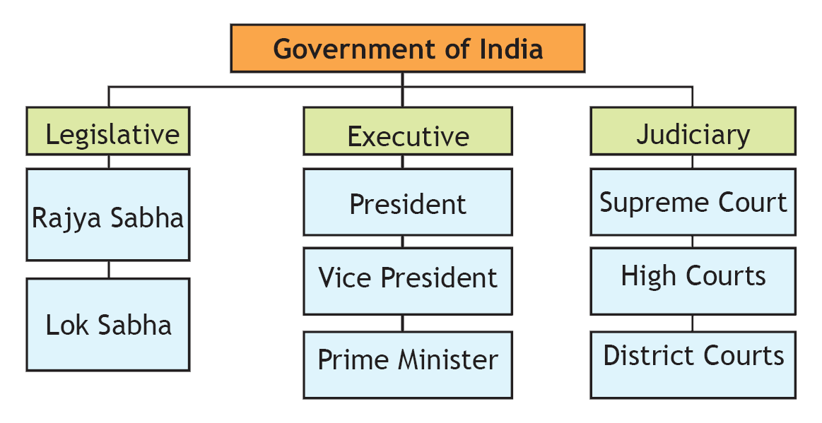

* India’s governing system is broadly similar to that of Britain’s. Both the countries have

adopted the Parliamentary System of Government.

* Under the Constitution of India, the three organs of Government are the legislature, executive and the judiciary. As stated in Article 79 of the Constitution of India, the Parliament consists of the President and two Houses known as the Council of States and the House of the People.
* The Constitution of India has not adopted the doctrine of separation of powers in its strict sense. Nevertheless, the Constitution of India has sufficiently differentiated the essential functions of the organs and no organ shall assume to itself what essentially belongs to the other.

##### EXECUTIVE

* The President of India is the nominal executive head. The real executive is the Prime Minister and his/her Council of Ministers. The President exercises his/her powers/functions with the aid and advice of the Prime Minister and his/her Council of Ministers. Usually the advice is binding on the President.
* The President is elected by the Electoral College consisting of the elected members of both

houses of Parliament and the elected members of the legislative assemblies of the state.

* He/she is appointed for a fixed term of 5 years.

##### POWERS OF THE PRESIDENT

The President has wide legislative powers to issue ordinances for immediate action during the recess of legislature. An ordinance issued shall have the force and effect as that of an Act by Parliament. President has the power to dissolve House of People. The President has the power to declare National Emergency, State Emergency and Financial Emergency. The President is authorized to exercise legislative powers in case of State Emergency.

##### LEGISLATURE

UNIT V

UNIT IV

UNIT III

UNIT II

**UNIT I**

The Prime Minister and his/her Council are normally Members of Parliament. They play an active role in proposing a bill and voting a bill in the Parliament. A bill becomes an Act when President gives his/her assent to it. The Council of Ministers including the Prime Minister is collectively responsible to the House of People. Thus, they remain in office so long as they enjoy the confidence of the House of People. The President may be impeached by the Parliament.

###### Powers and functions of the Legislature

The Constitution of India provides for the powers and functions of the legislature. Article 246 of the Constitution provides that the Parliament and the Legislatures of the States have power to make laws. The matters are listed in Schedule VII of the Constitution under Union List, State List and the Concurrent List.

##### JUDICIARY

Judiciary refers to the Supreme Court of India, High Courts and the subordinate courts. The Supreme Court of India is the final court of appeal for the whole of India.

###### Independence of Judiciary

Various provisions are incorporated in the Constitution to establish an independent judiciary. Article 50 of the Constitution of India provides that the State shall take steps to separate the judiciary from the executive in the public services of the state. The object behind Article 50 is to provide for the independence of judiciary.

Judges of the Supreme Court and High Courts shall be appointed by the President after consultation with such Judges of the Supreme Court and of the High Courts in the states, as laid down in Article 124 (2) of the Constitution. A nine-Judge Constitution Bench of the Supreme Court (In Re Presidential Reference, AIR 1999 SC 1) laid down the norms and requirements of consultation process to be observed by the executive on the appointment of judges to the Supreme Court and High Court and, transfer of the latter.

The privileges and the allowances of a Judge cannot be varied after his appointment. No discussion shall take place in Parliament with respect to the conduct of any Judge of Supreme Court or of High Court, except when a proceeding of impeachment is initiated against him.

###### Role of Judiciary

* The Judiciary in India interprets the Constitution. The judiciary is entitled to scrutinize the legislations and administrative process and assess whether or not they conform to the Constitution.
* The judiciary provides for remedies for enforcement of Fundamental Rights of citizens, guaranteed by the Constitution. A writ jurisdiction can be invoked to move the Supreme Court under Article 32 and High Court under Article 226 of the Constitution.
* The judiciary plays the role of legislature while laying its own procedures for the dispensation of justice. It supervises, administers and controls the subordinate judiciary and thus performs an administrative function.
* The judges of Supreme Court and High Court can be removed on impeachment by the

legislature, only on the grounds of proved misbehavior or incapacity.

* Article 368 of the Constitution provides for constituent powers of the Parliament, and lays down the procedure for amendment of the Constitution. In the exercise of its power of judicial review, the Supreme Court of India in Keshavananda Bharati case (AIR1973 SC1 461) popularly known as Fundamental Right’s Case, held that the Parliament in exercise of its amending power under Article 368 could not alter the Basic Structure of the Constitution. Thus the basic structure limits the amending power of the Parliament.
* The Judges while deciding this case could not form a unanimous opinion on the provisions of the Constitution which constitutes its Basic Structure. On a perusal of different cases decided by Supreme Court, the following features seem to emerge as the Basic Structure, so as to be beyond the amending power of the Parliament under Article 368:

UNIT V

UNIT IV

UNIT III

UNIT II

**UNIT I**

* 1. Supremacy of the Constitution
  2. Republic and democratic form of Government
  3. Secular character of the Constitution and State
  4. Sovereignty of India
  5. Judicial Review and jurisdiction of courts under Article 32 & Article 226
  6. Separation of Powers and Independent Judiciary (In the case of State of Bihar vs. Bal

Mukund Shah (AIR 2000SC1296)

* 1. Right to Equality and Rule of Law

It is, therefore, for the Supreme Court of India to determine finally the essential features constituting the framework of the Constitution. In other words, the Supreme Court has assumed to itself the constituent power in exercise of Judicial Review.

## Exercises

Based on your understanding, answer the following questions:

* 1. Write short notes on the following-
     1. Article 368
     2. Concept of Separation of Powers
     3. Separation of powers in Britain
     4. Separation of powers in USA
  2. Answer the following questions briefly-
     1. Enumerate a few features that comes under basic structure of the Constitution of India which are beyond the amending power of the Parliament under Article 368.
     2. How did Wade and Phillips interpret the Separation of powers in their 1960 work?
     3. What were the reasons that led Montesquieu to advocate the doctrine of Separation of Powers?
     4. List down a few powers of the following-
        1. The President of USA
        2. The Indian President
        3. The British Monarch
  3. Answer the following questions in about 200 words-
     1. Evaluate the doctrine of Separation of Powers by providing a few advantages and defects of the doctrine.
     2. Explain how doctrine of Separation of Powers is exercised in India.
  4. Can Montesquie’s separation of powers be applied in countries like India and UK? Q-5 Explain why America is the best example of separation of powers.

Q-6 In USA, ‘while apportioning the lion’s share of powers to one organ of Government, the Constitution gave smaller slices to each of the other organs. This was done to avoid concentration and consequent abuse of power’.

1. Which organ of the government has maximum power in the USA?
2. Comment whether power should be limited, controlled and diffused equally among the three organs of the government and support your argument with relevant doctrine.
3. Of the three countries USA, UK and India where is the power most evenly divided amongst the three organs of the government?



Unit 2

# Basic Features of

**the Constitution of India**

UNIT V

UNIT IV

UNIT III

**UNIT II**

UNIT I



UNIT V

UNIT IV

UNIT III

**UNIT II**

UNIT I



**Salient Features of**

**the Constitution of India**

CHAPTER

1

## Contents

1. Meaning of the term Constitution
2. Definition of the term Constitution
3. Historical perspective of the Constitution of India
4. Salient Features of the Constitution of India
   1. A Modern Constitution
   2. Lengthiest written Constitution
   3. Preamble to the Constitution
   4. Fundamental Rights; Directive Principles of State Policy; Fundamental Duties
   5. Constitutional Provision for Amendment of the Constitution of India
   6. Adult Suffrage
   7. Single Citizenship
   8. Independent Judiciary
   9. Emergency Provision
   10. Federal in form Unitary in character
   11. Division of Power- Centre- State Relations
   12. Schedules to the Constitution
5. Exercises

## Learning Outcomes

After the completion of this chapter, the students will be able to:

* Demonstrate understanding of the basic features of Constitution and contrast the various Constitutions around the world
* Recall the historical perspective of the Constitution of India
* Analyse and examine the various writs and their purpose
* Explain the meaning of terminologies used in the preamble of the Constitution
* Distinguish between Fundamental Rights and Directive Principles of State Policy
* Examine the reasoning behind why DPSP are non-justiciable
* Analyze the importance of Fundamental Duties
* List down the process of amendment of the Constitution and examine the basic structure of the Constitution

## Meaning of the term Constitution

UNIT V

UNIT IV

UNIT III

**UNIT II**

UNIT I

The term Constitution is derived from the Latin term “constitutio” which means ‘to establish’. The Oxford Latin Mini Dictionary describes Constitution as a ‘body of fundamental principles or established precedents according to which a State or other organization is acknowledged to be governed’.

Wade & Phillips in their book ‘Constitution and Administrative Law’, state that Constitution of a country seeks to establish its fundamental or basic or apex organs of government and administration, describes their structure, composition, powers and principal functions, defines the inter-relationship of these organs with one another, and regulates their relationship with the people, more particularly the political relationship.

The Constitution of a state lays down the duties, powers and functions of the various organs of government. It establishes relationship among the organs, and the State and its citizens. Hence, a Constitution is an agreed upon document, which ‘establishes’ the basis on which consenting people shall govern themselves.

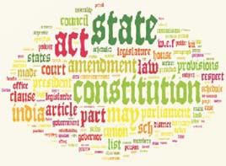

## Definition of the term Constitution

Aristotle (384 - 322 BCE) defined Constitution as ‘the way of life which the state has chosen for itself’.

Understood in its modern context, the Constitution of a State may have the following distinctive features:

* + It is a body of rules
  + It may be in a written or unwritten form
  + It determines the powers and responsibilities of state and organs of government
  + It may be written in a single document or in several documents
  + It determines the rights and duties of the citizens of a State

It is the fundamental law of a State. The features of Constitution may vary from state to state. Government of a state operates in accordance with the principles laid down in its Constitution. It helps to maintain law and order in the country. Georg Jellinek (1851-1911) had even argued that in the absence of Constitution, every individual, every institution and even the government will ignore law and as a result, there will be ‘reign of anarchy’.

The Constitution of India, which came into effect on 26 January 1950, holds the distinction of being one of the lengthiest Constitutions in the world. This lesson gives insights into various aspects of the Constitution of India.

After World War II, which ended in 1945, India’s independence from the British rule was around the corner. During the winter of 1945-46, general elections for India’s provincial legislatures or assemblies were held. These legislatures elected the members of the Constituent Assembly that would draft the Constitution of India. Although, in December 1946, the Constituent Assembly was ready in place in New Delhi, the Muslim League’s demand for a separate Pakistan delayed its work of creating the new Constitution. On August 15, 1947, after the last Viceroy of British India Lord Louis Mountbatten declared India and Pakistan as two independent countries, the Constituent Assembly continued with its mandate to create the new Constitution for India.

UNIT V

UNIT IV

UNIT III

**UNIT II**

UNIT I

#### Constituent Assembly

Dr. B.R. Ambedkar is considered to be the principal architect of the Constitution of India. He is known as modern Manu.

*Picture Above: Dr. Ambedkar, Chairman, Drafting Committee of Constitution of India with other members. (Sitting from left) Shri. N. Madhavrao, Sayyad Sadulla, Dr. Ambedkar (Chairman), Alladi Krishnaswamy Iyer, Sir Benegal, Narsingh Rao. Standing from left - Shri.S.N. Mukharjee, Jugal Kishor Khanna and Kewal Krishnan. (Aug 29, 1947)*

The Constituent Assembly had members mostly from the Congress Party with a few Communists and Independents. In 1885, Allan Octavian Hume, an Englishman had formed the Congress Party to enable Indian participation in the less popular British Government. In 1921, post World War I, Mohandas Karamchand Gandhi (Mahatma Gandhi), assumed the leadership of the Congress party and led the movement for India’s independence. Although the Constituent Assembly was largely a one-party body, the Congress Party had arranged for some persons distinguished in law and public affairs to be elected to the Constituent Assembly to contribute to the making of the Constitution. India’s first law minister, Bhimrao Ramji Ambedkar, was appointed the Chairman of the Constitution Drafting Committee. Therefore, Dr. Ambedkar has been termed as the principal architect of the Constitution of India. The Constituent Assembly had two roles to play- governance and the framing of the Constitution. In the mornings, it dealt with the governance matters and in the afternoons, it drafted the Constitution.

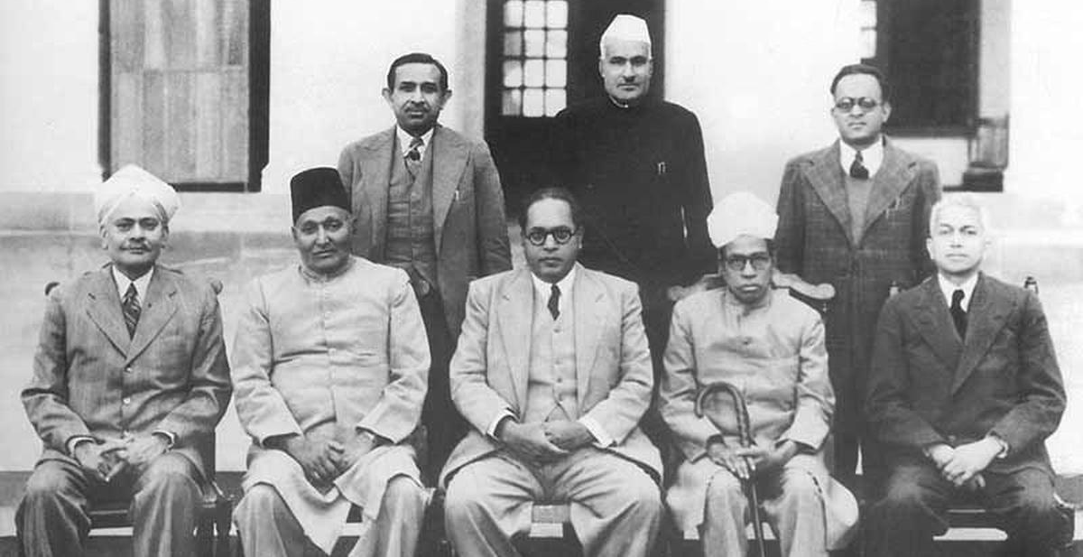

#### Sources of the Constitution of India

The framers of the Constitution of India, i.e. the Constituent Assembly, drew upon three sources to draft the Constitution. The first source was the foundation document or the base text- the Government

of India Act of 1935, which was passed by the Parliament in London. This Act was the basis for the government and was in force in India from 1935 until 1950 when the Constitution of India was adopted.

UNIT V

UNIT IV

UNIT III

**UNIT II**

UNIT I

The salient features of the 1935 Act were:

* + it provided for a parliamentary system (but the ultimate power was kept with the British);
  + it included a wide ranging administrative aspects for the structure of government;
  + it created a centralized federal system; and it provided for elections to provincial legislatures or

assemblies.

The second source was the constitutions of other countries. They were used mostly with respect to the two chapters of the Constitution namely, the Fundamental Rights and the Directive Principles of State Policy. As is described later in this section, fundamental rights largely deal with civil and political rights of citizens (for example: right to life, freedom of speech and expression) and the Directive Principles deal largely with the economic, social and cultural rights of the citizens (for example: right to health, and livelihood).

The third source was the Objectives Resolution adopted in the December 1946 Assembly session. The Constitution derived its spirit from this source. The Objectives Resolution laid down the philosophy and the Constitution expressed it through its many lengthy and detailed provisions. Jawaharlal Nehru, the first Prime Minister of India, had drafted the Objectives Resolution drawing upon the Congress Party documents of the previous two decades. The Objectives Resolution called for the integrity of the Indian Union and that its authority and power were derived from the Indian people. It stated that all the people should be secured with regards to justice- social, economic and political, equality of status, of opportunity, and before the law; freedom of thought, expression, belief, faith, worship, vocation, association and action, subject to law and public morality. Furthermore, the Objectives Resolution provided for adequate safeguards for minorities, depressed and backward classes, and underdeveloped and tribal areas. The Objectives Resolution can be summarized to consist of three interdependent salient features:

* 1. Protecting and enhancing national unity and integrity;
  2. Establishing the institutions and spirit of democracy; and
  3. Promoting a social revolution for the betterment of the citizens.

## Historical Perspective of Constitution of India

Before independence, India was the part of British colonial empire. Sovereignty of British Crown prevailed over India. Parliament of Britain enacted several legislations for the governance of India.

Some of the significant legislations of the British Parliament responsible for the governance of India were:

* Government of India Act, 1858
* Indian Councils Act, 1861
* Indian Councils Act, 1892
* Indian Councils Act, 1909
* Government of India Act, 1919
* Government of India Act 1935

UNIT V

UNIT IV

UNIT III

**UNIT II**

UNIT I

*Picture above: Pt. Jawaharlal Nehru moves the resolution for an independent sovereign republic in the Constituent Assembly in New Delhi.*

In the words of Durga Das Basu as stated in his book ‘Introduction to the Constitution of India’, “Constitution of India draws much of its source from Government of India Act, 1935. The Government of India Act, 1935 has provided the administrative details and language to the provisions of the Constitution”.

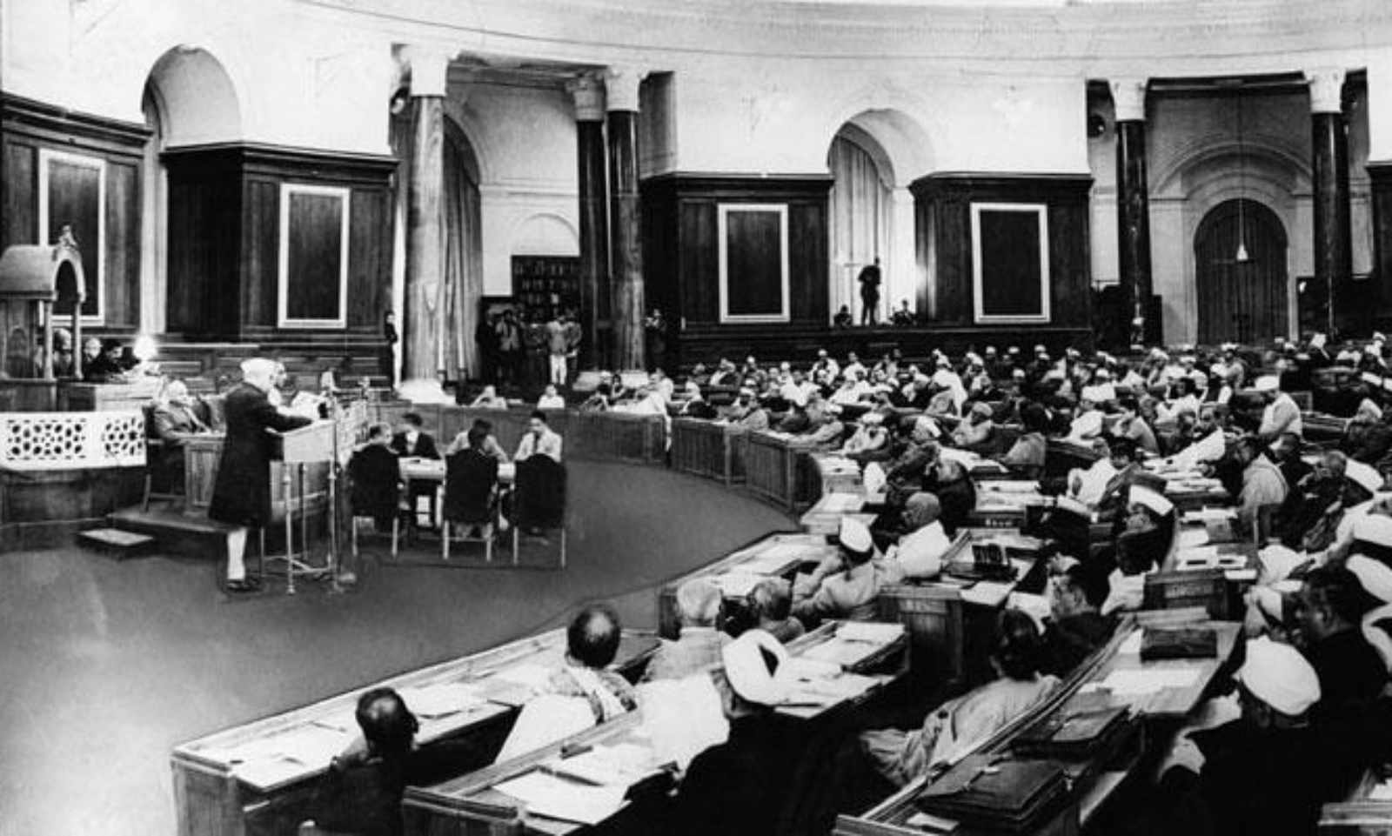

Unlike the other Government of India Acts, the Act of 1935 referred to India as a federation of Provinces and Indian States. Autonomy to provinces was given effect by dividing legislative and executive powers between the Provinces and the Centre. The Provinces were under the executive authority of Governor appointed by the Crown. Provinces were the autonomous units of administration. Governor exercised the powers on the advice of Ministers, who were in turn responsible to Provincial legislature. Governor was given discretion to carry out certain functions, without being bound by Ministerial advice, subject to the control of the Governor General.

At the Central level, Government of India was under the executive authority of Governor-General. Governor-General was to act on the advice of Ministers of Central legislature, who were in turn responsible to the Central Legislature. The Executive Council formed under Government of India Act, 1919 functioned as the Council of Ministers. Governor-General even had discretionary functions to perform, but subject to the control of Secretary of State.

Government of India assumed the role of Federal Government. The Central legislature was bicameral consisting of Federal Assembly and Council of States. Some of the Provincial legislatures had bicameral legislature and other Provinces had unicameral legislature. The legislative powers and matters were divided between Central Legislature and Provincial Legislatures. The powers assigned to the Central legislatures and provincial legislatures were included in the Federal List and Provincial List respectively. The Centre and Provinces could exercise their combined authority on matters included in the Concurrent List.

**Federal List:** It dealt with matters such as Currency, External Affairs, Armed Forces, etc. on which only Central legislature had the authority to legislate.

**Provincial List:** It dealt with matters such as Education, Public Health, and Agriculture, etc. on which only Provincial legislature had the authority to legislate.

**Concurrent List:** It dealt with matters such as marriage and divorce, criminal Law, civil law and procedure, etc. on which both federal and provincial legislatures had authority to legislate.

UNIT V

UNIT IV

UNIT III

**UNIT II**

UNIT I

The exercise of legislative power was subject to various limitations:

* Governor-General’s and Crown’s power to veto a bill passed by the legislature.
* Governor-General’s power to issue ordinance and permanent acts, when the legislative house

was not in session.

* Governor-General’s power to suspend legislature, if the proceedings would affect the discharge

of his special responsibilities.

* No bill to amend or repeal the law of British Parliament as applicable in India, could be introduced in legislature without the previous sanction of Governor-General. Thus, the Central legislature and similarly the Provincial legislatures were to act under the instructions of Governor- General, Secretary of State and ultimately the sovereign powers of the British Crown. Indians were given very limited rights of self-governance. Growing dissatisfaction over limited governing rights granted to Indians under 1935 Act led to widespread protests. Eventually the Colonial government conceded that the Constitution of India would be framed by an elected Constituent Assembly consisting of Indian people. It was also agreed to establish an independent Constituent Assembly free from outside interference to frame the Constitution of India. On December 9, 1946 the Constituent Assembly, a body elected by members of the provincial legislatures and state legislatures, met for the first time and formally commenced the task of ‘Constitution making’.

#### The Indian Independence Act, 1947

The Indian Independence Act, 1947 enacted by the British Parliament got Royal Assent and came into force on July 18, 1947. The Act provided that from 15 August 1947, referred to as ‘appointment date’ under Government of India Act, 1935, two independent Dominions, to be known as India and Pakistan would be established. The Constituent Assembly of each Dominion was to have unlimited power to frame, adopt any Constitution. It had all authority to repeal any Act of British Parliament including Indian Independence Act.

**LET US PONDER**

Various features and parts of the Constitution of India were influenced by the Constitutions of different countries. For instance, separation of powers among the major branches of government was adopted from the Constitution of United States.

Find out the Constitutions from which the following were adopted:

1. The concept of Liberty, Equality and Fraternity
2. The concept of 5 year plans
3. The Directive Principles (socio-economic rights)
4. The concept on which the Supreme Court functions

The Drafting Committee worked under the Chairmanship of Dr. Bhim Rao Ambedkar, the Law Minister from 15 August 1947 to 26 January 1950. After many discussions and deliberations to improve the existing system of administration, geographical compulsions, social and cultural diversities and historical precedents, a proposal on Draft Constitution of India was prepared. The draft received assent from the President of the Assembly, Dr. Rajendra Prasad and was declared passed on 26 November 1949. The Constituent Assembly held 11 sessions and took a period of 2 years, 11 months and 18 days before it signed two copies of the document one in Hindi by the name of ‘Bhartiya

Sanvidhan’ and another in English ‘The Constitution of India’. The original Constitution of India is hand-written with beautiful calligraphy by Prem Behari Narain Raizada. Artists from Shantiniketan including Beohar Rammanohar Sinha and Nandalal Bose adorned each page. The Constitution of India was adopted on 26 November 1949. Some of the provisions were given immediate effect. The bulk of the Constitution only became effective on 26 January 1950. This date is referred to as the date of commencement under Article 394 of the Constitution. Every year 26th January is commemorated as ‘Republic Day’ in India.

UNIT V

UNIT IV

UNIT III

**UNIT II**

UNIT I

Article 394 states that ‘This Article and Articles 5, 6, 7, 8, 9, 60, 324, 366, 367, 379, 380, 388, 391, 392 and 393 shall come into force at once, and the remaining provisions of this Constitution shall come into force on the twenty sixth day of January, 1950, which day is referred to in this Constitution as the commencement of this Constitution’.

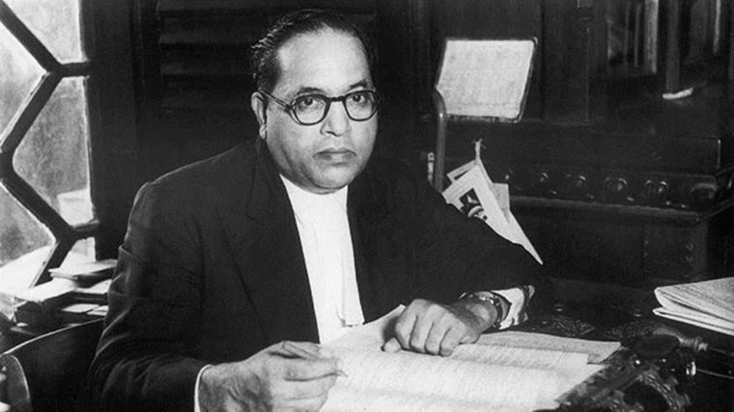

**IV. Salient Features of The Constitution Of India**

*Bhimrao Ramji Ambedkar, popularly known as Babasaheb Ambedkar, was a social reformer and the principal author of the Constitution of India. Born on April 14, 1891, in Mhow town of Madhya Pradesh, he later inspired the Dalit movement and campaigned against social discrimination. He also served as the law minister of India (1947–51)*

#### A Modern Constitution

The Constitution of India drafted in the mid-twentieth century, has assimilated the best features gathered from the existing Constitutions and fashioned to suit the existing conditions and needs of the country.

Article 1(1) declares that India, that is Bharat, shall be a Union of States.

All 552 Indian States within the geographical boundaries of the Dominion of India acceded to the Dominion of India by 15 August, 1947, thus unifying India into a compact State.

Dr. B.R. Ambedkar explained that the use of the word ‘Union’ instead of ‘Federation’ has its significance [In record from the Constituent Assembly Debates (C.A.D)] as summarized below:

* + - Indian Federation is not the result of an agreement between the units. The component units

UNIT V

UNIT IV

UNIT III

**UNIT II**

UNIT I

have no freedom to secede from the Union so created.

* + - The term Union was used ‘as symbolic of the determination of the Assembly to maintain the unity of the country’ as stated by Supreme Court of India in the case of Hinsa Virrodhak Sangh v. M.M.K. Jamat (2008 SCC33).

To promote the unitary basis of Indian Administration, the Constitution makers added detailed provisions on the distribution of powers and functions between the Union and the States in all aspects whether legislative, administrative or financial and also with regard to inter-state relations, co-ordination and adjudication of disputes amongst the states. Although the system of government is federal, the Constitution enables the federation to transform itself into a unitary state by the assumption of powers of the states by the Union in case of emergencies as described under Part XVIII. Such a combination of federal system and unitary system in the same Constitution is unique in itself.

The term Bharat was adopted by the Constituent Assembly because the country was so known in the ancient times. This was the only name that suited the history and the culture of the country.

Part III of the Constitution of India on Fundamental Rights is inspired by the American Bill of Rights. The system of prerogative writs namely the writs of habeas corpus, mandamus, quowarranto, prohibition and certiorari can be issued by Supreme Court and High Courts to protect fundamental rights and to exercise judicial control over administrative action as guaranteed by the Constitution of India. Some of these aspects are influenced by the British Constitutional Law. Part XX on Amendment of the Constitution is the modified version of U.S. Constitution.

As observed by Dr. Basu in his book Introduction to the Constitution of India, the Constitution- makers adopted the Parliamentary system of government for both the Union and States following the British model, for the primary reason that the people had long experience of this system under the Government of India Acts. The makers deliberately rejected the Presidential form of government as followed in the U.S, apprehending conflicts on account of separation of executive from the legislature, which our infant democracy would not have been able to afford. Unlike the British model, India declared itself as a Republic.

Part IV of the Constitution of India on Directive Principles of State Policy is inspired by the Irish Constitution. Special provisions for promoting freedom of trade and commerce in the country as included in Part XIII are influenced by the Australian system. The Constitution of India is unique in its form and contents. By virtue of the 73rd and 74th Constitution Amendment Act, 1993, Part IX and Schedule XI & XII were added to the Constitution. These amendments provide the framework for the establishment and election of Panchayats and Municipalities. Part XIV of the Constitution contains provisions regarding service matters of personnel appointed to public services under the Union and States, and provisions on the establishment and functions of Public Service Commissions.

Part XIV-A contains provisions on the setting-up and functioning of Administrative Tribunals for the adjudication of matters thereunder. Part XV contains provisions on the conduct of elections and concerned authorities thereof.

#### Lengthiest Written Constitution

Durga Das Basu in his book ‘Introduction to the Constitution of India’ has stated that “the Constitution of India has the distinction of being the lengthiest, most detailed, elaborate constitutional document the world has so far produced”. It consists of 395 Articles (many articles were added subsequently and some were repealed by way of amendments). The additions have

been given alpha numeric enumeration alongside the original article. Originally the Constitution consisted of 8 schedules; now it consists of 12 Schedules.

UNIT V

UNIT IV

UNIT III

**UNIT II**

UNIT I

**JUST TO POINT OUT**

It took almost three years (two years, eleven months and seventeen days to be precise) for the Constituent Assembly to complete its task of drafting the Constitution for Independent India. It held eleven sessions covering a total of 165 days. Of these, 114 days were spent on the consideration of the Draft Constitution.

The Constitution of India provides for the organization, structure and functioning of not only Central Government organs, but also of the organs of the State Governments. It contains a detailed framework on fundamental rights, fundamental duties, functions and powers of the Executive, functions and powers of the Parliament, Judiciary and judicial appointments, official language, citizenship, emergency provisions etc. Detailed provisions were incorporated in the Constitution to address issues concerning the Scheduled Castes and Tribes, Backward Classes, Religious and Linguistic Minorities etc.

The Directive Principles of State Policy outlined in Part IV of the Constitution shall not be enforceable in any Court, but nevertheless are fundamental in the governance of the country and it shall be the duty of the state to apply these principles in making laws.

India was established as ‘Union of States’ with a highly centralized federal structure with a strong center in relation with the states. The original preamble provided that India shall be a ‘sovereign democratic republic’. It was later, in 1976, that the words ‘socialist’ and ‘secular’ were added to the Preamble. The Constitution provides for adult suffrage to allow the citizens to vote and elect their representatives and the government. This ensures common participation of all in a democratic fashion. Other features of the Constitution like creation of democratic political institutions and processes of the parliamentary system, creating an independent judiciary, and stipulating for civil and political, and economic and social rights for people – fulfill the democratic essence and social transformation agenda of the Preamble.

#### Preamble to the Constitution

The Constitution begins with an introductory statement called the preamble. Based on the Objectives Resolution, it lays down the guiding principles and the philosophy for the Constitution. It provides for unity and integrity of the country.

The Constitution of India starts with its Preamble. The Supreme Court of India in the Fundamental Rights Case (Keshavananda Bharati v. Union of India, 1973 SC 1461) held that Preamble does form part of the Constitution. The objectives specified in the Preamble contain the ‘ basic structure’ of the Constitution. The Preamble is the guide to interpret the provisions of the Constitution.

UNIT V

UNIT IV

UNIT III

**UNIT II**

UNIT I

**PREMABLE**

WE, THE PEOPLE OF INDIA, having solemnly resolved to constitute India into a SOVEREIGN SOCIALIST SECULAR DEMOCRATIC REPUBLIC and to secure to all its citizens:

JUSTICE, social, economic and political; LIBERTY of thought, expression, belief, faith and worship;

EQUALITY of status and of opportunity; and to promote among them all;

FRATERNITY assuring the dignity of the individual and the unity and integrity of the Nation;

IN OUR CONSTITUENT ASSEMBLY this twenty sixth day of November, 1949, do HEREBY ADOPT,

ENACT AND GIVE TO OURSELVES THIS CONSTITUTION.

The Preamble to the Constitution reaffirms that the people of India have adopted, enacted and given to themselves the Constitution. Supreme Court in Charan Lal Sahu v. Union Of India (AIR 1990 SC 1480) popularly known as Bhopal Gas Leak Tragedy Case held that Sovereign denotes that India is not subject to any external authority and that India as a state has the power to legislate on any subject in conformity with Constitutional limitations.

The Preamble to the Constitution states that India’s governing system is based on Republican and Democratic principles. In S. R. Bommai v. U.O.I. (AIR 1994 SC 1918), the Supreme Court held that the word ‘democratic’ signifies that ‘India has a responsible parliamentary form of Government, which is accountable to the elected legislature’.

‘Republic’ denotes that the head of the state is an elected person and not a hereditary monarch. Any Indian without any discrimination as to the caste, creed, and religion can contest for Presidential elections and can occupy the office, provided he fulfills the eligibility conditions as provided by the Constitution. The Preamble seeks to achieve for all citizens, social, economic and political justice; liberty of thought, expression, belief, faith and worship; equality of status and opportunity; fraternity, unity and integrity of the nation.

The Preamble and the Constitutional provisions aim to secure to its citizens equality of status and opportunity in state affairs such as elections, and in state employment without any special privilege or discrimination based on the ground of religion, race, caste, sex, place of birth. The word ‘Socialist’ was added by the Constitution (forty-second Amendment) Act, 1976. This term is not defined in the Constitution. In general, it means a system under which the means of production and distribution are State owned. The Supreme Court in the case of S.R. Bommai

v. Union of India (AIR 1994 SC 1918) held that the principal aim of socialism is to eliminate inequality of income, status, standards of life and to provide a decent standard of life to working people.

The Preamble establishes India as a Secular State. India is a country of multifarious religions, beliefs and sects. Its people profess and practise different religions. But, India as a Union of states has no official religion. There is no state-recognized place of worship. The state does not identify itself with or favour any particular religion. State laws and policies prohibit any discrimination on the grounds of religion. It treats all religious equally and confers protection to citizens to profess, propagate and practise their religions. The word ‘Secular’ was added by the Constitution (forty-second Amendment) Act, 1976. Even before the Amendment, operation of the concept of secularism was visible in the Fundamental Rights and Directive Principles. This has also been given the status of Basic Structure of the Constitution in Keshavananda Bharati’s case.

UNIT V

UNIT IV

UNIT III

**UNIT II**

UNIT I

**LET US PONDER**

The phrase ‘we the people’ in the preamble of the Constitution of India emphasizes upon the concept of popular sovereignty as laid down by J. J. Rousseau. It signifies that the power emanates from the people and the political system will be accountable and responsible to the people.

Find out the significance and implied meanings of the following terms used in the preamble:

* Sovereign • Socialist
* Secular • Democratic
* Republic

#### Fundamental Rights; Directive Principles of State Policy; Fundamental Duties

###### Fundamental Rights

In the Constitution of India, the human rights provisions are set out in two chapters. Part III of the Constitution provides for Fundamental Rights, largely of political and civil nature, which are enforceable by a court of law. This chapter was revolutionary as it broke the barriers of the Indian traditional and hierarchical society that did not recognize the principles of individual equality.

The Constitution of India guarantees its people certain basic human rights and freedoms known as ‘Fundamental Rights’, which are listed in Part III of the Constitution (Articles 12 to 35). These are broadly rights of equality (equality before laws and prohibition of discrimination on grounds of religion, race, caste, sex or place of birth; equality of opportunity in matters of public employment; abolition of untouchability and titles); right to freedom (rights regarding freedom of speech such as freedom of speech and expression, right to free movement, to form associations, to practice any trade or occupation]; protection in respect to conviction for offences; protection of life and personal liberty; protection against arrest and detention in certain cases); right against exploitation, right to freedom of religion; cultural and education rights and right to constitutional remedies. The right to education was inserted as Article 21A vide the Constitution (eighty-sixth Amendment) Act, 2002. Fundamental Rights stated under Article 14 and 21 are even conferred to non-citizens.

**JUST TO POINT OUT**

Right to property was originally a fundamental right, but after the 44th Amendment Act, 1978, right to property ceased to be a Fundamental right. Instead the right to property is mentioned under 300 A of Constitution of India, stating that no person can be deprived of his property save by law.

The Fundamental Rights guarantee to the people certain basic rights. The legislative and executive actions which infringe upon or violate the Fundamental Rights are declared ultra vires the Constitution. The Supreme Court shall have power to issue directions or orders or writs, including writs in the nature of habeas corpus, mandamus, prohibition, quo warranto and certiorari, whichever may be appropriate, for the enforcement of fundamental rights under Article 32 and the High Courts under Article 226 of the Constitution. The speedy and effective remedy under Article 32 is itself guaranteed as a Fundamental Right. Therefore, these guaranteed rights are termed justiciable rights.

Given below is the meaning and origin of the word/phrases used for different types of writs and the context in which they are used:

UNIT V

UNIT IV

UNIT III

**UNIT II**

UNIT I

|  |  |  |  |
| --- | --- | --- | --- |
| **Type of Writ** | **Origin** | **Literal Meaning** | **Purpose of issue** |
| Habeas Corpus | Latin | You may have the body | To produce a person who has been detained, whether in prison or in private custody, before a court and to release him/ her if such detention is found illegal. |
| Mandamus | Latin | We command | A command issued by the court to any public or quasi-public legal body that has refused to perform its legal duty. It is an order by a superior court commanding a person or a public authority to do or forbear to do something in the nature of public duty. |
| Quowarranto | Latin | By what warrant or authority | It is an order issued by the court to prevent a person from holding office to which he is not entitled and to oust him from that office. |
| Certiorari | Latin | To be more fully informed | It is a writ issued by a superior court to an inferior court or body exercising judicial or quasi-judicial powers to remove a suit and adjudicate upon the validity of the proceedings or body exercising judicial or quasi-judicial functions. |
| Prohibition | English | To forbid or to stop | It is issued by a superior court to an inferior court in order to prevent the inferior court from dealing with a matter over which it has no jurisdiction. The aim of this writ is to keep the inferior courts within the limits of their jurisdiction. |

###### Difference between Writ Jurisdiction of Supreme Court and High Court

|  |  |  |
| --- | --- | --- |
| **Difference** | **Supreme Court** | **High Court** |
| Purpose | To only enforce fundamental rights | To enforce fundamental rights as well as ordinary legal rights |
| Power | Article 32 is a fundamental right- the Supreme Court cannot refuse to exercise its power to issue the writs | It is not a fundamental right. High Court may refuse to exercise its power to issue writs |

1. **Directive Principles**

The Directive Principles of State Policy are included in Part IV of the Constitution. These are the guiding principles governing state policies in the social sector. They are interpreted as economic and social rights and are classically socialist in nature and fulfil the social revolution agenda of the preamble. The provisions are not enforceable by any court of law, but provide guidance in carrying out and drafting laws regarding human and social development.

Article 37 states that these provisions shall not be enforceable by any court, but the principles laid down are nevertheless fundamental in the governance of the country and it shall be the duty of the State to apply these principles in making laws. These directives put an obligation on the State to take positive action in order to promote the welfare of people.

UNIT V

UNIT IV

UNIT III

**UNIT II**

UNIT I

Article 38 (1) states that the State shall strive to promote the welfare of the people by securing and protecting as effectively as it may a social order in which justice, social, economic and political, shall inform all the institutions of national life.

Article 38 (2) states that the State shall, in particular, strive to minimise the inequalities in income, and endeavour to eliminate inequalities in status, facilities and opportunities, not only amongst individuals but also amongst groups of people residing in different areas or engaged in different vocations.

Some of the important Directive Principles include the right to an adequate means of livelihood for citizens, equal pay for equal work for both men and women, living wages for workers, equal justice and free legal aid, organization of village Panchayats, provision of just and humane conditions of work and maternity relief, uniform civil code for citizens, promotion of educational and economic interests of Scheduled Castes, Scheduled Tribes and other weaker sections, duty of the state to raise the level of nutrition and to improve public health, protection and improvement of environment and promotion of international peace and security.

A large number of laws have been enacted and adopted to implement the Directive Principles of State Policy. Examples include the Legal Services Authority Act, 1987, Right to Free and Compulsory Education, 2009, Child Labour Prohibition Act, 1986, Environment Protection Act, 1986, Wild Life Protection Act, 1972, Minimum Wages Act, 1948, Equal Pay for Equal Work Act etc.

The Constitution (seventy-third, seventy-fourth Amendment) Acts, 1992 led to the establishment of Panchayati Raj Institutions and Urban Local Bodies based on democratic principles.

Importantly, the Constitution (86th Amendment) Act, 2002 paved way for introduction of Right to Education for children in the age group of 6 to 14 years as a Fundamental Right.

The Supreme Court of India while interpreting Constitutional provisions elevated some Directive Principles to the status of Fundamental Rights, for instance;

* Right to Equal pay for Equal work in Randhir Singh v. U.O.I. (AIR 1982 SC 879);
* Right to Clean and Healthy Environment in the case of M.C Mehta v. Kamal Nath, (AIR 2000

SC 1997);

* Right to Free Legal Aid in the case of Hussainara Khatoon v. Home secretary (AIR 1979 SC

1369).

On the question of inter-relationship between Fundamental Rights and Directive Principles, the Supreme Court in Kesavananda Bharti case held that ‘Fundamental Rights and Directive Principles constitute the conscience of the Constitution…There is no antithesis between the Fundamental Rights and Directive Principles… and one supplements the other’.

In Ashok Kumar Thakur v. Union of India (2008 (6) SCC 1) Supreme Court held that no distinction can be made between the two sets of rights. The Fundamental Rights represents the Political and Civil Rights and the Directive Principles embody Social and Economic Rights. Merely because the directive principles are non-justiciable by the judicial process, it does not mean that they are of subordinate importance.

UNIT V

UNIT IV

UNIT III

**UNIT II**

UNIT I

**Enforcement of the Directive Principle of State Policy under the Constitution of India:** In the case of Randhir Singh v. Union of India & others, the Hon’ble Supreme Court in its judgment enforced one of the directive principles of state policy. The relevant part of the Supreme Court judgment reads as follows :

“8. Article 39(d) of the Constitution proclaims ‘equal pay for equal work for both men

and women’ as a directive principle of State Policy. ‘Equal pay for equal work for both men and women’ means equal pay for equal work for everyone and as between the sexes. Directive principles, as has been pointed out in some of the judgments of this Court, have to be read into the fundamental rights as a matter of interpretation.

Article 14 of the Constitution enjoins the State not to deny any person equality before the law or the equal protection of the laws and Article 16 declares that there shall be equality of opportunity for all citizens in matters relating to employment or appointment to any office under the State………

Construing Articles 14 and 16 in the light of the Preamble and Article 39(d) we are of the view that the principle ‘Equal pay for Equal work’ is ‘deducible from those Article and may be properly applied to cases of unequal scales of pay based on no classification or irrational classification, though these drawing the different scales of pay do identical work under the same employer.”

###### Difference between Fundamental Rights and Directive Principles of State Policy

|  |  |
| --- | --- |
| **Fundamental Rights** | **Directive Principles of State Policy** |
| Part III of the Constitution of India contains the Fundamental Rights. They are given in Articles 12-35 of the Constitution of India. | Part IV of the Constitution of India contains Directive Principles of State Policy. They are given in Articles 36-51 of the Constitution of India. |
| These are basic, inalienable rights that are guaranteed to Indian citizens by the Constitution of India. | Directive Principles of the Constitution of India are the guidelines to be followed by the Government while framing policies. |
| They are civil and political in nature, *i.e*. they help the citizens in enjoying their life under a government. | They are social and economic in nature. |
| Fundamental Rights are justiciable as they can be enforced legally by the courts by way of writs. | Directive Principles are not justiciable as they cannot be enforced by the courts if there is a violation.  They can be enforced either by passing a legislation or by judicial process where they are linked to a fundamental right and hence its status is elevated. |
| The concept of Fundamental Rights was borrowed from the Constitution of the United States of America. | The concept of Directive Principles of State Policy was borrowed from the Constitution of Ireland which was in turn copied from the Constitution of Spain. |

1. **Fundamental Duties – Article 51A**

UNIT V

UNIT IV

UNIT III

**UNIT II**

UNIT I

It shall be the duty of every citizen of India:



* 1. to abide by the Constitution and respect its ideals and institutions, the National Flag and the National Anthem;
  2. to cherish and follow the noble ideals which inspired our national struggle for freedom;
  3. to uphold and protect the sovereignty, unity and integrity of India;
  4. to defend the country and render national service when called upon to do so;
  5. to promote harmony and the spirit of common brotherhood amongst all the people of India transcending religious, linguistic and regional or sectional diversities to renounce practice derogatory to the dignity of women;
  6. to value and preserve the rich heritage of our composite culture;
  7. to protect and improve the natural environment including forests, lakes, rivers and wild life and to have compassion for living creatures;
  8. to develop the scientific temper, humanism and the spirit of inquiry and reform;
  9. to safeguard public property and to abjure violence;
  10. to strive towards excellence in all spheres of individual and collective activity, so that the nation constantly rises to higher levels of endeavour and achievement;
  11. to provide opportunities for education to his/her child or, as the case may be, ward between age of 6 and 14 years;
  12. who is a parent or guardian to provide opportunity for education to his child or as the case may be, and between the age of six and fourteen years. (inserted by 86th constitution amendment act 2002).

The Constitution (forty-second Amendment) Act, 1976 added Part IV-A, Article 51-A on Fundamental Duties of citizens, to the Constitution. These are eleven in number.

There is no provision in the Constitution to enforce Fundamental Duties. Supreme Court in Bijoe Emmanuel v. State of Kerala (AIR 1987 SC 478) held that duties imposed on the citizens may be enforced through the enactment of legislations. For example ‘The Prevention of Insult to National Honours Act, 1971’punishes a person who insults the national honours. These duties are read along with Fundamental Rights. As stated by the Supreme Court in Mohan Kumar v. Union of India (AIR 1992 SC 1), the courts may also enforce the duties while balancing and harmonizing them with the Fundamental Rights.

**LET US PONDER**

* Till date there have been quite a few significant amendments in the constitution. Find out

about 10 amendments, in groups.

* Compare and discuss each individual amendment and how it relates to the people of

India.

#### Constitutional Provision for Amendment of the Constitution of India

UNIT V

UNIT IV

UNIT III

**UNIT II**

UNIT I

* + - Part XX of the Constitution of India provides in detail the procedure for amendment of the Constitution. Article 368 specifies the powers of the Parliament to amend the Constitution and lays down the procedure. There is no limitation on the constituent power of the Parliament for amending by adding, removing or improving the provisions in the Constitution.
    - The initial step of an Amendment is the introduction of a Bill for the purpose in either House of Parliament. The bill has to be passed in each House by a majority of the total membership of that House and by a majority of not less than two-thirds of that House present and voting. The Bill is then sent for President’s assent.
    - Some amendments also require to be ratified by the Legislature of not less than one-half of the States by resolutions to that effect passed by those Legislatures before the Bill making provision for such amendment is presented to the President for assent.
    - The Supreme Court in the case of Kesavananda Bharti v. State of Kerala (AIR 1973 SC 1461) case has restrained the powers of Parliament to amend the Constitution of India in respect of its Basic Structure.

#### Adult Suffrage

Article 326 confers on the citizens of India the right to vote in the general elections to the House of People and to the Legislative Assemblies of States. Every citizen who is not less than 18 years of age (reduced from 21 years by the Constitution (Sixty-first Amendment Act, 1988) and otherwise not disqualified under the Constitution or any other law on the grounds of unsoundness of mind, non- residence, crime or corrupt or illegal practice shall be entitled to be registered as a voter at any such election. There is one general electoral roll for every territorial constituency, as stated in Article 325 of the Constitution, for election to either House of Parliament or to the House or Houses of State Legislature. This Article further specifies that no person shall be ineligible for inclusion to the electoral roll on the grounds only of religion, race caste sex or any of them.

* + - Articles 330 and 332 provide for reservation of seats for the Scheduled Castes and Scheduled

Tribes, in the House of People and Legislative Assemblies respectively; and

* + - Article 331 provides for representation for members of the Anglo-Indian community in the

House of People.

* + - In the case of Indira Nehru Gandhi v. Raj Narain (AIR 1975 SC 2299), popularly known as Election case, right to free and fair elections has been declared to constitute the Basic Structure of the Constitution.

#### Single Citizenship

The Constitution of India provides single citizenship to its citizens. Part II of the Constitution of India contains provisions regarding citizenship at the commencement of the Constitution and other matters. The Citizenship Act 1955 provides that citizenship can be acquired by way of birth, descent or registration. (The Act also provides for citizenship by naturalization and by incorporation of territory.) The citizens of India enjoy political and civil rights enshrined under the Constitution such as the right to vote, right to contest elections, right to hold high offices such as that of the President, Vice President, Governor, Judges, subject to satisfaction of other criteria prescribed for the purpose. No citizen can be denied employment in any State on the grounds of being non- resident of that State.

There are **four ways** in which Indian citizenship can be acquired: **birth, descent, registration and naturalisation**. The provisions are listed under the **Citizenship Act, 1955**.

* **By Birth:** Every person who takes birth in India and whose parents are not illegal migrants are entitled to Citizenship by birth.

UNIT V

UNIT IV

UNIT III

**UNIT II**

UNIT I

* **By Registration:** Citizenship can also be acquired by registration. It usually requires residence of atleast 7 years.
* **By Descent:** If either of the parents is a citizen of India.
* **By Naturalisation:** A person can acquire citizenship by naturalisation if he/she is ordinarily resident of India for 12 years.

#### Independent Judiciary

Another notable feature of the Constitution of India is its provisions which uphold the independence of the judiciary from the influence of other organs of the Government. The Judiciary functions in accordance with the set principles of the Constitution. This topic has been dealt with in the preceding chapters.

#### Emergency Provisions

* + - The Constitution makers also foresaw that there could be situations when the government could not be run as in ordinary times. To cope with such situations, Part XVIII of the Constitution elaborates on emergency provisions.
    - The President, who is advised by the Cabinet of ministers at the center, proclaims the state of

emergency. Accordingly, the President is concerned to declare three types of emergencies:-

* + - * Emergency caused by war, external aggression or armed rebellion [Aricle 352]
      * Emergency arising out of the failure of constitutional machinery in states [Article 356 &

365]

* + - * Financial emergency [Article 360].
    - The rationality behind the incorporation of these provisions is to safeguard the sovereignty, unity, integrity and security of the country, the democratic political system and the Constitution.
    - During an emergency, the central government becomes all-powerful and the states go under

total control of the centre.

* + - This kind of transformation of the political system from federal (during normal times) to

unitary (during emergency) is a unique feature of the Indian Constitution.

#### Federal in form Unitary in character

* + - The Constitution of India establishes a federal system of government.
    - It contains all the usual features of a federation, such as two governments, division of powers, written constitution, the supremacy of the constitution, the rigidity of the Constitution, independent judiciary and bicameralism.
    - However, the Indian Constitution also contains a large number of unitary or non-federal features, such as a strong Centre, single Constitution, appointment of state governor by the Centre, all-India services, integrated judiciary, and so on.
    - Moreover, the term ‘Federation’ has nowhere been used in the Constitution.
    - Article 1, describes India as a ‘Union of States’ which implies two things:
* Indian Federation is not the result of an agreement by the states.

UNIT V

UNIT IV

UNIT III

**UNIT II**

UNIT I

* No state has the right to secede from the federation.

#### Division of Power- Centre- State Relations

Various articles and schedules of the Constitution lay down rules about the powers of the central and the state governments as well as the relations between them.

The Seventh Schedule contains three legislative lists: Union list, State list, and the Concurrent list. These three lists define the legislative jurisdictions.

The central government has the exclusive legislative authority to frame laws over matters listed in the Union list. There are 99 items in the Union list that include foreign affairs, defense, armed forces, communications, posts and telegraph, foreign trade etc.

The state governments ordinarily have the authority on matters stated in the State list. There are exceptional situations however, such as emergency, national interest, and international trade when the Centre can legislate on matters of the State list. There are 61 subjects in the State list that include public order, police, administration of justice, prison, local governments, agriculture and so on.

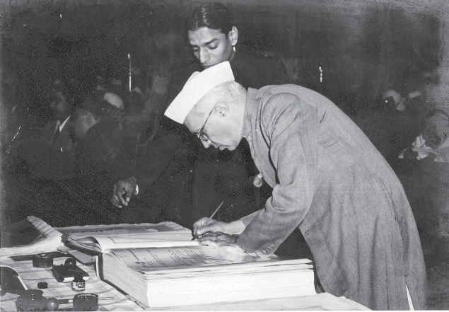

Both Parliament and State legislatures have powers over matters enumerated in the Concurrent list. However, the Parliament has supremacy in this list. It comprises of 52 items and includes criminal and civil procedure, marriage and divorce, economic and special planning, trade unions, electricity, newspapers, books, education, population control and family planning and so on.

Residuary items rest with the center.

#### Schedules to the Constitution

Originally there were eight schedules but now there are 12 Schedules attached to the Constitution of India. They provide necessary administrative details to the functioning of the organs of Government. These Schedules are amendable by Parliament.

*Picture Above: Pt. Jawaharlal Nehru was the first one to sign on the Constitution of India.*

**LET US PONDER**

Did you ever get an opportunity to read the Constitution of India? If not, have you heard of some of the above parts in it? Being a citizen of India, don’t you think it is not late for you to know at least some details, if not all about it? Don’t you think that you should have a copy of the Constitution of India in your home for your reading and reference as well as for your family members?

## Exercises

UNIT V

UNIT IV

UNIT III

**UNIT II**

UNIT I

Based on your understanding, answer the following questions:

* 1. Briefly write the facts/ observation of the court with regards to the following cases-
     1. Charan Lal Sahu v. Union of India
     2. S.R. Bommai v. Union of India
     3. Randhir Singh v. U.O.I
     4. M.C Mehta v. Kamal Nath
     5. Ashok Kumar Thakur v. Union of India Q-2 Write brief notes on-

1. Fundamental Rights
2. Fundamental Duties
3. Preamble
4. Directive Principles of State Policy
   1. Give one point of difference between the following –
      1. Unicameral and Bicameral legislature
      2. Fundamental rights and Fundamental duties
      3. Sovereign and Secular
      4. Article 32 and Article 226
      5. Original and Advisory jurisdiction of the Supreme Court Q-4 Answer the following questions briefly-
5. Why would one term the Constitution of India as a ‘living document’?
6. Briefly describe the three sources of the Constitution of India.
7. How was the Constituent Assembly formed? What was its purpose?
8. When can the President of India proclaim a state of emergency? What happens during such a situation?
9. Can the Basic structure of the Constitution be amended? Why/ why not? Q-5 Answer the following questions in about 200 words
10. Describe any six features of the Constitution of India.
11. What is the importance of Fundamental Rights in a democratic country like India?
    1. When can the President run the country in a unitary fashion? What are the three conditions under which it can happen? Explain.
    2. Ajit was arrested by the police without giving any ground nor was he granted other basic rights behind the bars. Identify and explain the remedy available to him.
    3. On the question of interrelationship between Fundamental rights and Directive Principles, the Supreme court in a landmark judgement held that ‘Fundamental rights and Directive Principles constitute the conscience of the Constitution’.

In light of the above passage, answer the following questions:

* + 1. What are Fundamental rights and Directive Principles?
    2. Which is the landmark judgment mentioned by the Supreme Court?
    3. Evaluate the inter-relationship between Fundamental rights and Directive Principles.
  1. You may identify the invocation of particular writ remedy from the judgments of the Supreme Court of India or any High Court.

## Activity

UNIT V

UNIT IV

UNIT III

**UNIT II**

UNIT I

Divide the class into 4 groups and assign following tasks to each group:

Group 1: Try and find out at least 5 more people associated with the making of the Constitution and prepare a presentation on their contribution.

Group 2: Write a brief biography of any two out of the ten contributors mentioned above.

Group 3: Enact a dialogue between the members of the Constitution drafting committee after they have finished the task. (Focus on their excitement, apprehensions and other such feelings).

Group 4: A panel discussion on the importance and significance of a written and living constitution. (A living Constitution is the one that can be amended).



UNIT V

UNIT IV

UNIT III

**UNIT II**

UNIT I



CHAPTER

2

**Administrative Law**

## Contents

1. Background
2. Administrative Law and Constitutional Law: Key Differences
3. Reasons for Growth, Development and Study of Administrative Law
4. Types of Administrative Actions
5. Fundamental Principle of Administrative Law: Rule of Law
6. Droit System

## Learning Outcomes

After the completion of this chapter, the students will be able to:

* + Interpret the meaning of administrative law
  + Differentiate between Administrative law and Constitutional law
  + State reasons for growth of administrative law as a separate discipline
  + Explain and identify the types of administrative actions
  + Critically evaluate the concept of rule of law
  + Explain the Droit system

## Background

History tells us that societies and civilizations can survive without science and technology but not without administration. Administrative Law aims to ensure that the policies, rules, regulations and legislations formulated for public good are not misused.

## Administrative Law and Constitutional Law: Key Differences

Before the 21st century, Administrative Law was considered a part of Constitutional Law. However, there has been a clear distinction in the subject matter of their respective studies in recent times. Administrative law aims to keep a check on the actions of the Government when dealing with the procedures affecting the rights of citizens. On the other hand, Constitutional law clarifies the scope of rights and duties of citizens and the Government. For example, how elections are held, Parliament is formed, the powers of the Parliament and of the different branches of the State. These are essentially the key questions in the scheme of any democratic constitution. Whereas, when a Minister is finally appointed and his actions affect the general public good, then we can categorize the study of these actions as a core constituent of Administrative Law.

## Reasons for Growth, Development and Study of Administrative Law

UNIT V

UNIT IV

UNIT III

**UNIT II**

UNIT I

In the 21st century, developing countries like India expect a very proactive State for their own welfare. The welfare quotient in the administration cannot solely be vested in the legislature. This is impossible in practical terms as Governance as a whole will cease to function, if for all kinds of administrative actions, the sanction of the legislature is compulsorily required.

This need for delegation is often pointed out as the single most important factor which has led to the growth of Administrative Law. Moreover, if we were to examine the scheme of our Constitution, while defining ‘State’, Article 12 of the Constitution of India mentions ‘any other authority’. Hence, ‘any other authorities’ includes authorities created by law, authorities which are agencies and instrumentalities of the State or authorities which are essentially discharging public functions which have an impact on the common people, are all part of the State.

For example, an NGO being funded by the Government- whose control vests with the Government- its functions are akin to the Government’s functions; in this case such an NGO would be considered as ‘State’ for the purpose of Article 12 of the Constitution.

## Types of Administrative Action

Administrative action can be of four types:

#### Administrative Legislative Action

Wherein the administration puts on the hat of the legislature simply because it is not practically possible for any legislature in the world to legislate so perfectly that their laws are able to cover the possibility of all kinds of conflicts which can arise out of a decision even if the Members of Parliament sit for all days in a year. Administrative legislative action includes rule-making action as well as delegated legislation.

#### Quasi-judicial action or administrative adjudicatory action

In these cases, the administration performs functions which can be put under the judicial domain as

there is some adjudication on legal rights of the individuals involved in the matter. Eg-Tribunals

#### Simply Administrative Action

Of all the actions undertaken by administrative authorities, other than the two types of actions mentioned above, the rest are called ‘Administrative Actions’ which essentially deal with execution of crucial administrative decisions. In administrative action, there is discretion to the administrative authority (that is,the authority has the right to exercise his/her own understanding and discretion in dealing with the matter).

#### Ministerial Action/Purely Administrative action

Actions which are copybook action and actions in which no discretion is vested with the authority (that is there is only one way of performing that action), such action will be called purely administrative action or ministerial action. For example, the statute which created a University mandates that the University open a bank account with a given Bank Y. This is a purely administrative action or a ministerial action as there is no scope of any discretion in its performance.

Hence, as is clear from the aforesaid classification, it would be wrong to say that Administrative Law deals only with the execution of policies or that it is only procedural in nature. In contemporary times, it can be called a full-fledged discipline which is very substantive in nature.

## Fundamental Principle of Administrative Law: Rule of Law

UNIT V

UNIT IV

UNIT III

**UNIT II**

UNIT I

It essentially deals with the doctrine of constitutional morality which states that even in doing something legal, an administrative action must always be fair and reasonable. For example, University guidelines read that you can appoint any person as the Professor of Law. No other qualification as such is laid down. University appoints a person who has no qualification of Law and has no teaching experience. Hence in this case, it is the principle of administrative morality which operates and vitiates the said appointment.

Rule of law is an essential tool to protect the freedom and dignity of individuals against organized powers. In the landmark ruling by the Supreme Court of India in Keshavananda Bharti v. State of Kerala, ‘rule of law’ was categorized as a ‘basic structure’ of the Constitution. Basic structure means those basic characters/attributes which are enshrined in the heart of the Constitution and which cannot be repealed/ replaced by any Parliament. Hence, it is a bundle of characteristics of the Constitution of India which can never lose their relevance and can never be derogated.

There was opposition to the doctrine in the days of monarchy as it limits the powers of the monarch or king to change laws and rules according to his own fancy. Hence, rule of law as a principle is essentially based only in democratic societies and is not a known feature of monarchies.

In a democratic society, fundamental principles of Administrative Law are: transparency or openness, the principle of participation, of impartiality and objectivity, reasoned decisions, legality, effective review of administrative rules and administrative decisions, accountability and non-arbitrariness. All these principles are broadly encompassed under the

* 1. Rule of law
  2. Doctrine of separation of powers
  3. Principles of natural justice.

Since we have dealt with Doctrine of separation of powers and principles of natural justice, here we will focus on Rule of Law. For recapitulation let’s recall the two concepts;

#### Separation of power

‘Separation of powers’ was meant to create divisions within the Government setup to create better administration within the State.

Separation of powers refers to the division of a state’s government into branches, each with separate, independent powers and responsibilities, so that the powers of one branch are not in conflict with those of the other branches. The typical division is into three branches: a legislature, an executive, and a judiciary, which is the triaspolitica model. It can be contrasted with the fusion of powers in parliamentary and semi-presidential systems, where the executive and legislative branches overlap.

The intention behind a system of separated powers is to prevent the concentration of power by providing for checks and balances. The separation of powers model is often imprecisely and metonymically used interchangeably with the triaspolitica principle. While the triaspolitica model is a common type of separation, there are governments that have more or fewer than three branches.

#### Principles of Natural Justice

Natural justice is an expression of English common law, and involves a procedural requirement of fairness. The principles of natural justice have great significance in the study of Administrative law. It is also known as substantial justice or fundamental justice or Universal justice or fair play in action. The principles of natural justice are not embodied rules and are not codified. They are judge made rules and are regarded as counterpart of the American procedural due process.

Mr. Justice Bhagwati called principles of natural justice as fair play in action. Article 14 and 21 of the Indian Constitution has strengthened the concept of natural justice.

UNIT V

UNIT IV

UNIT III

**UNIT II**

UNIT I

Basis of the application of the principle of natural justice:

The principles of natural justice, originated from common law in England are based on two Latin maxims, (which were drawn from jus natural).

In simple words, English law recognizes two principles of natural justice as stated below-

1. NemoJudex in causasua or Nemodebetessejudex in propriacausa or Rule against bias (No man

shall be a judge in his own cause).

1. Audi Alterampartem or the rule of fair hearing (hear the other side).

Rule against bias or bias of interest- the term bias means anything which tends to or may be regarded as tending to cause such a person to decide a case otherwise than on evidence must be held to be biased. In simple words, bias means deciding a case otherwise than on the principles of evidence.

This principle is based on the following rules

1. No one should be a judge in his own cause.
2. Justice should not only be done, but manifestly and undoubtedly be seen to be done.

The above rules make it clear that judiciary must be free from bias and should deliver pure and impartial justice. Judges must act judicially and decide the case without considering anything other than the principles of evidence.

**Kinds of Bias:** The rule against bias may be classified under the following three heads:

1. Pecuniary bias
2. Personal bias
3. Bias as to subject matter.

###### Pecuniary Bias

Pecuniary bias arises, when the adjudicator/ judge has monetary/ economic interest in the subject matter of the dispute/ case. The judge, while deciding a case should not have any pecuniary or economic interest. In other words, pecuniary interest in the subject matter of litigation disqualifies a person from acting as a judge.

###### Personal Bias

Personal bias arises from near and dear i.e. from friendship, relationship, business or professional association. Such relationship disqualifies a person from acting as a judge.

###### Bias as to subject matter (official bias)

Any interest or prejudice will disqualify a judge from hearing the case. When the adjudicator or the judge has general interest in the subject matter in dispute on account of his association with the administration or private body, he will be disqualified on the ground of bias if he has intimately identified himself with the issues in dispute. To disqualify on the ground there must be intimate and direct connection between the adjudicator and the issues in dispute.

2. Audi alterampartem or the rule of fair hearing (hear the other side)

The second fundamental principle of natural justice is audialterampartem or the rule of fair

hearing. It means no one shall be condemned unheard i.e. there must be fairness on the part of the deciding authority.

UNIT V

UNIT IV

UNIT III

**UNIT II**

UNIT I

According to this principle, reasonable opportunity must be given to a person before taking any action against him. This rule insists that the affected person must be given an opportunity to produce evidence in support of his case. He should disclose the evidence to be utilized against him and should be given an opportunity to rebut the evidence produced by the other party.

###### Essentials of fair hearing

To constitute fair hearing, the following ingredients are to be satisfied-

1. Notice
2. Hearing
3. **Notice:** There is a duty on the part of the deciding authority to give notice to a person before taking any action against him. The notice must be reasonable and must contain the time, place, nature of hearing and other particulars.
4. **Hearing:** Fair hearing in its full sense means that a person against whom an order to his prejudice is passed should be informed of the charges against him, be given an opportunity to submit his explanation thereto, have a right to know the evidence both oral and documentary, by which the matter is proposed to be decided and to have the witnesses examined in his presence and have the right to cross examine them and to lead his own evidence both oral and documentary in his defence. It is a code of procedure, which has no definite content, but varies with the facts and circumstances of the case.

Ingredients of fair hearing: a hearing will be treated as fair hearing if the following conditions are satisfied:

1. Adjudicating authority receives all the relevant material produced by the individual
2. The adjudicating authority discloses to the individual concerned evidence or material which it wishes to use against him
3. The adjudicating authority provides the person concerned an opportunity to rebut the evidence or material which they said authority wants to use against him

###### Maneka Gandhi Vs Union of India-

In Maneka Gandhi’s case, the petitioner’s passport was confiscated by the Union Government under Section 10(3)(c) of the Passport Act, 1967. The provision under which impoundment took place authorizes the central government to carry out the same if it was necessary for the interest of the general public at large. But the government did not provide any reasons for carrying out the same.

The petitioner filed a writ petition under Article 32 of the Constitution which mentioned the following things:

1. Section 10(3)(c) of the Passport Act, 1967 was in violation with Article 14 of the Constitution for

it vested excessive discretionary powers in the hand of the passport authority.

1. Section 10(3)(c) did not align with the principles of natural justice because it did not provide any space for allowing the passport holder to be heard.
2. There was a lack of reasonable procedure by Section 10(3)(c) which also led to the same contravening with Article 21 of the Constitution.
3. Section 10(3)(c) was also in violation with Article 19(1)(a) and(g).

UNIT V

UNIT IV

UNIT III

**UNIT II**

UNIT I

The Supreme Court highlighted that the subject-matter of Article 21 of the Constitution does not promote unfair procedures to carry out the execution of the same and the principle of reasonability which is an essential requirement of equality as provided in Article 14 which is supposed to be adopted in context with Article 21 was violated. Therefore, along with the breach of the provided statutory provisions, there was also a contravention of the principles of natural justice as infused in the doctrine of Audi AlteramPartem commonly means that both sides should be heard. The court laid down certain aspects that need to be fulfilled before a person is said to be deprived of personal liberty guaranteed in Article 21 of the Constitution. They are:

1. Presence of a valid law.
2. The law must also consist of a procedure to carry it out.
3. The procedure must be fair, just and reasonable by nature.
4. The element of reasonability can be said to be satisfied if the requirements of Article 14 and Article 19 of the Constitution are aligned with.

The court did not generally quash the contravening grounds for then the administrative efficacy would have been hampered along with the necessity of the Passport Act. The court was with the observance that fair procedure cannot be ignored to maintain administrative efficiency rather it should strike a balance in order to provide equal importance to both. This led to the development of the concept of post-decisional hearing. Although in this case passport was returned to the petitioner on socio-economic grounds, in further cases that followed the Maneka Gandhi case, the concept of post decisional hearing was given preference. Article 14 and Article 21 of the Constitution are the two provisions that keep the principles of natural justice intact in the Indian Constitution. They also establish Dicey’s concept of the rule of law.

###### Post decisional hearing

Post decisional hearing can be identified as a harmonizing tool to balance between administrative efficacy and fair procedures governing an individual. Post decisional hearing was not brought about to overpower pre-decisional hearing but to supplement the latter whenever the case demands. The usage of post-decisional hearing is restricted to exceptional usage only. Such exceptional grounds are likely to include deprivation of property, liberty, livelihood or any other public interest that any individual can demand and is relevant by nature.

The Maneka Gandhi case gave rise to the principle as the case was in conflict with statute and the principle of natural justice and it became relevant for the court to decide as to whom to prefer more. Although a prior hearing is always better than subsequent hearing, the latter is preferred over no hearing at all. The fact that supports post decisional hearing is the speedy disposal of cases and remedying of injustice. Post decisional hearing is, therefore, a demand when immediate decisions are to be taken in light of the public interest. In the case of post decisional hearing, an individual is provided with an opportunity to be heard after a decision has been adopted by the concerned authorities within a specific time frame.

The important feature that is required to be highlighted by this kind of hearing is that the decision taken by the concerned authorities are not permanent and final by nature rather, a tentative one for without the parties being heard, the final decision cannot be taken as it goes against the Principles of Natural Justice. As the conflict between pre-decisional hearing and that of post decisional hearing rises, the courts developed a test, which is divided into three parts to determine which is mandated when. They are:

1. The public interests that are involved need to be considered.
2. Association of the risks that are involved in allowing the adoption of pre-decisional hearing needs

UNIT V

UNIT IV

UNIT III

**UNIT II**

UNIT I

to be taken care of along with taking care of the values of the Constitution that are involved.

1. Government’s administrative and economic implications.

###### References:

1. Dr. Kailash Rai, Administrative Law (Allahabad Law Agency, Law Publisher, Faridabad

(Haryana)-121002, 7th edn.,2011)

1. Dr. I. P. Massey, Administrative law (Eastern Book Company, Lucknow, 8th edn., 2012)
2. https://blog.ipleaders.in/post-decisional-hearing-development-maneka-gandhis-case

**Did you know?**

India’s Vedas, Smritis and Upanishads are all texts which perpetuate the ideals of fair administration

(dharma) and hence, rule of law.

## Droit System

#### Droit Administrative Law

Under the French system of administration of justice a landmark event occurred when Napoleon took over the power of administration and became the Consul General in the late eighteenth century. To exercise the judicial powers, there existed the King’s court called Conseil Du Roi. This Court only played an advisory role to the King. Ordinary Courts on the other hand were much neglected and their salary was dependent on the fee collected.

As a competitor to the King’s court, Ordinary Courts started developing an attitude of putting breaks on schemes and programmes of the Government. Hence, the reforms brought about by Napoleon had two objectives, namely to usher in as quickly as possible, socio-economic movements in the country and in this process, if there is any dispute between an individual and the Government departments, it should be decided as quickly as possible. Hence, the Court was disallowed from putting a spanner in the wheels of administration.

Likewise, the King’s powers were also curtailed and the King’s court was abolished. The new system evolved a paradigm shift from conventional judicial decision making. Special Courts had been established to expeditiously dispose the matter pending by this system. France had evolved a dual system of justice operating on the same land, governing the same set of people in the same constituency. While an all private parties’ dispute found its way in the civil court, a dispute between a private individual and Government departments nearly always went to the administrative courts.

The highest administrative court was Counseil de’ Etat. Initially, when this system was established, direct filing of cases was not allowed. The court could only entertain the petition when the Minister had forwarded the same to the court and the decision of the court could have only been of advisory value for the minister.

Although there have been theoretical objections to the Droit system, it is often considered far more efficient than its contemporary common law system.

UNIT V

UNIT IV

UNIT III

**UNIT II**

UNIT I

|  |  |
| --- | --- |
| **Napoléon Bonaparte,** (born August 15, 1769 —died May 5, 1821) was the French general, first consul, and emperor of the French and one of the most celebrated personages in the history of the West. He revolutionized military organization and training; sponsored the Napoleonic Code, the prototype of later civil-law codes; reorganized education; and established the long-lived Concordat with the papacy. Napoleon’s many reforms left a lasting mark on the institutions of France and of much of western Europe. But his driving passion was the military expansion of French dominion, and he was almost unanimously revered during his lifetime and until the end of the Second Empire under his nephew Napoleon III as one of history’s great heroes. |  |





Unit 3

# Jurisprudence, Nature and Sources of Law

UNIT V

UNIT IV

**UNIT III**

UNIT II

UNIT I



UNIT V

UNIT IV

**UNIT III**

UNIT II

UNIT I



CHAPTER

1

**Jurisprudence, Nature**

**and Meaning of Law**

## Contents

1. Introduction
2. Historical Perspective
3. Schools of Law

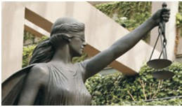

1. Function and Purpose of Law
2. Exercises

## Learning Outcomes

After the completion of this chapter, the students will be able to:

* Describe the meaning, nature, essentials and objectives of law along with its multi-faced role
* Define Law and explain the meaning of jurisprudence
* State two rules that shows natural justice is firmly grounded in Articles 14 and 21 of the Constitution
* Write down two points each in favour of and against conviction in Speluncean Explorers Case
* Compare the five schools of law-Natural, Analytical, Historical, Sociological and Realist Schools of Law
* List the distinguishing features and sources of law for each school
* Discuss the need for law in society by assessing the function and purpose of law

## I. Introduction

Justitia, a Roman goddess of justice, wore a blindfold and has been depicted with sword and scales. Representations of the Lady of Justice in the Western tradition occur in many places and at many times. Like Justitia, she too usually carries a sword and scales. Almost always draped in flowing robes and mature but not old, she symbolizes the fair and equal administration of law without corruption,avarice, prejudice, or favor.

*Source* [*www.commonlaw.com/Justice.html*](http://www.commonlaw.com/Justice.html)

The law and the legal system are very important in any civilization. In modern times, no one can imagine a society without law and a legal system. Law is not only important for an orderly social life but also essential for the very existence of mankind. Therefore, it is important for everyone to understand the meaning of law.

*In layman’s language, law can be described as ‘a system of rules and regulations which a country or society recognizes as binding on its citizens, which the authorities may enforce, and violation of which attracts punitive action’.* These laws are generally contained in the constitutions, legislations, judicial decisions etc.

UNIT V

UNIT IV

**UNIT III**

UNIT II

UNIT I

Jurists and legal scholars have not arrived at a unanimous definition of law. The problem of defining law is not new as it goes back centuries.

Some jurists consider Law as a *‘divinely ordered rule’* or as *‘a reflection of divine reasons’*. Law has also been defined from philosophical, theological, historical, social and realistic angles.

It is because of these different approaches that different concepts of law and consequently various schools of law have emerged. Jurists hold different perceptions and understanding of what constitutes the law and legal systems.

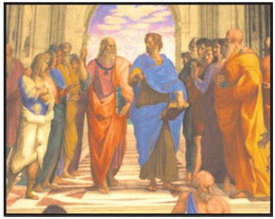

**II. Historical Perspective**

**The Case of the Speluncean Explorers**

**The Case of the Speluncean Explorers** is a *fictitious case created by Lon Fuller in 1949 for the*

*Plato* (left) is carrying a copy of his *Timeus*, and pointing upwards, which symbolizes his concern with the eternal and immutable forms. Aristotle (384 BC - 322 BC) (right) is carrying a copy of his *Nicomachean* Ethics, and keeping his hand down, which symbolizes his concern with the temporal and mutable world. It depicts different approaches towards law from ancient times.

Source : The Critical Thinker (TM), ‘Plato vs. Aristotle: The Classic Philosophical Duel’,http:// thecriticalthinker. wordpress.com/2009/01/12/plato-vs-aristotle

*Harvard Law Review*. The case takes place in the equally fictitious ‘Commonwealth of Newgarth’ in the year 4300. Fuller’s article offers five possible judicial responses. Each has a different viewpoint on whether the survivors should be charged for breach of law. Fuller’s account has been called a ‘classic in jurisprudence’ and an example of mid-20th century legal theory.

###### Facts

Five cave explorers (spelunkers) are trapped inside a cave following a landslide, one of them being Roger Whetmore. They have limited food supplies and no source of food inside the cave. The rescue was difficult, time-consuming, and costly due to the remote location. Ten workmen were killed in the rescue. Approaching starvation, a radio contact is eventually established with the rescue team on the 20th day of the cave-in. The explorers learn that another 10 days would be required in order to free them. After consultation with medical experts, they were told that they are unlikely to survive another

10 days without food. The explorers inquire the doctors about their chances of surviving if they killed and ate one of their own.

UNIT V

UNIT IV

**UNIT III**

UNIT II

UNIT I

The doctors hesitantly stated that they would. No one on the rescue team said yes when asked if they should hold a lottery to decide who to kill and eat. The radio is turned off, and later a lottery is held. The explorers were initially hesitant to use this desperate step, but after hearing the radio chats, they agreed.

Roger Whetmore proposed casting lots, using a pair of dice he happened to have with him. Roger Whetmore backed out of the deal before the dice were rolled, indicating he would wait another week. The other accused him of betraying their trust and continued to cast the dice.

The defendants invited Whetmore to announce any concerns to the fairness of the dice throw before throwing it on his behalf. He didn’t raise an objection, and the throw went against him. Whetmore was put to death and devoured.

In the Case of the Speluncean Explorers, the person to be eaten was chosen by throwing a pair of dice.

Following their rescue and recovery, the survivors were charged with murder of Roger Whetmore. In the Commonwealth of Newgarth, the mandatory sentence for murder is death by hanging.



On the facts as found by the jury, the trial judge ruled that the defendants were guilty of murder and sentenced them to be hanged.

Post-trial, both the trial judge and the jury joined in a petition to the Chief Executive of Newgarth, to commute the death sentence of surviving explorers to six months’ imprisonment. The Chief Executive waits for the Supreme Court’s disposition of the petition of error before making a decision regarding clemency.

Jury involved in Judgement

* Chief Justice Truepenny
* Justice Foster
* Justice Tatting
* Justice Keen
* Justice Handy

**In your opinion, should they be acquitted or convicted for murder?**

#### Opinion of Chief Justice Truepenny

###### Verdict: Guilty

Chief Justice Truepenny holds that in this extraordinary case, the course followed by the jury and trial judge was not only ‘fair and wise’ but the only one open to them to be taken under the law. He believes that the statute is unambiguous and must be applied by the judiciary. The public opinion and sentiment has no sway over the word of the law.

Moreover, granting mercy falls within the scope of the executive and not the judiciary. The Chief Justice depends on the possibility of executive clemency to mitigate the word of law. He proposes that the Supreme Court petitions the Chief Executive for clemency. Thus, by relying on the executive, justice can be done without violating the letter or spirit of the law.

Thus, Truepenny CJ upholds the conviction but recommends clemency.

**Verdict: Innocent**

#### Opinion of Justice Foster

###### Natural Law

Justice Foster makes two main points in determining whether the convictions should be overturned or not. Firstly, the explorers were not in a ‘state of civil society’ but in a ‘state of nature’. Consequently, the laws of Commonwealth of Newgarth do not apply but laws of nature applied to them. Within the scope of the laws of nature, it is acceptable to sacrifice one person if it means the others (many) can survive.

Secondly, the purpose of the statute should be considered if it is assumed that laws of Newgarth did apply to the facts of the case. Therefore, a ‘purposive approach’ must be taken to the statute. The judges can find an exception to the law just like the courts had done earlier with self defence. The main aim of criminal law is punishing the criminals, and by that punishment, deterring further offenders. In this case, punishing the offenders will not serve the purpose of deterrence.

It is not necessarily judicial activism, as the judges have a certain leeway in interpretation of the law especially in cases that are extraordinary in nature. The decision made by the judges in this case would not be going against the will of the legislature, but ensuring that the legislative will is effective. Justice Foster concludes that the conviction should be set aside.

#### Opinion of Justice Tatting

###### Verdict: Uncertain; Recuses

Justice Tatting is torn between empathy for the defendants and the disgust over the horrible act that they had to commit to survive. Finally, he finds that he is unable to reach a decision. He criticizes the view under natural law that prioritises freedom of contract to kill above the right to life in state of nature.

He also notes the difficulty of applying the purposive approach to the criminal statute which has multiple purposes, including retribution and rehabilitation. He finds that the self-defence exception could not be applied to the present case as it would raise many challenges. The doctrine that is taught in law schools is that ‘The man who acts to repel an aggressive threat to his own life does not act wilfully, but in response to an impulse deeply ingrained in human nature’. In the case of the explorers, they not only acted wilfully but deliberated before killing Roger Whetmore.

The judge cites the case of Commonwealth v Valjean, in which starvation was held not to justify the theft of a loaf of bread, let alone homicide (killing of a person). In this case the defendant was charged for theft of a loaf of bread, and he pleaded starving condition as a defense. The court refused to accept it. Thus, raising a question- If hunger cannot justify the theft of food, then how can it justify killing and eating of a man? Justice Tatting rejects J Foster’s reasoning but he cannot decide due to competing legal rationales and emotions.

Justice Tatting makes the unprecedented decision of withdrawing from the case.

**Verdict: Guilty**

#### Opinion of Justice Keen

###### Positivism

Justice Keen raises two questions that are not matters for the court: that of executive clemency and that of morality. Justice Keen stated that it is not for the judiciary to decide whether executive clemency

UNIT V

UNIT IV

**UNIT III**

UNIT II

UNIT I

should be extended to the defendants.

The morality of the defendants’ actions is not something that the courts should concern themselves with or judge, as this falls outside their scope and ambit and is in violation of the doctrine of separation of powers. The Chief Executive should be petitioned for clemency and the decision should be left up to him. Keen J states that the difficulties in deciding the case arise from a failure to separate the legal and moral aspects of the case.

Justice Keen maintains that he does not concern himself with questions of ‘right’ and ‘wrong’. He agrees that the defendants have gone through extreme suffering, but that is his opinion as an individual and not a Judge.

Judges are not to apply their conceptions of morality, but to apply the ‘law of the land’. In this case, the sole question before the court to decide is purely one of applying the legislation of Newgarth and determining whether the defendants willfully took the life of Roger Whetmore. Everything outside of that is outside their consideration.

He criticises his fellow judges because he believes that they are being influenced by their personal emotions and prioritizing that over the word of the law and he is determined to put personal views aside. He is averse to Justice Foster’s purposive approach to statutory interpretation that would allow the court to justify a result it considers proper. He emphasizes that laws may have many possible purposes, with difficulties arising in divining the actual “purpose” of a piece of legislation.

The actions of the defendants clearly fall within the scope of the statutory provision. A hard decision

is never a popular decision. Justice Keen affirms the conviction.

**Verdict: Innocent**

#### Opinion of Justice Handy

###### Legal Realism; Common Sense

Justice Handy holds the case to be one of application of practical wisdom. As per him, court should take account of public opinion and ‘common sense’. For him, it is a simple decision. He is aware that a vast majority want the sentence to be mitigated or pardoned. He criticizes his fellow judges for hiding behind the technical wording of the law. He emphasizes the need for the courts to maintain public confidence, which requires them to follow 90% majority opinion. Government is ‘a human affair’ in which people ‘are ruled well when their rulers understand the feelings and conceptions of the masses’. Judiciary is one branch of the government that is most likely to lose its contact with the common man. Justice Handy states that to preserve the harmony between the judiciary and public opinion, the defendants should be declared innocent. If these men are pardoned no one will think that the statute was stretched any more than our ancestors did when they created the excuse of self- defence. He is aware that his fellow judges will without doubt be troubled by the suggestion of taking into account the emotional public opinion.

UNIT V

UNIT IV

**UNIT III**

UNIT II

UNIT I

Justice Handy taking a common-sense approach, concludes the defendants are innocent and states that the conviction should be set aside.

###### Verdict by the Court:

The Supreme Court, divided evenly, affirmed the conviction. Fuller provides no further details as to the outcome.

Both the trial judge and members of the jury petition the Chief Executive to commute the sentence of the surviving spelunkers from the death penalty to six months’ imprisonment.

UNIT V

UNIT IV

**UNIT III**

UNIT II

UNIT I

#### Activity



**Activity 1:** Write a paper in 500 words on *‘Killing an innocent life to save one’s own does not justify murder even if it’s under extreme necessity of hunger’ in light of the judgment in Rv Dudley and Stephens case.*

**Activity 2:** In the Plank of Carnedaes thought experiment, the scenario envisioned was the following-

* *There are two shipwrecked sailors, A and B. They both see a plank that can only support one of them and both of them swim towards it. Sailor A gets to the plank first. Sailor B, who is going to drown, pushes A off and away from the plank and thus, causes A to drown. Sailor B gets on the plank and is later saved by a rescue team.*
* Do you think Sailor B can be tried for murder because if B had to kill A in order to live, then

it would arguably be in self-defence? Explain your reasoning in 500 words.

**Activity 3:** *Read the following case study from sinking of William Brown Ship-*

Trial of Alexander Holmes:

* Holmes knew that killing people was wrong, but he faced a dilemma. Holmes was a member of the crew onboard the ship The William Brown, which sailed from Liverpool to New York in early April 1842. During its Atlantic crossing, ‘The William Brown’ ran into trouble. The crew and half the passengers managed to escape to a lifeboat. Once there, tragedy struck again. The lifeboat was too laden with people and started to sink. Something had to be done.
* The captain made a decision. The crew would have to throw some passengers overboard, leaving them to perish in the icy waters, but raising the level of the boat. It was the only way anyone was going to get out alive. Holmes followed these orders and was complicit in the death of 14 people. But the remaining passengers were saved. Holmes and his fellow crew were their saviours. Without doing what they did, everyone would have died.

What is your opinion on this paradoxical case? Do you think the captain’s decision was justified or not? Explain your reasoning within 500 words.

**Activity 4**: *Two movies, Souls at Sea and Seven Waves Away, based on similar theme can be shown to students.*

## SCHOOLS OF LAW

The various schools of law are as follows:

#### Natural Law School

Natural law is generally explained as the ‘law of nature, divine law, a law which is eternal and universal’. However, it has been given different meanings at points in time. For instance, it was considered to be associated with theology but at same it was also used for secular purposes. Natural law is believed to exist independent of human will.

It is considered natural in the sense that it is not created by man but is found through nature. Natural law theory varies in its aims and content but there is one central idea. This central idea states that, there is a higher law based on morality against which the moral or legal validity of human law can be measured. At the heart of the natural law theory is a belief that there are certain universal moral laws that human laws may not go against, without losing legal or moral force.

Natural law theory asserts that there is an essential connection between law and morality. The law is not simply what is enacted in statutes, and if legislation is not moral, then it is not law. St. Thomas Aquinas called law without moral content, as ‘perversion of law’.

UNIT V

UNIT IV

**UNIT III**

UNIT II

UNIT I

Exponents of natural law believe that law and morality are linked. This view is expressed by the maxim Lex iniusta non est lex (an unjust law is not a true law). It was also asserted that, if it is not a true law then there is no need to follow it. According to this view, the notion of law cannot be fully articulated without some reference to morality.

While it appears that the classical naturalists believed that the law necessarily includes all moral principles, this argument does not mean that the law is all about moral principles. This is only to substantiate that the legal norms that are promulgated by human beings are valid only if they are consistent with morality.

The principles of Natural law were rejected by Jurists such as Bentham and Austin in the 19th century because of its vague and ambiguous character. However, undue emphasis on morality as an element of law reduced the law into a command of a gunman and therefore, failed to satisfy the aspirations of the people. It was realised that over-emphasis on the historical approaches to law had led to the rise of fascism in Italy and Nazism in Germany.

The change in socio-political conditions of the world, like the rise of materialism after the First World War, shook the conscience of the western society. It compelled the twentieth century western legal thinkers to ponder over the existing legal regimes, so as to provide some alternatives based on value- oriented ideology and to check moral degradation of the society. These factors led to the revival of natural law theory in its modified form, which is different from its traditional form.

##### RULE OF LAW AND PRINCIPLES OF NATURAL JUSTICE

‘Rule of Law’ essentially means that law carries supremacy over all individuals,even those in the position of power. The notions of equality and non-arbitrariness are also important and non- detachable components of rule of law.

The rule of Law is one of the basic and general principles of the Constitution. It is characterized in the words of Max Weber as “legal domination as an idea of government of law rather than an idea of men’’.

So, in essence rule of law means that everyone from the government to its officials, together with citizens should act according to the law.

The doctrine of rule of law has been described as supremacy of the law. This means that where there is rule of law no person can be said to be above the law, even the functions and actions of the executive organ of the state shall be within the ambit of law.

Rule of law imposes a duty on all citizens in a parliamentary democracy to obey the law and for such obedience the law itself must be just law and not arbitrary or oppressive law.

###### Principles of Natural Justice:

Natural Justice in simple terms means the minimum standards or principles which the administrative authorities should follow in deciding matters which have the civil consequences. In India, the principles of natural justice are firmly grounded in Article 14 & 21 of the Constitution. With the introduction of the concept of substantive and procedural due process in Article 21, fairness, which is included in the principles of natural justice, can be read into Article 21. The violation of the principles of natural justice results in arbitrariness; therefore, violation of natural justice is a violation of the equality clause of Article 14.

The principle of natural justice encompasses the following two rules: -

* 1. *Nemo judex in causa sua -* No one should be a judge in his own cause or, the rule against bias.

UNIT V

UNIT IV

**UNIT III**

UNIT II

UNIT I

* 1. *Audi alteram partem -* Hear the other party or, the rule of fair hearing or, the rule that no one should be condemned unheard. Generally, the *‘rule of law’* and *‘due process of law’* are considered as new incarnations of natural justice in the twentieth century.

#### Analytical School

This school mainly aims to create a scientifically valid system of law, by analyzing legal concepts and ideas on the basis of empirical or scientific methods. It is also referred to, as the positive or imperative school of jurisprudence. It came as a reaction against the school of natural law. Most of the founders of this school like *Jeremy Bentham* (1748-1832), an English philosopher and jurist and John Austin (1790-1859), an English jurist and a student of Bentham (also popularly credited for founding the analytical school of jurisprudence) discarded and rejected natural law as ‘vague and abstract ideas’.

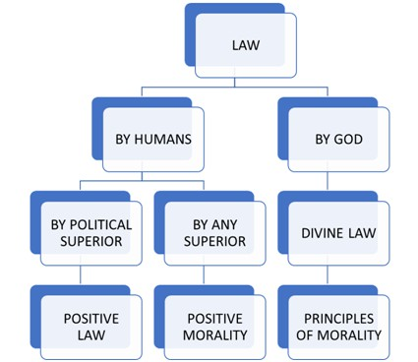

The idea of positivism emphasizes the separation of law and morality. According to the exponents of this school, law is man-made, or enacted by the legislature. Natural law thinkers proposed that if a law is not moral, no one is under any duty to obey it, while positivists believe that a duly enacted law, until changed, remains law and should be so obeyed.

John Austin propounded that law is the command of the sovereign, backed by threat of punishment. In his work, *‘The Province of Jurisprudence Determined’* published in 1832, Austin made an effort to explain the distinction between law and morality. According to him, natural law doctrines were responsible for blurring the distinction between law and morality. To get rid of this confusion he defined law as *‘species of command of sovereign’*.

Austin held that command is an expression of desire by a political superior (e.g. king, Parliament etc.) to a political inferior (eg. subjects, citizens). The political inferior shall commit or omit an act, under an obligation to obey the command and if, the command is disobeyed, then, the political inferior is liable for punishment. Commands are prescribed modes of conduct by the ‘sovereign’. He further viewed sovereign as a person or group of persons, to whom a society gives habitual obedience and who gives no such obedience to others.

This idea of command and punishment for disobeying the command is the most prominent and distinctive character of *‘positive law’*. It differentiates positive law from the *‘principles of morality’*, which consider law as *‘law of God’*, and from ‘positive morality’, which considers law as man-made rules of conduct, such as customary rules and international law, etc. *‘Principles of morality’* and

*‘positive morality’* do not originate from a sovereign.

UNIT V

UNIT IV

**UNIT III**

UNIT II

UNIT I

With passage of time, analytical school was rejected by jurist such as Dworkin, Fuller and Finnis because it gave too much emphasis on ‘law as a command’ and rejected morality and custom as a source of law. It failed to give morality its due importance.

#### Historical School

History is considered as the foundation of knowledge in the contemporary era. According to the followers of the historical school, laws are the creation of interactions between the local situation and conditions of the people. The historical school suggests that the law should conform to the local needs and feelings of the society. It started as a reaction against natural law and positivism to grow as a form of law that emphasized the irrational, racial and evolutionary character of law.

According to Friedman, a noted jurist, the main features of *Savigny’s historical* school of jurisprudence can be summarized as follows:

v Law should be a reflection of the common spirit of the people and their custom.

v Law is not universal; it is particular like the language of a particular society.

v Law is not static; it has relationship with the development of the society.

v Law is not given by a political superior, but is found or given by the people.

*Sir Henry James Sumner Maine* (August 15, 1822 - February 3, 1888), a British jurist and legal historian, who pioneered the study of comparative law, primitive law and anthropological jurisprudence, is the main exponent the of British Historical School of Jurisprudence.

Even the historical approach is not free from criticism. There are many problems with this approach and it was rejected on the ground of its vague, parochial and unscientific explanation of the law.

#### Sociological School

Exponents of this school consider law as a social phenomenon. It visualizes law from the perceptions of people in the society. This approach emphasizes on balancing the conflicting interests in society. The sociological school considers law as a *tool for social change*. Followers of this school insist on the fact that law exists for the needs of the society. The philosophy of the sociological approach provides an opportunity to social and legal reformers. Roscoe Pound (1870-1964), an American jurist, was considered as the chief exponent of sociological jurisprudence in the United States.

According to Roscoe Pound, the main features of the sociological school can be summarized as follows:

v It highlights the purpose and function of law rather than its’ content.

v Law is a social institution designed for social need.

v Law is a tool to balance conflicting interests of society.

#### Realist School

Realists consider laws made by judges as the real law. They give less importance to the traditional rules and concepts as real sources of law. Realism is contrary to idealism. It is a combination of analytical positivism and sociological jurisprudence. Realists do not give much importance to laws enacted by legislative bodies and consider the judge-made laws as the actual law.

Realists place great emphasis on the role of judges in the implementation, interpretation and

development of law. Realists believe that the social, economic and psychological background of a judge plays an important part in his decision-making.

UNIT V

UNIT IV

**UNIT III**

UNIT II

UNIT I

A prominent American jurisprudential scholar *Karl Llewellyn* (1893-1962), who was associated with the school of legal realism, had identified some of the main features of the realist school which are as follows:

v Law is not static as it keeps on changing.

v Law is a means to a social end.

v Society changes faster than the law.

v Law cannot be certain. Decisions of the courts depend on many factors like the psychological, social and economic background of the judges.

v Case studies are important and the court room is a laboratory of law.

#### Conclusion

From the above description of the major approaches or schools of law, it may be interpreted that these approaches can neither be accepted in totality nor rejected completely. Every school has its own approach of understanding and explaining law. These theories are products of certain times and places, which are relevant only in a given setting.

Some part or parts of the above enlisted theories might have become outdated or unacceptable in the present day scenario, but all of those cannot be totally rejected.

The various schools of law are represented diagrammatically in the following manner.

**Schools of Law**

|  |  |  |  |  |
| --- | --- | --- | --- | --- |
| Natural Law School  Jurists/ philosophers: Aristotle, plato, Thomas  Aquinas, Hobbes Montesquieu, Rousseau etc. | Analytical School of Law Jurists/ philosophers: Bentham, Austin, Kelsan, HLA Hart etc. | Historical School of Law  Jurists/ philosophers: Savigny, Henry Maine etc. | Sociological School of Law Jurists/ philosophers: Roscoe Pound, Duguit, Ihering, Ehrlich etc. | Realist School of Law (American & Scandinavian Realism ) Jurists/ Philosophers: Jerome Frank, O W Holmes Alf Ross, Olivecrona, Hangerstorm etc. |
| Distinguishing features/source of Law:   * Nature * Human   Reasons   * Divine Sources | Distinguishing features/source of Law:   * Command of   the sovereign   * Morality   ignored | Distinguishing features/source of Law:   * Custom * Common spirit   of the people | Distinguishing features/source of Law:   * Purpose of law is to balance conflicting interests in the society | Distinguishing features/ source of Law:   * Judicial decisions are the prime source of Law |

## Function And Purpose of Law

UNIT V

UNIT IV

**UNIT III**

UNIT II

UNIT I

After discussing and understanding the meaning of the term ‘law’, it is natural to ask the following questions: Why is there law in the society? What is the need for law? Can a society be governed smoothly without any kind of law? What is the function and purpose of law? etc.

Functions and purpose of law have been changing with time and place. They depend on the nature of the state. However, at present in a welfare and democratic state, there are several important functions of law.

It can be stated that law starts regulating the welfare and other aspects of human life, from the moment a child is conceived in her mother’s womb. In fact, the State interacts with and protects its citizens throughout their lives, with the help of law.

Some of the major functions and purposes of law are listed below:

1. To deliver justice
2. To provide equality and uniformity
3. To maintain impartiality
4. To maintain law and order
5. To maintain social control
6. To resolve conflicts
7. To bring orderly change through law and social reform

## Exercises

Based on your understanding, answer the following questions:

* 1. Provide one point of difference between the following-
     1. Natural law school and Analytical school.
     2. Sociological school and Realist school
     3. Original and revived Natural Law School Q-2 Answer the following questions briefly-

1. On what grounds historical approach to law was criticized?
2. What do you understand by the maxim “lex iniusta non est lex”?
3. State the two important rules of natural justice principles.
4. State two examples of the principles of natural Justice grounded in the Constitution of India. Q-3 Answer the following questions in detail-
5. Explain the purpose of law.
6. Explain the viewpoint of analytical Law School. Also state the reasons for its rejection.
   1. Imacia, a country follows laws which appeal to the conscience of people only. They strongly believe in the principles of natural justice and due process of law. Which school of law do they follow? Explain the school.

UNIT V

UNIT IV

**UNIT III**

UNIT II

UNIT I



**Classiftcation of Laws**

CHAPTER

2

## Contents

1. Classification of law based on Subject Matter
2. Classification of law based on Scope of Law
3. Classification of law based on Jurisdiction
4. Exercises

## Learning Outcomes

After the completion of this chapter, the students will be able to:

* Classify the various branches of law
* Summarise the purpose behind classification of law
* Compare International Law and Municipal Law
* Compare Public and Private International Law
* Compare Public and Private Municipal law
* Identify the sub types of each branch
* Analyse the difference between civil and criminal law
* Differentiate between substantive and procedural laws

The classification of law is important for the correct and comprehensive understanding of law. The following are the benefits of classifying law:

* 1. Useful in understanding the interrelation of rules
  2. Useful in the systematic arrangements of rules
  3. Useful for the profession and students of law

There are several ways of classifying law and the idea of classification of law is not new. Even in ancient civilizations, the jurists were well aware of the difference between civil and criminal laws. However, with the passage of time, many new branches have come into existence and therefore, the old classification has become outdated. Law can be classified in many ways with respect to time and place.

## Classification of Laws Based on Subject Matter

UNIT V

UNIT IV

**UNIT III**

UNIT II

UNIT I

**Laws**

Criminal

Civil

#### Criminal Laws

* Any act which is considered to be an offence/prohibited by the laws in force in India is covered under criminal law



* Crimes affect the society as a whole
* In crimes, action is initiated by the state on behalf of the individual
* Remedy- imprisonment or fine or both
* Examples – theft, murder, rape etc.

#### Civil Laws

* All acts which are not specifically defined as a crime are civil in nature
* Private in nature-affects only an individual and not the society as a whole
* A civil action is initiated by the individual himself/herself
* Remedy- compensation (monetary relief), damages (monetary relief), injunction (court orders asking a person to do or not do what he/she is legally obliged to do/not do)
* Examples – property disputes, family matters etc.

## Classification based on Scope of Law

###### Laws

Substantive

Procedural

Legislative acts are classified as ‘substantive acts,’ on the basis of the subject matter of the law; and ‘procedural acts’, on the basis of the procedure to be followed by the executive and judiciary in implementation of those laws.

#### Substantive Laws

* Laws which define rights and liabilities of an individual
* Eg- consumer protection act; right to information act, etc.

#### Procedural Laws

UNIT V

UNIT IV

**UNIT III**

UNIT II

UNIT I

* + Laws which define the procedures and protocols for enforcing substantive law or filing a case
  + Eg - code of civil procedure for civil cases
  + Eg - code of criminal procedure for criminal cases

Amending Acts modify/ amend the existing laws on the statute book, taking into account the changing social, political and economic conditions of the country.

## Classification based on Jurisdiction

**International Laws**



Public International Law

Private International Law

### International Law

International law is an important branch of law. It deals with those rules and regulations of nation which are recognized and are binding upon each other through reciprocity. Many jurist however, do not give much importance to this branch. In recent times, this branch of law has grown manifold and has acquired increasing importance on account of globalization and other related factors.

International law has been further classified as follows:

* + 1. **Public International Law**

This branch of law relates to the body of rules and regulations which governs the relationship between nations. Countries mutually recognise these sets of rules which are binding on them in their transactions on a reciprocal basis.

* + 1. **Private International Law**

Private international law is that part of law of the State, which deals with cases having a foreign element. Private international law relates to the rights of private citizens of different countries. Marriages and adoption of individuals fall within its domain.

**Municipal Law**

Private Municipal Law

Public Municipal Law

### Municipal Law

UNIT V

UNIT IV

**UNIT III**

UNIT II

UNIT I

Municipal laws are basically domestic or national laws. They regulate the relationship between the State and its citizen and determines the relationship among citizens. Municipal law can be further classified into two segments:

* + 1. **Public Law**

Public law *chiefly regulates the relationship between the State and its’ subjects*. It also provides the structure and functioning of the organs of States. The three *important branches of Public Law* are the following:

* + - 1. **Constitutional Law :** Constitutional law is considered to be the basic as well as the supreme law of the country. The nature of any State is basically determined by its Constitution. It also provides the structure of the government. All the organs of states derive their powers from the Constitution. Some countries, such as India, have a written Constitution, while countries such as the United Kingdom have an ‘uncodified Constitution’. In India, the fundamental rights are granted and protected under the Constitution.
      2. **Administrative Law :** Administrative law mainly deals with the powers and functions of administrative authorities - government departments, authorities, bodies etc. It deals with the extent of powers held by the administrative bodies and the mechanism whereby their actions can be controlled. It also provides for legal remedies in case of any violation of the rights of the people.
      3. **Criminal Law :** Criminal law generally deals with acts which are prohibited by law and defines the prohibited act as an offence. It also prescribes punishments for criminal offences. Criminal law is very important for maintaining order in the society, and for maintaining peace. It is considered a part of public law, as crime is not only against the individual but against the whole society. Indian Penal Code, 1860 (also known as IPC) is an example of a criminal law legislation, in which different kinds of offences are defined and punishments prescribed.
    1. **Private Law**

This branch of law defines, regulates, governs and enforces relationships between individuals and associations and corporations. In other words, this branch of law deals with the definition, regulation and enforcement of mutual rights and duties of individuals. The state intervenes through its judicial organs (e.g. courts) to settle the dispute between the parties. Private or Civil law confers civil rights which are administered and adjudicated by civil courts. Much of the life of a society is regulated by this set of private laws or civil rights. This branch of law can be further classified into the following:

* + - 1. **Personal Law :** It is a branch of law related to marriage, divorce and succession (inheritance). These laws are based on religion, ritual and customs of marriage, divorce, and inheritance. In such matters, people are mostly governed by the Personal laws laid down by their religions. For example, the marriage of Hindus is governed by Personal laws like the Hindu Marriage Act, 1955 while Muslim marriages are governed by the Muslim personal law based on a Muslim customary law which is largely un-codified.
      2. **Property Law :** This branch of law deals with the ownership of immovable and movable properties. For example, the Transfer of Property Act, 1882, deals with transfer of immovable property, whereas the Sales of Goods Act, 1930, deals with movable property.
      3. **Law of Obligations :** This branch of the law pertains to an area where a person is required

to do something because of his promise, contract or law. It puts an obligation on the person to perform certain actions which generally arise as a consequence of an enforceable promise or agreement. If someone violates his promise, that promise may be enforced in a court of law.

UNIT V

UNIT IV

**UNIT III**

UNIT II

UNIT I

According to the Indian Contract Act, 1872, a contract is ***an agreement which is enforceable by law***. In other words a contact is an agreement with specific terms between two or more persons in which there is a promise to do something in lieu of a valuable profit which is known as consideration. For example,’A’ has offered his mobile phone to ‘B’ for Rs.15,000. ‘B’ agreed to purchase the same. This has created a legal relationship where both have made a promise which is enforceable by law.

* + - 1. **Law of Torts: Tort is a civil wrong.** This branch of law creates and provides remedies for civil wrongs that do not arise out of contractual duties. A tort deals with negligence cases as well as intentional wrongs which cause harm. An aggrieved person may use law of tort to claim damages from someone who has caused the wrong or legal injury to him/ her. Torts cover intentional acts and accidents.

For instance, if ‘A’ throws a stone and it hits another person namely ‘B’ on the head, ‘B’ may sue ‘A” for the injury caused by the accident.

## Exercises

Based on your understanding, answer the following questions:

* 1. Provide brief answers for the following-
     1. Why is classification of law important? What are its benefits?
     2. What is International Law? Explain the two types of International Law.
     3. Differentiate between International and Municipal Law.
     4. What is a contract?
     5. Discuss the different types of Public and Private Municipal Laws.
  2. Identify the branch of law and define-
     1. Antilla and Portico are two countries who have a border dispute.
     2. Shefali was aggrieved because her passport was refused by the Passport Department without any reason.
     3. Gita died intestate and her kids don’t know how to divide the property.
     4. Ajit was in an agreement to supply 50 kgs of rice to Bittu but did not do so.
  3. Sheena was a victim of sexual harassment at workplace. Explain why her criminal case is a part of public municipal law.
  4. Halestina and Xina, two Countries are bound by some laws which foster their relations by following some rules based on reciprocity. Identify the branch of law and explain its two sub types.
  5. The Government of India introduced a new law whereby the passport of any person could be revoked on mere suspicion of fraudulent financial transactions without providing a chance of hearing. Identify and define the branch of law under which such a law can be challenged.

UNIT V

UNIT IV

**UNIT III**

UNIT II

UNIT I



**Sources of Laws**

CHAPTER

3

## Contents

1. Where does law come from?
2. Custom as a Source of Law
3. Importance of Custom as a Source of Law in India
4. Judicial Precedent as a Source of Law
5. Legislation as a Source of Law
6. Exercises

## Learning Outcomes

After the completion of this chapter, the students will be able to:

* + Discuss the three main sources of law- Customs, Legislation and Judicial Precedent
  + Explain the essential tests laid down by jurists/ courts for customs to be recognized as sources of law
  + Evaluate the importance of custom as an important source of law in India
  + Differentiate between the two parts of judicial decisions- Ratio decidendi and Obiter dicta
  + Critically evaluate the importance of different sources of law
  + Enumerate and explain different kinds of legislation

## Where does law come from?

To have a clear and complete understanding of law, it is essential to understand the sources of law. Sources of law mean the sources from where law or the binding rules of human conduct originate. In other words, law is derived from sources. Jurists have different views on the origin and sources of law, as they have regarding the definition of law. As the term ‘law’ has several meanings, legal experts approach the sources of law from various angles.

For instance, Austin considers Sovereign as the source of law while Savigny and Henry Maine consider custom as the most important source of law. Natural law school considers nature and human reason as the source of law, while theologians consider the religious scriptures as sources of law. Although there are various claims and counter claims regarding the sources of law, it is true that in almost all societies, law has been derived from similar sources.

The three major sources of law that can be identified in any modern society are as follows:

* 1. Custom
  2. Judicial precedent

UNIT V

UNIT IV

**UNIT III**

UNIT II

UNIT I

* 1. Legislation

## Custom as a Source of Law

A custom, to be valid, must be observed continuously for a very long time without any interruption. Further, a practice must be supported not only for a very long time, but it must also be supported by the opinion of the general public and morality. However, every custom need not become law. For example, the Hindu Marriages Act, 1955 prohibits marriages which are within the prohibited degrees of relationship. However, the Act still permits marriages within the prohibited degree of relationship if there is a proven custom within a certain community.

**Custom can simply be explained as *those long established practices or unwritten rules which have acquired binding or obligatory character.*

In ancient societies, custom was considered as one of the most important sources of law; in fact it was considered as the real source of law. With the passage of time and the advent of modern civilization, the importance of custom as a source of law diminished and other sources such as judicial precedents and legislation gained importance.

#### Can Custom be law?

There is no doubt about the fact that custom is an important source of law. Broadly, there are two views which prevail in this regard on whether custom is law. Jurists such as Austin opposed custom as law because it did not originate from the will of the sovereign. Jurists like Savigny consider custom as the main source of law. According to him the real source of law is the will of the people and not the will of the sovereign. The will of the people has always been reflected in the custom and traditions of the society. Custom is hence a main source of law.

**Saptapadi** is an example of customs as a source of law. It is the most important rite of a Hindu marriage ceremony. The word, Saptapadi means ‘Seven steps’. After tying the Mangalsutra,the newly-wed couple take seven steps around the holy fire, which is called Saptapadi. The customary practice of Saptapadi has been incorporated in Section 7 of the Hindu Marriage Act, 1955.

#### Kinds of Customs

Customs can be broadly divided into two classes:

* 1. **Customs without sanction:** These kinds of customs are non-obligatory in nature and are followed because of public opinion.
  2. **Customs with sanction:** These customs are binding in nature and are enforced by the State. These customs may further be divided into the following categories:
     1. **Legal Custom :** Legal custom is a custom whose authority is absolute; it possesses the force of law. It is recognized and enforced by the courts. Legal custom may be further classified into the following two types:

**General Customs :** These types of customs prevail throughout the territory of the State.

**Local Customs :** Local customs are applicable to a part of the State, or a particular region of the country.

* + 1. **Conventional Customs :** Conventional customs are binding on the parties to an

agreement. When two or more persons enter into an agreement related to a trade, it is presumed in law that they make the contract in accordance with established convention or usage of that trade. For instance, an agreement between a landlord and tenant regarding the payment of rent will be governed by convention prevailing in this regard.

UNIT V

UNIT IV

**UNIT III**

UNIT II

UNIT I

#### Essentials of a valid custom

All customs cannot be accepted as sources of law, nor can all customs be recognized and enforced by the courts. The jurists and courts have laid down some essential tests for customs to be recognized as valid sources of law. These tests are summarized as follows:

**Antiquity :** In order to be legally valid, customs should have been in existence for a longtime, even beyond human memory. In England, the year 1189 i.e. the reign of *Richard I* King of England has been fixed for the determination of validity of customs. However, in India there is no such time limit for deciding the antiquity of the customs. The only condition is that those should have been in practice since time immemorial.

**Continuous :** A custom to be valid should have been in continuous practice. It must have been enjoyed without any kind of interruption. Long intervals and disrupted practice of a custom raise doubts about the validity of the same.

**Exercised as a matter of right :** Custom must be enjoyed openly and with the knowledge of the community. It should not have been practised secretly. A custom must be proved to be a matter of right. A mere doubtful exercise of a right is not sufficient to a claim as a valid custom.

**Reasonableness :** A custom must conform to the norms of justice and public utility. A custom, to be valid, should be based on rationality and reason. If a custom is likely to cause more inconvenience and mischief than convenience, such a custom will not be valid.

**Morality :** A custom which is immoral or opposed to public policy cannot be a valid custom. Courts have declared many customs as invalid as they were practised for immoral purpose or were opposed to public policy. Bombay High Court in the case of *Mathura Naikon v. EsuNaekin*, ((1880) ILR 4 Bom

545) held that, the custom of adopting a girl for immoral purposes is illegal.

**Status of Custom with regard to Legislation :** In any modern State, when a new legislation is enacted, it is generally preferred to the custom. Therefore, it is imperative that a custom must not be opposed or contrary to legislation. Many customs have been abrogated by laws enacted by the legislative bodies in India. For instance, the customary practice of child marriage has been declared as an offence. Similarly, adoption laws have been changed by legislation in India.

## Importance of custom as a Source of Law in India

Custom was the most important source of law in ancient India. Even the British initially adopted the policy of non-intervention in personal matters of Hindus and Muslims. The British courts, in particular, the Privy Council, in cases such as Mohammad Ibrahim v. Shaik Ibrahim (AIR 1922 PC59) observed and underlined the importance of custom in moulding the law. At the same time, it is important to note that customs were not uniform or universal throughout the country. Some regions of the country had their own customs and usages.

These variances in customs were also considered a hindrance in the integration of various communities of the country. During our freedom struggle, there were parallel movements for social reform in the country. Social reformers raised many issues related to women and children such as widow re-marriage and child marriage. After independence and with the enactment of the Constitution, the Indian Parliament took many steps and abrogated many old customary practices with some progressive legislation. Hindu personal laws were codified and the Hindu Marriage Act, 1955 and the

Hindu Adoption Act, 1955, were adopted. The Constitution of India provided a positive environment for these social changes. After independence, the importance of custom has definitely diminished as a source of law and judicial precedent, and legislation has gained a more significant place. A large part of Indian law, especially personal laws, however, are still governed by customs.

UNIT V

UNIT IV

**UNIT III**

UNIT II

UNIT I

## Judicial Precedent as a Source of Law

In simple words, judicial precedent refers to previously decided judgments of the superior courts, such as the High Courts and the Supreme Court, which judges are bound to follow. This binding character of the previously decided cases is important, considering the hierarchy of the courts established by the legal systems of a particular country. In India, this hierarchy has been established by the Constitution of India.

Judicial precedent is an important source of law, but it is neither as modern as legislation nor is it as old as custom. It is an important feature of the English legal system as well as of other common law countries which follow the English legal system.

In most of the developed legal systems, judiciary is considered to be an important organ of the State. In modern societies, rights are generally conferred on the citizens by legislation and the main function of the judiciary is to adjudicate upon these rights. The judges decide those matters on the basis of the legislations and prevailing custom but while doing so, they also play a creative role by interpreting the law. By this exercise, they lay down new principles and rules which are generally binding on lower courts within a legal system.

Given this background, it is important to understand the extent to which the courts are guided by precedents. It is equally important to understand what really constitutes the judicial decision in a case and which part of the decision is actually binding on the lower courts.

#### DOCTRINE OF PRECEDENT IN INDIA - A BRITISH LEGACY

###### Pre-Independence:

According to Section 212 of the Government of India Act, 1919, the law laid down by Federal Court and any judgment of the Privy Council was binding on all courts of British India. Hence,Privy Council was supreme judicial authority - (AIR 1925 PC 272).

###### Post-Independence:

Supreme Court (SC) became the supreme judicial authority and a streamlined system of courts was established.

###### Supreme Court:

* + Binding on all courts in India
  + Not bound by its own decisions, or decisions of Privy Council or Federal Court - (AIR 1991

SC 2176)

###### High Courts:

* + Binding on all courts within its own jurisdiction
  + Only persuasive value for courts outside its own jurisdiction
  + In case of conflict with decision of same court and bench of equal strength, referred to a

higher bench

###### Lower Courts:

* + Bound to follow decisions of higher courts in its own state, in preference to High Courts of

other states

###### Judicial decisions can be divided into following two parts:

UNIT V

UNIT IV

**UNIT III**

UNIT II

UNIT I

1. **Ratio decidendi (Reason of Decision):** ‘Ratio decidendi’ refers to the binding part of a judgment. ‘Ratio decidendi’ literally means reasons for the decision. It is considered as the general principle which is deduced by the courts from the facts of a particular case. It becomes generally binding on the lower courts in future cases involving similar questions of law.
2. **Obiter dicta (Said by the way):** An ‘obiter dictum’ refers to parts of judicial decisions which are general observations of the judge and do not have any binding authority. However, obiter of a higher judiciary is given due consideration by lower courts and has persuasive value.

Having considered the various aspects of the precedent i.e. ratio and obiter, it is clear that the system of precedent is based on the hierarchy of courts. Therefore, it becomes important to understand the hierarchy of courts in order to understand precedent.

Every legal system has its own distinct features. Therefore, the doctrine of precedent is applied differently in different countries. In India, the doctrine of precedent is based on the concept of hierarchy of courts.

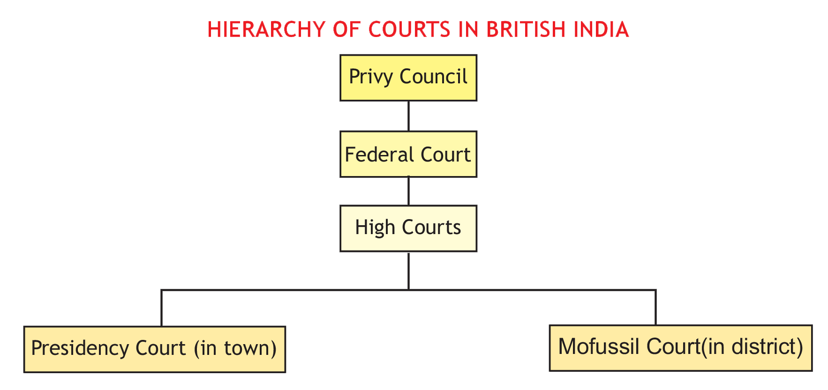

The modern system of precedent developed in India during the British rule. It was the British who introduced the system of courts in India.

However, post-independence, India adopted its own Constitution, which provided for a hierarchical judicial system that is pyramidal in nature. Under the Constitution of India, a single monolithic unified command of the judiciary has been established. The Supreme Court of India,which was established by the Constitution of India, came into existence on 28 January, 1950 under Article 124(1) of the Constitution of India.

The Supreme Court replaced the Federal Court established by the Government of India Act,1935. The Supreme Court of India is the Apex Court in the hierarchy of courts, followed by the High Courts at the State level. Below them are the District Courts and Sessions Court. The structure of the judiciary in all states is almost similar, with little variation in nomenclature of designations.

#### HIERARCHY OF CRIMINAL JUSTICE SYSTEM

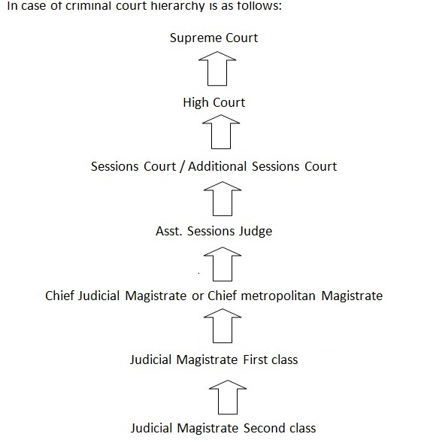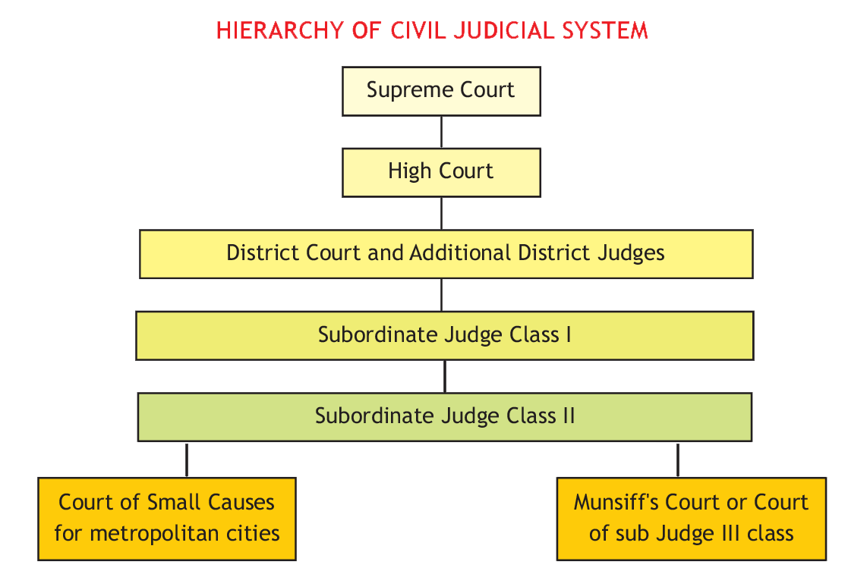

UNIT V

UNIT IV

**UNIT III**

UNIT II

UNIT I

**HIERARCHY OF CIVIL JUDICIAL SYSTEM**

In a nutshell, the decisions given by the Supreme Court are binding on all the courts throughout the territory of India. While the decision given by the High Courts are binding on the subordinate courts within the jurisdiction of that particular High Court, the decisions of the High Courts are not binding beyond their respective jurisdictions.

UNIT V

UNIT IV

**UNIT III**

UNIT II

UNIT I

The decisions of the High Courts, however, have persuasive value for the other High Courts and the Subordinate Courts beyond their jurisdiction. It is important to note that the Supreme Court is not bound by its previous decisions; with an exception that a smaller bench is bound by the decision of the larger bench and that of the co-equal bench.

**Justice Kania**

*was the First Chief Justice of India.*

*Source:* [*http://supremecourtofi*](http://supremecourtofi/) *ndia. nic.in/judges/rcji/01hjkania.htm*

#### Do Judges make Law?

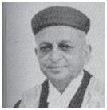

Discussion in the foregoing paragraphs regarding the hierarchy of courts and the binding authority of decisions of the Supreme Courts in the lower courts raises another important question regarding the role of judges in law-making. This part of the topic deals with the fundamental question. Do judges make law?

The Constitution of India confers power on the legislature to make law, while the judiciary has the power to examine the constitutionality of the laws enacted by the legislature. The courts also adjudicate upon the rights and duties of citizens, and further interpret the provisions of the Constitution and other statutes.

Through these processes, the courts create new rights for the citizens. By this exercise, the judiciary makes additions to the existing laws of the country. It is argued that while doing this,judges actually make law.

There are two views regarding this issue. One set of jurists say that judges do not make the law but that they simply declare the existing law. Another set of jurists say that judges do make the law. Jurists like Edward Coke and Mathew Hale are of the opinion that judges do not make law. According to them judicial decisions are not sources of law but, they are simply the proof of what the law is. Judges are not law-givers, but they discover law.

At the same time jurists like Dicey, Gray, Salmond are of the opinion that judges do make law. They hold the view that judges, while interpreting the law enacted by the legislative bodies, contribute to the existing body of law. A large part of the English law is judge-made law.

The above arguments seem to be complementary. It can be inferred that judges do not make the law in the same manner in which, legislative bodies do. Judges work on a given legal material passed as law by the legislature. While declaring the law, judges interpret the ‘legislation’ in question and play a creative role. By this creative role, judges have contributed significantly to the development of law.

In the Indian context, former judges of the Supreme Court of India like Justice P.N. Bhagwati and Justice Krishna Iyer enlarged the meaning and scope of various provisions of the Constitution through their creative interpretation of the legal text. The Supreme Court, too in its role as an activist, has created many new rights such as the: right to privacy, right to live in a pollution free environment, right to livelihood etc.

The Right to Education has received considerable impetus during the last decade as a result of the concerted effort of many groups and agencies towards ensuring that all children in India receive at least minimum education, irrespective of their socio-economic status and their ability to pay for education, in a situation of continuous impoverishment and erosion of basic needs. In a way, the right to education is the culmination of efforts made possible by judicial interpretations and a constitutional amendment.

Sour[ce:http://www.ncpcr.gov.in/Acts/Fundamental_Right_to_Education_Dr_Niranjan_Aradhya_ArunaKashyap.pdf](http://www.ncpcr.gov.in/Acts/Fundamental_Right_to_Education_Dr_Niranjan_Aradhya_ArunaKashyap.pdf)

These new rights were created only by way of interpreting Article 21 (Right to Life) of the Constitution of India. These rights developed by the courts are not in any sense lesser than the laws enacted by the legislative bodies. Therefore, it can be concluded that the ***judicial precedents are important sources of law in modern society and judges do play a significant role in law-making.***

UNIT V

UNIT IV

**UNIT III**

UNIT II

UNIT I

## Legislation as a Source of Law

In modern times, legislation is considered as the most important source of law. The term ‘legislation’ is derived from the Latin word legis which means ‘law’ and latum which means ‘to make’ or ‘set’. Therefore, the word ‘legislation’ means the ‘making of law’. The importance of legislation as a source of law can be measured from the fact that it is backed by the authority of the sovereign, and it is directly enacted and recognised by the State. The expression ‘legislation’ has been used in various ways. It includes every method of law-making. In the strict sense, it means laws enacted by the sovereign or any other person or institution authorised by him.

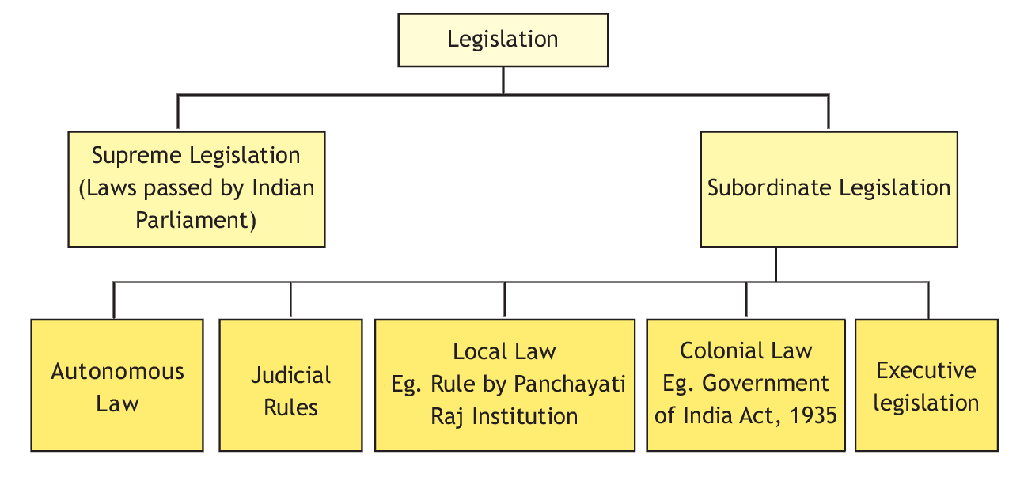

The chart below explains the types of legislation:

The kinds of legislation can be explained as follows:

#### Kinds of Legislation

* Supreme Legislation (Laws passed by Indian Parliament)
* Subordinate Legislation

#### Types of Subordinate Legislation

* Autonomous Law
* Judicial Rules
* Local Laws (Eg. Rule by Panchayati Raj Institution)
* Colonial Law (Eg. Government of India Act, 1935)
* Laws made by the Executive

1. **Supreme Legislation:** When the laws are directly enacted by the sovereign, it is considered as supreme legislation. One of the features of Supreme legislation is that, no other authority except the sovereign itself can control or check it. The laws enacted by the British Parliament fall in this category, as the British Parliament is considered as sovereign.

The law enacted by the Indian Parliament also falls in the same category. However in India, powers of the Parliament are regulated and controlled by the Constitution, though the laws enacted by it are not under the control of any other legislative body.

UNIT V

UNIT IV

**UNIT III**

UNIT II

UNIT I

1. **Subordinate Legislation :** Subordinate legislation is a legislation which is made by any authority which is subordinate to the supreme or sovereign authority. It is enacted under the delegated authority of the sovereign. The origin, validity, existence and continuance of such legislation totally depends on the will of the sovereign authority. Subordinate legislation further can be classified into the following types:-
   1. **Autonomous Law:** When a group of individuals recognized or incorporated under the law as an autonomous body, is conferred with the power to make rules and regulation, the laws made by such body fall under autonomous law. For instance, laws made by the bodies like Universities, incorporated companies etc. fall in this category of legislation.
   2. **Judicial Rules:** In some countries, judiciary is conferred with the power to make rules for their administrative procedures. For instance, under the Constitution of India, the Supreme Court and High Courts have been conferred with such kinds of power to regulate procedure and administration.
   3. **Local laws:** In some countries, local bodies are recognized and conferred with the law- making powers. They are entitled to make bye-laws in their respective jurisdictions. In India, local bodies like Panchayats and Municipal Corporations have been recognized by the Constitution through the 73rd and 74th Constitutional amendments. The rules and bye- laws enacted by them are examples of local laws.
   4. **Colonial Law:** Laws made by colonial countries for their colonies or the countries controlled by them are known as colonial laws. For a long time, India was governed by the laws passed by the British Parliament. However, as most countries of the world have gained independence from the colonial powers, this legislation is losing its importance and may not be recognized as a kind of legislation.
   5. **Laws made by the Executive :** Laws are supposed to be enacted by the sovereign and the sovereignty may be vested in one authority or it may be distributed among the various organs of the State. In most of the modern States, sovereignty is generally divided among the three organs of the State. The three organs of the State namely legislature, executive and judiciary are vested with three different functions. The prime responsibility of law-making vests with the legislature, while the executive is vested with the responsibility to implement the laws enacted by the legislature.

However, the legislature delegates some of its law-making powers to executive organs which are also termed delegated legislation. Delegated legislation is also a class of subordinate legislation.

In welfare and modern states, the amount of legislation has increased manifold and it is not possible for legislative bodies to go through all the details of law. Therefore, it deals with only a fundamental part of the legislation and wide discretion has been given to the executive to fill the gaps. This increasing tendency to delegate legislation has been criticized. However, delegated legislation is resorted to, on account of reasons like paucity of time, technicalities of law and emergency. Therefore, delegated legislation is sometimes considered as a necessary evil.

## Exercises

UNIT V

UNIT IV

**UNIT III**

UNIT II

UNIT I

Based on your understanding, answer the following questions:

* 1. Write one point of difference between the following-
     1. Ratio decidendi and Obiter Dicta
     2. Custom and legislation as a source of law
     3. Supreme legislation and Subordinate legislation
     4. Judgements of Supreme Court and High Court
     5. General customs and Local customs Q-2 Write short notes on the following-

1. Custom as a source of law
2. Subordinate legislation
3. Parts of Judicial decision
   1. Identify the following legislations-
      1. The law made by sovereign
      2. Law made by Municipal corporation
      3. Law made by universities
      4. Law made by executive
      5. Laws made by colonial rulers
   2. Provide brief answers for the following-
      1. How did Austin and Savigny view custom as a source of law?
      2. What are the two parts of Judicial decisions?
      3. Do judges make law? Comment.
      4. What is the importance of custom as a source of law in India?
      5. Enumerate the legislations that are based on customs.
      6. What is the hierarchy of civil and criminal justice system in India? Q-5 Provide detailed answers for the following-
4. Explain different kinds of customs.
5. What are the essentials of a valid custom?
6. Explain legislation as a source of law.
7. Explain different kinds of legislation.

Q-6 Why is delegated legislation sometimes considered as a necessary evil? Q-7 Which is the most relevant source of law in today’s time? Define.

1. Give any two difference between its two types.
2. Also explain which of its form is a necessary evil and why?
   1. What are judicial precedents? Also answer the following questions:
3. The Chennai High Court gave a decision in the year 2005 which was overturned by SC in 2011.

Which of the two decisions should be followed by a district court in Chennai.

1. Kerala High Court and Calcutta High Court gave contradicting decisions in the year 2009 and 2017 respectively.

Which decision should Kerela District Court follow?

1. In the year 2018, a division bench of SC and Constitutional bench of SC gave two contradicting decisions. Which decision should be followed?

UNIT V

UNIT IV

**UNIT III**

UNIT II

UNIT I

* 1. The Supreme Court of India passed a judgment in the year 2015 which banned diesel cars registered before the year 2005 from plying on the road. The rationale behind the judgment was the deterioration of engine and hence poor performance and increased pollution. While writing the judgment the judges made many remarks on other sources of pollution too like construction, fires, etc.
     1. What is the relevance of this judgment in the creation of laws?
     2. What two parts of this judgment are being talked above?
     3. Can the Delhi High Court overturn this judgment?
  2. “All customs cannot be accepted as sources of law, nor can all customs be recognized and enforced by the Courts”.
     1. Explain any three factors which are taken into consideration for deciding any custom as a valid source of law.
     2. What is the relevance of customs as a source of law in the present day context?

## Activities

* 1. How do you find out whether a society has a very good legal system or not? What criteria should inform your opinion? Divide your class into two sections and hold a discussion.
  2. You may also watch some of the videos posted by Professor Michael Sandel at [http://www.](http://www/) justiceharvard.org/watch/in guiding your debate.

UNIT V

UNIT IV

**UNIT III**

UNIT II

UNIT I



**Law Reforms**

CHAPTER

4

## Contents

* + 1. Need for Law Reform
    2. Law Reforms in India
    3. Recent Law reforms in Independent India
    4. Exercises

## Learning Outcomes

After the completion of this chapter, the students will be able to:

* + - * Discuss the meaning of law reform
      * Critically analyse the need for law reform in India
      * Explain the role of British administrators in improving the Civil and Criminal justice system in pre-independent India
      * Describe the role of law commissions in law reforms in pre-independent India
      * Enumerate recent law reforms in Independent India

## Need for Law Reform

There is a strong relationship between the law and the society. Law has to be dynamic. It cannot afford to be static. In fact, law and society act and react upon each other.

Law reform is the *process by which the law is adapted and advanced over a period of time* in response to changing social values and priorities. The law cannot remain stagnant. Law has to respond to the social concerns and has to provide amicable solutions to the problems that keep coming up before the society. It has to respond to social, economic or technological developments. Law reforms also help to shape democracies to suit changing political and legal environments. Law reform is not a one-time process but a tedious and gradual process.

## Law reforms in India

Law reforms in India can be broadly classified into two periods, which are as follows:

* 1. Pre-independent India law reforms
  2. Post-independent India law reforms

Before the advent of British rule, the Indian society was by and large governed by its customary laws, either based on Hindu Dharmashastra or Islamic religious scripts. These customary laws were followed by the rulers and the ruled. Customary laws were considered as rigid and averse to the idea of social change.

The East India Company introduced the western legal system as well as legal reforms in India. Prior to the First War of Independence in 1857, the East India Company ruled India under the permission of the British crown, and later on the British crown governed India till 1947. During the British Raj,

UNIT V

UNIT IV

**UNIT III**

UNIT II

UNIT I

i.e. from 1600 A.D to 1947 there were major changes in political, economic, administrative and legal fields.

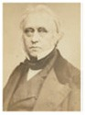

Lord Macaulay, 1800-1859, came to India in 1834 as a member of the Supreme Council of India when William Bentinck was the Governor- General of India. He stayed in India till early 1838. However, during his short stay Macaulay had left his unforgettable imprint on the Indian legal system which made a long term impact on the Indian society.

Modern courts were established by the enactment of various Acts such as the Regulating Acts, 1773, the Government of India Act 1935, etc. Further, well accepted principles of English law like justice, equity, and good conscience were used by the courts in India for their decisions. British administrators like *Warren Hastings* (1732-1818), the first Governor-General of India, *Cornwallis* (1738-1805), a British Army officer and colonial administrator, who served as a civil and military governor in India, and is known for his contribution to the policy for the Permanent Settlement and *William Bentinck* (1774- 1839), a British statesman, who served as Governor- General of India from 1828 to 1835, played crucial roles in the reforms in the Judicial System in pre-independent India.

A major milestone in law reform during the *British Raj*, was the establishment of the Law Commission. The first Law Commission was established in 1834 under the Charter Act of 1833, under the Chairmanship of *Thomas Babington Macaulay*.

The major contribution of the Law Commission was the recommendation on the codification of the penal code and the criminal procedure code. Thereafter, the Second, Third and Fourth Law Commissions were established in the years 1853, 1861 and 1879 respectively. The Indian Code of Civil Procedure, 1908, the Indian Contract Act, 1872, the Indian Evidence Act, 1872 and the Transfer of property Act, 1882, are major contributions of these above Law Commissions.

### Post-Independent India

Freedom brought the winds of change and an ideological shift in post-colonial India. This change was very visible in the field of law reform as well. In Independent India, the newly enacted Constitution and Principles enshrined under it were the main guiding forces of law. The Fundamental Rights and Directive Principles of State Policies are now the basis for any social change. After Independence, the Constitution under Article 372, recognized the pre-constitutional laws. However, there were demands from various quarters to have a fresh look at the colonial laws. Responding to the feeling of the Indian masses, the government constituted the First Law Commission of India under the chairmanship of the then Attorney General, Mr. M.C Setalvad. Since then, twenty Law Commissions have been constituted.

The Law Commission of India has dealt with wide range of issues. The government is equally aware and concerned about the need for timely reform in laws, in order that law may respond to the changing needs of society.

However, in recent years, economic reforms have brought about many changes in the Indian society. New categories of crimes including white-collar crimes, crimes against women and economic inequality in particular, have to be tackled on an urgent basis. The Law Commission therefore occupies a central role in law reforms in India.

## Recent Law Reforms in Independent India

UNIT V

UNIT IV

**UNIT III**

UNIT II

UNIT I

#### The Right to Information Act, 2005

The Right to Information Act, 2005 also known as RTI Act, aims to promote transparency in government institutions in India. The Act came into existence in 2005 after continuous struggle by anti-corruption activists.

It is a revolutionary Act as it opens public authority for scrutiny by an ordinary citizen. An Indian citizen can demand information from any government agency, who in turn is bound to furnish the information within 30 days, failing which the officer concerned is fined. As a common person it is important to be equipped with the knowledge of RTI.

#### Information Technology Act, 2000

This Information Technology Act, 2000 is based on the United Nations UNCITRAL Model Law on Electronic Commerce, 1996.

Information Technology Act is most important law in India dealing with Cybercrime and E-Commerce. It provides legal recognition for transactions carried out by means of electronic data interchange and other means of electronic communication, commonly referred to as electronic commerce.

#### Muslim Women (Protection of Rights on Marriage) Act, 2019

Muslim Women (Protection of Rights on Marriage) Act, 2019 was passed by the Parliament of India criminalizing triple talaq to protect the rights of married Muslim women and to prohibit divorce by pronouncing talaq by their husbands.

In 2017, the Supreme Court of India declared triple talaq, which enables Muslim men to instantly divorce their wives, to be unconstitutional.

#### The Consumer Protection (Amendment) Act, 2019

The Consumer Protection (Amendment) Act, 2019 came into effect in July 2020. It repeals and replaces the Consumer Protection Act, 1986. The purpose of the amendment act is to prevent unfair trade practices in e-commerce to protect consumers.

The Act also protects the consumers from misleading and deceptive advertisements. Now, an advertising code gives customer protection against false advertisements, especially protecting them from celebrities, who do paid reviews of the products and services. The advertising code is applicable throughout all mediums of communication like social media, print media etc.

The Act also provides for settlement of consumer disputes in India and strict penalties, including jail terms for adulteration and for misleading advertisements. It now prescribes rules for the sale of goods through e-commerce.

The Consumer Protection (Amendment) Act, 2019 provides greater transparency and gives more power to the customer for redressal of disputes.

**Highlights of the Act:**

* + - * An aggrieved consumer can file complaints about a defect in goods or deficiency in services from where she/he lives, instead of the place of business or residence of the seller or service provider.
      * One can now do an e-filing of consumer complaints.
      * No fees is required to be paid if the claim is within Rupees 5 lakhs.

UNIT V

UNIT IV

**UNIT III**

UNIT II

UNIT I

* + - * The consumer need not engage a lawyer and can conduct her/his own case via video conferencing.
      * A concept of product liability now allows aggrieved consumers to claim compensation due to the negligence of the manufacturer or service provider.
      * A class action suit can now be filed by a group of aggrieved consumers who can now join hands to reduce costs and improve chances of redressal or settlement. (like in the US)
      * Producers of spurious goods may be punished with imprisonment.
      * Those celebrities who now endorse a product can now be barred from endorsing if the advertisement is misleading.
      * E-commerce is tightly regulated. E-commerce companies now have to disclose all relevant product information, including country of origin and address all of consumer grievances within prescribed timelines.
      * Settlement of consumer disputes through mediation is encouraged thus saving time and resources of disputing parties.

## Exercises

Based on your understanding, answer the following question:

* 1. What is the need for Right to Information Act in today’s context?

## Activity

* 1. Research paper/ PPT on Law reforms that took place due to recommendations by various law commissions, for instance, Passive Euthanasia.

UNIT V

UNIT IV

**UNIT III**

UNIT II

UNIT I



**Cyber Laws, Safety**

**and Security in India**

CHAPTER

5

## Contents

* + 1. Introduction
    2. Why do we need Cyber Laws?
    3. What is Cyber law?
    4. What is Cyber safety and Security?
    5. What is Cyber-crime?
    6. Categories of Cyber-crime.
    7. Cyberlaw in India
    8. Scope or Extent of The Information Technology Act, 2000 (IT Act)
    9. What was Section 66 A IT Act, 2000?
    10. Exercises

## Learning Outcomes

After the completion of this chapter, the students will be able to:

* Define Cyber Space and list its features
* Analyse the importance of Cyber Security and Safety
* Explain the meaning of Cyber-crime and the need for Cyber Laws
* Evaluate Cyber Laws in India
* Explain types of Cyber-crimes
* Analyse Cyber-crime and Cyber bullying
* Critically analyse the judicial pronouncement repeating Section 66A of the Information Technology Act, 2000

## Introduction

We live in a world where we see rapid technological advances on a day-to-day basis. The emergence of advanced digital innovations are providing new opportunities for people from all over the world to connect and communicate. All these opportunities and advances are possible because of the internet. The Internet is defined as, *‘a system architecture that has revolutionized communications and methods of commerce by allowing various computer networks around the world to interconnect’.*

This computer-generated world of the internet that involves interactions between people, software and

services is known as cyberspace. It is a dynamic, exponential and undefined space. As information and the Internet become more complex and large, it has become critical to maintain systems up and running all the time for safety and security.

UNIT V

UNIT IV

**UNIT III**

UNIT II

UNIT I

## Why do we need Cyber Laws?

When internet was developed, the founding fathers hardly had any idea that it could transform itself into an all pervading revolution which could be misused for criminal activities. Internet usage has significantly increased over the past few years.

The anonymous nature of the internet makes it possible for it to be used for many criminal activities. Cyber Law is important because it touches almost all aspects of transactions and activities on the internet. Every action and every reaction in the cyber space has cyber legal perspectives. Cyber law concerns every individual using the internet like booking a domain name, disputes relating to online intellectual property etc.

## What is Cyber law?

Cyber law deals with legal issues related to use of inter-networked information technology. It provides the legal rights and restrictions governing technology. In short, cyber law is the law governing computers and the internet.

Cyber law encompasses laws relating to Cyber crimes, Electronic and digital signatures Intellectual property, Data protection and privacy etc.

The Internet was initially developed as a research and information sharing tool and was unregulated. As the time passed by it became more transactional with e-business, e-commerce, e-governance and e-procurement etc. All legal issues related to internet crime are dealt with through cyber laws. As the number of internet users is on the rise, the need for cyber laws and their application has also gathered great momentum.

## What is Cyber safety and security?

Cyber safety is the safe and responsible use of information and communication technology.

It is not only about keeping information safe and secure, but also about being responsible with that information and being respectful of other people online. Cyber safety and security can be ensured by enacting laws, and use of technologies, processes and practices that are designed to protect networks, computers, programs and data from attack, damage or unauthorized access.

## What is Cyber-crime?

Cyber-crime refers to an activity done with criminal intent in cyberspace. In other words, any offence or crime in which a computer is used is a cyber-crime. Even a petty offence like stealing can be brought within the broader purview of cyber crime if the basic data or aid to such an offence is a computer or information stored in a computer used (or misused) by the fraudster. Cyber crimes can be against persons, property or government. For example, cyber stalking, computer vandalism, stealing of data, hacking, phishing, mail fraud etc. The term cyber-crime is not defined in Information Technology Act, 2000 neither in the National Cyber Security Policy 2013 nor in any other regulation in India.

However, ‘Cybercrime’ has been defined by the National Cyber-crime Reporting Portal (a body set up by the government to facilitate reporting of cyber-crime complaints) to ‘mean any unlawful act where a computer or communication device or computer network is used to commit or facilitate the commission of crime’.

## Categories of Cyber-crime

UNIT V

UNIT IV

**UNIT III**

UNIT II

UNIT I

Cyber-crimes can be divided into three major categories:

* 1. **Cyber Crime against person-** It includes crimes like cyber stalking, cyber harassment, transmission of child pornography etc.
  2. **Cyber Crime against property-** It includes computer trespassing, vandalism and unauthorised possession of computerised information etc.
  3. **Cyber Crime against Government-** Cyber terrorism is a distinct kind of crime in this category.
  4. **Cyber Harrassment-** Various kinds of harassment can occur in cyber space or by use of cyber space. It can be sexual, racial, religious or others. It can also take within its ambit violation of privacy of netizens (online citizens). Internet makes it easy to invade the privacy of any person which can result in harassment.
  5. **Cyber Bullying-** Cyber Bullying is bullying with the help of cyber space and use of devices like cell phone, tablets, laptops etc.

It can occur through SMS, email, social forums as well as gaming. It means sending, sharing or posting false, derogatory, harmful or negative content about any person. It includes sharing personal information about a person without his or her consent causing humiliation. Cyber bullying can even result in unlawful or criminal behaviour online.

###### Cyber Bullying and online gaming

Playing video games is a popular past time for children these days. It therefore becomes a platform for cyber bullying. If someone doesn’t perform well in a game, he or she becomes a victim of negative remarks and even excluded from the game altogether. This results in cyber bullying.

Sometimes, the bully may use the game as a medium to obtain personal information of the gamers, thereby compromising not just the child’s information but also their parents. This tactic is known as Doxing, and makes children more vulnerable to harassment by the bully.

###### Hacking as a cyber-crime

It is one of the gravest cyber-crimes known. It happens when a stranger breaks into a person’s computer system without that person’s knowledge or consent and tampers with confidential information. Hacking into government or military owned website results in Cyber Terrorism.

Attack on World Trade Centre- The September 11, 2001 attack on the Pentagon and the World Trade Centre, USA demonstrated the use of cyber space for terrorism. The terrorists gained access to intellectual resources of the government and used it as weapons of destruction. The terrorists hijacked the flight procedures and schedules and executed the ghastly September 11 attack.

###### Cybersecurity

Under the Act, ‘cybersecurity’ means protecting information, equipment, devices, computers, computer resources, communication devices and information stored therein from unauthorised access, use, disclosure, disruption, modification or destruction.

## Cyber Law in India

UNIT V

UNIT IV

**UNIT III**

UNIT II

UNIT I

In India, cyber laws are contained in the Information Technology Act, 2000 which came into force on October 17, 2000. The main purpose of the Act is to provide legal recognition for transactions carried out by means of electronic data interchange and other means of electronic communication, commonly referred to as electronic commerce and to facilitate filing of electronic records with the Government.

#### History of Cyber Law in India

In 1996, the United Nations Commission on International Trade Law (UNCITRAL) adopted the Model Law on Electronic Commerce to bring uniformity in the law in different countries.

The Model Law on Electronic Commerce aims to enable and facilitate commerce conducted by electronic means by providing countries with a set of universally acceptable rules that are aimed at removing legal obstacles and increasing legal predictability for electronic commerce. This model law provides for equal treatment which is essential for enabling paperless communication and fostering efficiency in international trade.

India became the 12th country to enable cyber law after it passed the Information Technology Act, 2000.

## Scope or Extent of The Information Technology Act, 2000

The Information Technology Act, 2000 extends to the whole of India. It also applies to any offence or contravention committed outside India by any person irrespective of his/her nationality, provided such offence or contravention involves a computer, computer system or network located in India.

The courts in India have also recognised cybercrime (eg, the Gujarat High Court in the case of *Jaydeep Vrujlal Depani v State of Gujarat R/SCR.A/5708/2018 Order*), to mean ‘the offences that are committed against individuals or groups of individuals with a criminal motive to intentionally harm the reputation of the victim or cause physical or mental harm, or loss, to the victim directly or indirectly, using modern telecommunication networks such as Internet (networks including but not limited to Chat rooms, emails, notice boards and groups) and mobile phones (Bluetooth/SMS/ MMS)’.

The Act provides legal infrastructure for e-commerce, electronic records (like online contracts) and other activities carried out by electronic means. It also deals with electronic governance and cyber crimes.

**Interesting Fact :** The Information Technology Act, 2000 defines Digital Signature as Authentication of any electronic record by a subscriber by means of electronic method or procedure.

**SECTION 66A AND SHREYA SINGHAL**

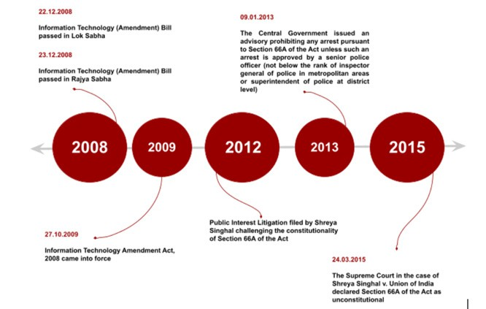

UNIT V

UNIT IV

**UNIT III**

UNIT II

UNIT I

## What was Section 66 A IT Act, 2000?

Section 66 A of the IT ACT, 2000 made it a punishable offence for any person to send ‘grossly offensive’ or ‘menacing information’ using a computer resource or communication device.

Section 66A was inserted by way of an amendment in the year 2009. The reason behind the amendment was to address new forms of cyber crimes such as publishing sexually explicit materials in electronic form, video voyeurism and breach of confidentiality and leakage of data by intermediary, e-commerce frauds like personation commonly known as Phishing, identity theft and offensive messages through communication services. Therefore, the said Section 66 A IT Act, 2000 imposed punishment and criminalised the sending of offensive messages through a computer or other communication devices. However, the act used wide terms in this Section which were not defined under the Act and hence caused a lot of confusion as the perception of an individual in defining “grossly offensive” and “menacing information” varies from one individual to another.

In the year 2012, in the matter of Shreya Singhal v. Union of India, a batch of writ petitions were filed under Article 32 of the Constitution of India raising an important question relating primarily to the fundamental right of free speech and expression guaranteed by Article 19 of the Constitution of India. The immediate cause for concern in these petitions was Section 66A of the Information Technology Act of 2000. The petitioners argued that wordings of the section were too wide and ambiguous leading to misuse. Most of the terms used in the section had not been specifically defined under the Act. Further, the petitioners argued that the section restricted the right to free speech and expression prescribed under Article 19(1)(a) of the Constitution of India.

#### What did the Supreme Court decide?

On March 24, 2015, the Hon’ble Supreme Court struck down Section 66 A of the IT Act, 2000 and declared it unconstitutional for “being violative of Article 19(1)(a) of the Constitution of India.

UNIT V

UNIT IV

**UNIT III**

UNIT II

UNIT I

**Interesting Fact :** Phishing- The fraudulent practice of sending emails purporting to be from reputable companies in order to induce individuals to reveal personal information, such as passwords and credit card numbers. (Source: Oxford Dictionary)

## Exercises

Based on your understanding, answer the following questions:

* 1. Answer the following questions briefly-
     1. Explain the importance of cyber laws in current times.
     2. What are the various categories of cyber crime? Give examples.
     3. What is cyber bullying? How does it take place? Q-2 Answer the following questions in about 150 words-

1. Trace the evolution of cyber laws in India.
2. Critically analyse the importance of Section 66A of the Information Technology Act, 2000.

## Activities

* 1. Divide the class into four groups and initiate a discussion on ‘Legal problems that arise by use of Cyberspace’.
  2. Students can enact a street play making their peers aware of Cyber crime and safety. Q-3 Debate on the topic ‘Cyberspace- A Boon or a bane’.

UNIT V

UNIT IV

**UNIT III**

UNIT II

UNIT I





Unit 4

# JUDICIARY : CONSTITUTIONAL, CIVIL AND CRIMINAL COURTS AND PROCESSES

UNIT V

**UNIT IV**

UNIT III

UNIT II

UNIT I



UNIT V

**UNIT IV**

UNIT III

UNIT II

UNIT I



CHAPTER

1

**Judiciary: Constitutional, Civil and**

**Criminal Courts and Processes**

## Contents

1. Introduction
2. Judiciary: it’s Constitution, Roles and Impartiality
   1. Independence and Impartiality of the Supreme Court
   2. Structure and Hierarchy of the Courts in India
   3. The Civil Process and functioning of Civil Courts
3. The Civil Court Structure
   1. Common Legal Terminologies
   2. Types of Jurisdiction
   3. Res subjudice and Res judicata in Code of Civil Procedure, 1908
4. Structure and Functioning of Criminal Courts in India
   1. Types of Offences
   2. Criminal Investigations and First Information Report (FIR)
   3. Criminal Process - Investigation and Prosecution
   4. Doctrine of autrefois acquit and auterfois convict (i.e. previously acquitted or previously convicted)
   5. Function and Role of Police
5. Other Courts In India
   1. Family Courts
   2. Administrative Tribunals
6. Exercises

## Learning Outcomes

After the completion of this chapter, the students will be able to:

* State reasons for independence and impartiality of judiciary
* Draw a flow chart of hierarchy of courts in India
* Explain legislations governing courts in India
* Distinguish between Civil and Criminal Cases
* Explain the process of criminal investigation, inquiry and trial

UNIT V

**UNIT IV**

UNIT III

UNIT II

UNIT I

* Distinguish between Cognizable and Non Cognizable offences, Bailable and Non Bailable offences
* Describe the role of police
* Examine the importance of FIR in Criminal Investigation
* Analyse the judicial structure envisaged in the Constitution of India

## Introduction

The aim of this chapter is, in the first place, to understand the salient features of Indian judiciary, its constitution, its roles and its independence. The introduction to this topic is meant to spur thoughts about court structure and their functions. The Indian legal system derives its authority from the Constitution of India and is deeply embedded in the Indian political system. The presence of judiciary substantiates the theory of separation of powers wherein the other two organs, viz., legislature and executive stand relatively apart from it.

Parliamentary democracy as envisaged in the Constitution of India works at Union and State level. Especially in making of law, there is direct participation of the legislature and the executive. It is the judiciary that safeguards the interest of citizens by not allowing the other organs to go beyond their role assigned in the Constitution.

In brief, the Supreme Court of India is the logical and primary custodian of the Constitution of India, while also being its interpreter and guardian. Parliament enjoys the authority to amend the Constitution and the Supreme Court has the authority to examine the validity of constitutional amendments. The Supreme Court ensures that the other branches of government perform their responsibilities in accordance with the Constitution.

Judiciary is the final authority in interpreting legal issues and constitutional arrangements. The nature of democracy and development of the state depends upon how the legal system conducts itself to sustain the overall socio-economic and political environment.

#### Establishment of Supreme Court and High Courts

After India attained independence in 1947, the Constitution of India came into being on 26 January, 1950. The transition from the Federal Court to the Supreme Court of India (SCI) was seamless. Justice Kania became the first Chief Justice of India. It is often said that the Supreme Court of India exercises jurisdiction far greater than that of any comparable court in the world.

The original Constitution of India envisaged a Supreme Court with a Chief Justice and seven puisne judges, while empowering the Parliament to increase the number of judges. Subsequently, the Parliament has the power to increase the number of judges of Supreme Court. Judges generally sit in smaller benches of twos or threes and form larger benches of five or more only when required to do so, or to settle a difference of opinion or controversy.

The Supreme Court has a threefold jurisdiction. As a **federal court**, it has exclusive original jurisdiction in any dispute arising between the Government of India and one or more states, between the Government of India and any state or states on one side and one or more states on the other or between two or more states.

As an **appellate court**, the Supreme Court of India can hear appeals from the State High Courts on civil, criminal and constitutional matters.

The Supreme Court has also a very wide appellate jurisdiction in as much as it has the discretion

to grant special leave to appeal under Article 136 of the Constitution from any judgment, decree, determination, sentence or order in any cause or matter passed or made by any court or tribunal in the territory of India. In addition, the Supreme Court hears a number of statutory appeals provided under separate legislations.

UNIT V

**UNIT IV**

UNIT III

UNIT II

UNIT I

The Supreme Court has **special advisory jurisdiction** in matters, which may specifically be referred to it by the President of India under Article 143 of the Constitution.

Furthermore, the Supreme Court has a **concurrent original jurisdiction** along with the High Courts, for the enforcement of fundamental rights under Article 32 of the Constitution of India. The jurisdiction of the Supreme Court of India can be enlarged by the Parliament.

The Supreme Court may also pass any decree or order as may be necessary for doing complete justice. According to Article 141 of the Constitution of India, the law declared by the Supreme Court shall be binding on all courts within the territory of India.

More importantly, the Supreme Court of India exercises **judicial review** - the power to strike down or declare unconstitutional, both legislative and executive actions, which are contrary to the provisions of the Constitution of India, or violative of the fundamental rights guaranteed by the Constitution, and also on the distribution of powers between the Union and the States.

The President appoints the Judges after consultation with the Judges of Supreme Court and High Courts of States. Article 124 (4) confers on the President power to remove the Judges if a motion is passed by a special majority of each House of Parliament, on the basis of proved misbehavior or incapacity to discharge one’s duties.

The Supreme Court of India has the special responsibility to render justice (social, economic and political) and to enforce equality, liberty, dignity and the ideals of democracy, socialism, secularism and such other values enshrined in the Constitution of India. Professor K.T.Shah, a member of the Constituent Assembly observed as follows: “the judiciary is the only authority that we are going to set up in the Constitution to give effect to whatever hopes and aspirations, ambitions and desires, we may have, in making these laws and in laying down this Constitution. Even constitutional and legislative amendments are not immune from judicial challenges”.

In the historic Fundamental Rights case (Kesavananda Bharti case, 1973), the Supreme Court of India held that the power to amend the Constitution was subject to the limitation that the ‘basic structure’ of the Constitution cannot be taken away. This decision means that the sovereign’s power to change or alter the Constitution of India is subject to limitations.

After the President’s Rule case (1994), the ‘basic structure’ doctrine was not just limited to challenges to constitutional validity, but was also extended to interpret the validity of exercise of power by the legislature and the executive.

The High Courts in various states are the apex judicial bodies of the States. There are currently 25 High Courts in India. The bulk of the work of the High Courts consists of appeals from lower courts and writ petitions under Article 226 and 227 of the Constitution of India. Apart from writ petitions, any civil or criminal case which does not fall within the purview or ambit of the subordinate courts of that State, due to lack of pecuniary or territorial jurisdiction, can be heard by the High Court of that State. Also certain other matters or issues may be heard by the High Court as part of its original jurisdiction, if the law laid down by the legislature provides to that effect.

## Judiciary: It’s Constitution, Roles and Impartiality

The Judiciary, in India, today is an extension of the British Legal System. The Supreme Court is the apex body, followed by 25 High Courts, which in turn supervise and govern numerous District Courts.

Article 129 of the Constitution of India makes the Supreme Court a ‘court of record’ and confers all the powers of such a court including the power to punish for its contempt as well as of its subordinate courts.

Article 141 of the Constitution of India provides that the law declared by Supreme Court is binding on all courts.

Judiciary in India plays an important role of interpreting and applying the law and adjudicating upon controversies between the citizens, the states and various other parties. It is the function of the courts to uphold the rule of law in the country and to safeguard civil and political rights. As India has a written constitution, courts have an additional function of safeguarding the supremacy of the Constitution by interpreting and applying its provisions and limiting the functioning of all authorities within the constitutional framework.

In a federation [i.e. union of states], the judiciary has another meaningful assignment (legally known as Original Jurisdiction of the Supreme Court of India envisaged in the Constitution of India), namely to decide controversies between the constituent states inter se as well as between the Union and the States.

A federal government is a legislative government, a characteristic feature of which is the allocation of power between the Centre and the States. Disputes usually arise between the governments relating to distribution of power and function between them. An arbiter is therefore, required to examine laws to see whether they fall within the allotted legislative domain of the enacting legislature and this function is usually left to the judiciary.

In this connection, the Supreme Court of India often invoked the following principles of interpretation of law viz., doctrine of pith and substance, doctrine of severability and doctrine of colourable legislation etc.

**Doctrine of pith and substance** i.e., the true object of the legislation or a statute, relates to a matter with the competence of the legislature which enacted it. In order to ascertain the true character of the legislation one must have regard to the enactment as a whole, to its object and to the scope and effect of its provisions.

**Doctrine of severability** separates repugnant provisions of a statute or law from others that are constitutional. The violating part of any provision of a statute is declared unconstitutional and void to the extent of such inconsistency, but the remainder remains enforceable and valid.

**Doctrine of colourable legislation** prevents legislatures to make laws that they would otherwise not be able to create given the constitutional constraints. The whole doctrine of colourable legislation is based upon the maxim that *you cannot do indirectly what you cannot do directly*.

## Case Laws

Facts

###### State of Maharashtra v. FN Balsara

*State of Maharashtra passed a law putting a cap on the maximum amount of liquor (both domestic and imported) that could be held by any dealer/wholesaler.*

UNIT V

**UNIT IV**

UNIT III

UNIT II

UNIT I

*The petitioner, FN Balsara was aggrieved by this law and challenged it in the SC as the law was putting a cap on quantity of imported liquor which was a topic in union list and hence state government was incompetent to make such a law.*

*State government took the stand that the purpose of law was to regulate consumption of liquor in the state and not regulation of import and export. Cap was on both domestic and foreign liquor.*

Issue

UNIT V

**UNIT IV**

UNIT III

UNIT II

UNIT I

*Was the law made by state government valid or violative of Art 246?*

Decision

The supreme court held that when judging the validity of any law, the Act should be read as a whole to get its essence. The essence of the law in this case is not regulation of import and export but regulation of liquor consumption in the state, which is a topic in the state list and hence the law is valid.

###### Balaji v. State of Mysore

* Mysore *government* introduced reservations to the extent of 51% under article 16 of the constitution.
* This was challenged in the SC as being violative of Article 14.
* The government took defense that it did not make reservations under Art 14 but made them only

under Art 16.

Decision

* SC held that a law made should be legal under all provisions. By resorting to one provision only, the government cannot ignore another provision by applying the doctrine of colorable legislation.
* By applying doctrine of severability, the court upheld 49% of reservations but struck down as

invalid 2% of the excess reservation.

While the power of the Parliament to legislate is supreme, at the same time the Judiciary has been made the watchdog of Indian democracy. The role of the judiciary has been ever changing and has evolved based on the constitution of India and the socio-economic needs of the country.

The phrase **‘basic structure’** was introduced for the first time in the Golaknath case (Golaknath v. State of Punjab, AIR 1967 SC 1643), but it was only in 1973 that this phrase was used by the Supreme Court and it means and includes those features of the Constitution which lay at its core requiring much more than the usual procedures to change them. It was held in the historic Kesvananda Bharati case that any amendment which aims at abrogating the basic structure of the Constitution would be unconstitutional. Hence, every proposed amendment is subject to judicial scrutiny if it is aimed at abrogating the basic structure of the Constitution.

Constituent elements of the basic structure include the supremacy of the Constitution, republican and democratic form of government, secular character of the Constitution, separation of powers between the legislature, executive and the judiciary and primarily the federal character of the Constitution.

In addition, the Judiciary also has the power of judicial review. It implies that every piece of legislation passed by the Parliament is subject to judicial scrutiny by the Supreme Court of India. No specific provisions exist for this arrangement, however the power and extent of judicial review has been clarified through judicial pronouncements.

The Supreme Court of India, thus, has the power to strike down any piece of legislation aimed at amending the Constitution of India on two grounds.

* Firstly, if the procedure prescribed under Article 368 is not followed; and
* Secondly, if the amending Act seeks to violate one or more basic features of the Constitution.

In India, in addition to the above, the Judiciary also has the significant function of protecting and enforcing the fundamental rights of the people guaranteed to them by the Constitution. The Supreme Court keeps a watch on the functions of the other limbs of the state as to whether they are working in accordance with the Constitution and other laws made by the Parliament and the State legislatures.

UNIT V

**UNIT IV**

UNIT III

UNIT II

UNIT I

**Supreme Court and Judicial Review**

The Supreme Court has concurrent jurisdiction with the High Courts to issue directions, orders and writs for enforcement of fundamental rights (Article 32 of Constitution of India). These are in the nature of the writs of Habeas Corpus, Mandamus, Prohibition, Certiorari and Quo Warranto. These writs make the Supreme Court a protector and guarantor of fundamental rights. The idea is that in case of violation of a law or right, the Court may issue directions for compliance with the Constitution. Thus, the citizens of India are secure as far as fundamental rights are concerned. The Supreme Court has the power to declare a law passed by the legislature null and void if it encroaches upon the fundamental rights. It has exercised this power on several occasions. This shows how the Supreme Court has always served as the guardian of fundamental rights.

Further, the Supreme Court has also assumed additional duties under a concept called **‘Public Interest Litigation’ (PIL)**, under which any citizen can bring any matter of general importance to the general public for consideration of the Supreme Court. If the Supreme Court finds that the executive has been failing in due discharge of its duties, it passes the required directions to the concerned authorities in government.

## Appellate Jurisdiction of the Supreme Court

Appeal in Constitutional Matters: Under Article 132 (1) of the Constitution of India, an appeal shall lie to the Supreme Court from any judgment, decree or final order of a High Court whether in civil, criminal or other proceedings, if the High Court certifies under Article 134-A that the case involves a substantial question of law as to the interpretation of this Constitution.

Appeal in Civil cases: Article 133 provides that an appeal shall lie to the Supreme Court from any judgment, decree or final order in a civil proceeding of a High Court only if High Court certifies under Article 134-A - (a) that the case involves a substantial question of law of general importance; and (b) that in the opinion of the High Court the said question needs to be decided by the Supreme Court.

Appeal in Criminal Cases: Article 134 provides that an appeal shall lie to the Supreme Court from any judgment, final order or sentence in a criminal proceeding of a High Court.

This appeal can be in two ways: without a certificate of High Court and with a certificate of the High Court.

An appeal lies without the certificate if the High Court:

1. has on appeal reversed an order of acquittal of an accused person and sentenced him to death.
2. has withdrawn for trial before itself any case from any court subordinate to its authority and has in such trial convicted the accused person and sentenced him to death.

## Advisory Jurisdiction of the Supreme Court

The Supreme Court of India also has advisory jurisdiction. Article 143 reads if at any time it appears to the President that - (a) a question of law or fact has arisen or is likely to arise and (b) the question is of such a nature and of such public importance that it is expedient to obtain the opinion of the

Supreme Court upon it, s/he may refer the question for the advisory opinion of the Court and the Court may after such hearing as it thinks fit, report to the President its opinion thereon.

UNIT V

**UNIT IV**

UNIT III

UNIT II

UNIT I

In re Kerala Education Bill case (1958), the Supreme Court laid down the following principles:(a)The Supreme Court has under clause (1) a discretion in the matter and in proper case and for good reason to refuse to express any opinion on the question submitted to it; (b) It is for the President to decide what question should be referred to the Court and if he does not entertain any serious doubt on the other provisions it is not for any party to say that doubts arise also out of them; (c) The advisory opinion of the Supreme Court is not binding on courts because it not a law within meaning of Article 141.

But In re Special Court Bill case (1979), the Supreme Court held that its advisory jurisdiction are binding on all courts in the territory of India. It also held that the Supreme Court is under duty under Article 143 to give its advisory opinion if question referred to it are not vague and of a political nature.

#### Independence and Impartiality of the Supreme Court

‘Independence’ and ‘impartiality’ are most crucial concepts for any court. The two concepts are separate and distinct. ‘Impartiality’ refers to a state of mind and attitude of the court or tribunal in relation to the issues and the parties in a particular case, while ‘independence’ refers not only to the state of mind or attitude, but also to a status or relationship to others particularly to the executive branch of Government that rests on objective conditions or guarantees.

**Review of its own Judgements**

If the Supreme Court discovers that there are some new facts or evidences or if it is satisfied that some mistake or error took place in its previous decision, it has the power to review the case and alter its previous decisions. This is generally done when a review petition is filed. Normally, review is done by the same bench that originally decided the case. In a review petition, an error of substantial nature only can be reviewed.

We now refer to some of the factors that contribute to ‘judicial impartiality and independence’ and thus help to ensure a ‘pure and efficient administration of justice between the individual and the State as well as between the two individuals’.

Though, the limits of judicial review and independence of Judiciary were the main issues addressed by the Constituent Assembly, other subsidiary questions were also raised during the debates. Some of the ancillary issues addressed included whether the jurisdiction of the Supreme Court, for example, be confined to ‘federal’ issues? Or should it have original and appellate jurisdiction in a wide variety of civil and criminal matters? Another question was whether India should have a dual system of courts, state and federal,as in the United States?

As discussed earlier, India is a parliamentary democracy having a federal constitution system. The Constitution of India has not provided for a dual system of courts. There is a single integrated system of courts for the Union as well as the States which administer both Union and State laws. Dr. B R Ambedkar, the architect of the Constitution of India was perhaps the greatest proponent in the Constituent Assembly for establishing **‘one single integrated judiciary’** capable of providing remedies in civil, criminal and constitutional law matters.

Thus, India has a unified judicial system with the Supreme Court at the apex. There are High Courts below the Supreme Court and under each High Court there exists a system of subordinate courts. The Supreme Court is the supreme interpreter of the Constitution and the guardian of various fundamental rights guaranteed by the Constitution. The Supreme Court also helps in maintaining uniformity of laws throughout the country.

The Constitution of India has ensured independence of judiciary through a number of provisions. These include: (1) subscribing to an oath or affirmation; (2) providing security of tenure for judges by ensuring that judges cannot be removed except through a special impeachment procedure;

(3) retirement at the age of 65 years for judges of Supreme Court and 62 for judges of High Court, which is significantly higher than the retirement age in other public services; (4) protection of privileges, allowances, perks and emoluments by charging them to the Consolidated Fund of India; (5) the power to punish for their contempt; (6) not being subject to discussion on the floor of a legislature for their conduct in judicial matters, etc.

UNIT V

**UNIT IV**

UNIT III

UNIT II

UNIT I

###### Appointment of Judges of Supreme Court

The Constitutional provisions regarding the appointment of a judge is that only those persons can be appointed as a judge of the Supreme Court, who are citizens of India, and has been judge of a High Court or of two or more courts in succession at least for five years; or (b) has been an advocate of a High Court or of two or more such courts in succession at least for ten years; or

(c) is a distinguished jurist, in the opinion of the President. However, most of the appointments to the Supreme Court have been made from sitting judges or Chief Justices of High Courts.

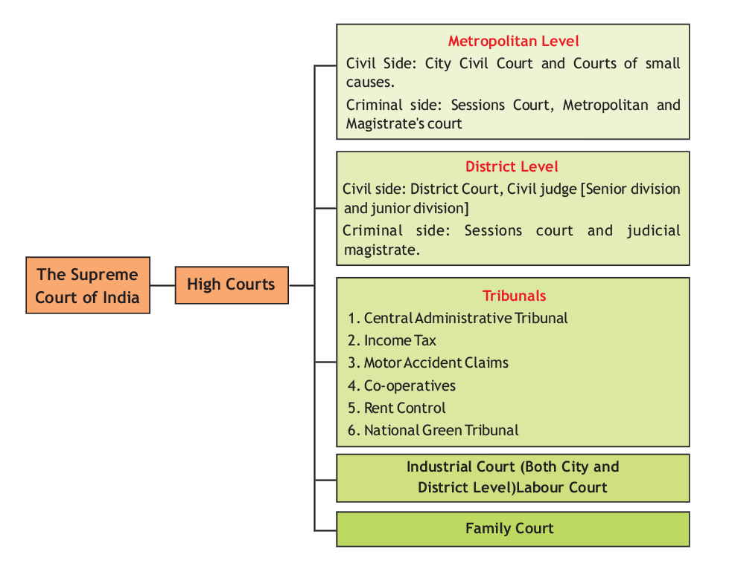

As Dr. Ambedkar said in the Constituent Assembly, it was the intention of the framers to create a judiciary and to give it ample independence so that it could act without fear or favour of the executive or anybody else. The judiciary through its collegium of judges enjoys considerable powers in the appointment of judges to the higher constitutional courts.

It has also been reported that the Government of India has initiated various measures to introduce reforms in the judiciary. It has proposed to enact a new law, ‘The Judges Standards and Accountability Act’, which seeks to introduce greater accountability in judiciary.

#### Structure and Hierarchy of Courts in India

Below the Supreme Court and High Courts, there are subordinate courts such as civil courts, family courts, criminal courts and various other district courts which are involved in the administration of justice.

##### HIERARCHY OF INDIAN LEGAL SYSTEM

The High Court stands at the head of the Judiciary in a State. It enjoys civil as well as criminal, ordinary as well as extraordinary and general as well as special jurisdiction. The institution of the High Court is fairly old as it dates back to 1862 when under the Indian High Court Act, 1861, High Courts were established at Calcutta, Bombay and Madras. In course of time, other High Courts have also been established.

UNIT V

**UNIT IV**

UNIT III

UNIT II

UNIT I

The High Courts enjoy Original Jurisdiction in respect of testamentary, matrimonial and guardianship matters. Original Jurisdiction is conferred on the High Courts under various statutes. The High Courts also enjoy extraordinary jurisdiction under Article 226 to issue various writs. Each High Court has supervisory power over subordinate courts under it. Each High Court, being a court of record enjoys the power to punish for its contempt as well as of its subordinate courts.

**CONSTITUTION OF INDIA: HIGH COURTS**

Article 214: High Courts for States.-There shall be a High Court for each State. Article 215: High Courts to be courts of record.

Every High Court shall be a court of record and shall have all the powers of such a court including the power to punish for contempt of itself.

There is a High Court for each of the States, except Mizoram, Arunachal Pradesh and Nagaland which have the High Court of Assam at Guwahati as their common High Court; and Haryana, which has a common High Court (at Chandigarh) with Punjab; and Goa which is under Bombay High Court.

The Supreme Court has appellate jurisdiction over the High Courts and is the highest court of the land.

###### Subordinate Courts in India

The subordinate courts, at the level of districts and lower levels, have almost similar structure all over the country with slight variation. They deal with civil and criminal cases in accordance with their respective jurisdictions. At the lowest stage, the two branches of judicial system, civil and criminal, are bifurcated.

The Munsiff’s Courts are the lowest civil courts. Above the Munsiffs are Subordinate Judges. The District Judge hears first appeals from the decisions of Subordinate Judges and also from the Munsiffs (unless they are transferred to a Subordinate Judge) and he possesses unlimited original jurisdiction, both civil and criminal.

The District and Sessions Judge is the highest judicial authority (civil and criminal) in the district since the enactment of the Code of Criminal Procedure, 1973 (CrPC). The criminal trials are conducted exclusively by Judicial Magistrates. The Chief Judicial Magistrate is the head of the criminal courts in a district. In metropolitan areas, there are Metropolitan Magistrates.

Appeals can be made from the District Court to the High Court.

###### Appointment of Subordinate Court Judges

The subordinate judiciary in each district is headed by a District and Sessions Judge.

The usual designations on the civil side are District Judge, Additional District Judge, and Civil Judge.

On the criminal side, the widely known designations are Sessions Judge, Additional Sessions

Judge, Chief Judicial Magistrate, Judicial Magistrate etc.

UNIT V

**UNIT IV**

UNIT III

UNIT II

UNIT I

The Governor in consultation with the High Court of that particular State appoints the district judges. A person who is not already in Government Service should have at least seven years experience at the bar to become eligible for the position of a District Judge (Article 233).

Appointment of persons other than District Judges to the judicial service of a State shall be made by the Governor in accordance with rules made there under. Besides the State Public Service Commission, the High Court has to be consulted in the matter of such appointments (Article 234).

###### The Civil Process and functioning of Civil Courts

The Code of Civil Procedure 1908 (CPC) is a procedural law; it neither creates nor takes away any right. It is intended to regulate the procedure to be followed by civil courts. In other words, the CPC regulates the functioning of civil courts. Civil case is such that it is not criminal in nature. It is generally on property, business, personal domestic problems, divorces and such types where ones constitutional and personal rights are breached.

In brief, CPC lays down the procedure of filing a civil case; Powers of court to pass various orders; Court fees and stamps involved in filing of a case; Rights of the parties to a case (plaintiff & defendant); Jurisdiction and parameters of civil courts functioning; Specific rules for proceedings of a case; Right of Appeals, review or reference.

In fact, the first uniform Code of Civil Procedure was enacted in 1859. The present Code of Civil Procedure was enacted in 1908. The object of the Code is to consolidate and amend the laws relating to procedure of Civil Judicature. CPC is designed to further the ends of justice and is not a penal enactment for punishments and penalties.

The CPC can be divided into two parts:

* + 1. the main body of the CPC containing 158 sections; and
    2. the First Schedule, containing 51 Orders and Rules.

The Sections deal with matters of a substantive nature laying down the general principles of jurisdiction, while the First Schedule relates to the procedure and the method, manner and mode in which the jurisdiction may be exercised.

The body of the CPC containing sections is fundamental and cannot be amended except by the legislature.

The First Schedule of the CPC, containing Orders and Rules, on the other hand, can be amended by High Courts. The CPC has no retrospective operation.

## The Civil Court Structure

Disputes relating to property, breach of contracts, wrongs committed in money transactions, minor omissions etc. are categorized as civil wrongs and are subject to a civil process. In such cases civil suits should be instituted by the aggrieved persons. Courts of law administer justice by considering the nature of the wrong done. Civil wrongs are redressed before civil courts by granting injunctions or by payment of damages or compensation to the aggrieved party.

#### Common Legal Terminologies

UNIT V

**UNIT IV**

UNIT III

UNIT II

UNIT I

Some Common terminologies :



* + Plaintiff- person who files the civil case against another
  + Defendant- person against whom the case has been filed
  + Plaint- document filed by the plaintiff containing his version of the case
  + Written statement- reply to the plaint, filed by the defendant
  + Appellant- one who files the appeal
  + Respondent- other party against whom appeal has been filed
  + Prosecution- (criminal)victim’s side. They file the case
  + Defence- from the side of accused
  + Application- document seeking an urgent instant relief. It can be filed by the plaintiff or the defendant. It can be filed with the plaint/ written statement or even in between the proceedings. An application is always filed under a plaint(after a case has been filed). The person who files an application is known as an applicant and person against whom application is filed is known as respondent.
  + Interim- in between the proceedings
  + Arrested and Accused Person- When a person is arrested by the police during investigation merely on the basis of suspicion that he/she has committed an offence, the person is known as an arrested person. Arrest of a person does not necessarily amount to conviction.

When concrete evidence is gathered against an arrested person and a trial is initiated against the person, the person becomes an accused.

#### Types of Jurisdiction

Jurisdiction means the extent of power of a court to entertain suits and applications.

###### Types of jurisdiction

1. Territorial jurisdiction- The physical area or local limits within which a court exercises its jurisdiction is known as territorial jurisdiction.
2. Pecuniary jurisdiction- Jurisdiction defined on the basis of money claims that can be heard by a Court.
3. Original jurisdiction- The power of a Court to hear and try a case for the first time is known as original jurisdiction.
4. Appellate jurisdiction- The power of the Court to hear appeals from decisions of a lower court is known as appellate jurisdiction.
5. Jurisdiction as to subject matter- This is defined on the basis of types of cases that can be heard by a Court. Eg- Family law, Criminal law, etc

#### Res sub judice and Res judicata in Code of Civil Procedure, 1908

* + Res sub judice- Sec 10, Code of Civil Procedure, 1908- It implies that where the same

subject matter is pending in a Court of law for adjudication between the same parties, any

other Court is barred from entertaining that case as long as the first suit is going on.

UNIT V

**UNIT IV**

UNIT III

UNIT II

UNIT I

* + - Res judicata- Sec 11, Code of Civil Procedure, 1908- It literally means a thing which has been decided. This doctrine operates as a bar to the trial of a subsequent suit on the same cause of action between the same parties.
    - It is based on the principle of finality of litigation and conclusiveness of a decision.
    - It is founded on the principle of justice, equity and good conscience.

Eg- X sues Y for breach of contract. The suit gets dismissed. X now files a suit for damages for breach of contract. The suit for damages is barred as it is res judicata.

Eg- X files a case for negligence in service against Y, his employee. Whilst this suit is pending, he also files another suit for claiming accounts from his employee. The subsequent suit is stayed as the matter is Res sub-judice.

* + - Once the first suit is determined the matters raised in the subsequent suit would be res

judicata by reason of the decision in prior suit. Difference between res judicata and Res Sub-Judice

* + - Res judicata refers to matters already decided where as res sub judice applies to matters

pending in a Court of law.

## Structure And Functioning of Criminal Courts in India

Administration of criminal justice is carried out through Magistrate Courts and Sessions Courts.

The Indian Penal Code, 1860 (IPC), together with other penal laws’ constitutes India’s substantive criminal law. The IPC draws inspiration from the English criminal law and has stood the test of time. However, it cannot be self-operative.

As a sequel to the IPC, a Code of Criminal Procedure, 1861 was enacted. The 1861 Code was repealed after which a new Code of Criminal Procedure, 1973 (CrPC) was enacted to carry out the process of the administration and enforcement of the substantive criminal law. The CrPC also controls and regulates the working of the machinery set- up for the investigation and trial of the offences.

In addition to the CrPC, the Indian Evidence Act of 1872 was enacted to guide the process of investigation and trial.

**Categories of Criminal Courts in India**

**Courts of Session**

As per Section 9 of CrPC, the court is established by the State Government for every sessions division. The court is presided over by a Judge, appointed by the High Court of that particular state. The High Court may also appoint Additional Sessions Judges and Assistant Sessions Judges in this court. It has the power to impose any sentence including capital punishment.

**Chief Judicial Magistrate and Additional Chief Judicial Magistrate, etc.**

In every district (not being a metropolitan area), the High Court shall appoint a Judicial Magistrate of the First Class to be the Chief Judicial Magistrate. A Chief Judicial Magistrate may impose a sentence except (a) sentence of death, (b) imprisonment of life, or (c) imprisonment for a term exceeding seven years. A Chief Judicial Magistrate shall be subordinate to the Sessions Judge; and every other Judicial Magistrate shall, subject to the general control of the Sessions Judge, be

subordinate to the Chief Judicial Magistrate.

UNIT V

**UNIT IV**

UNIT III

UNIT II

UNIT I

**Courts of Judicial Magistrates**



Section 11 of CrPC states that in every district (not being a metropolitan area), there shall be established as many Courts of Judicial Magistrates of the first class and of the second class and at such places, as the State Government may after consultation with the High Court, by notification specify. Courts of Judicial Magistrate of First Class are at the second lowest level of the Criminal Court structure in India. According to Section 15 of the CrPC, a Judicial Magistrate is under the general control of the Sessions Judge and is subordinate to the Chief Judicial Magistrate. In terms of Section 29 of the CrPC, a Judicial Magistrate of First Class may pass a sentence of imprisonment for a term not exceeding three years, or of fine not exceeding 10 thousand rupees or of both.

The Court at the lowest level is called Judicial Magistrate of the Second Class. This Court is competent to try the case if the offence is punishable with imprisonment for a term not exceeding one year, or with fine not exceeding five thousand rupees, or with both. The First Class Magistrate is competent to try offences punishable with imprisonment for a term not exceeding three years or with fine up to ten thousand rupees. In States such as Kerala, the Second and the First Class Magistrate Courts have been unified. The Chief Judicial Magistrate can impose any fine and impose punishment up to seven years of imprisonment. The Assistant Sessions Judge is competent to impose punishments up to ten years imprisonment and impose any fine. The Sessions Judge can impose any punishment authorized by law, but the sentence of death passed by him should be subject to the confirmation by the High Court. (See for details Sections 28 and 29 of CrPC).

**Metropolitan Magistrates**

The Courts of Metropolitan Magistrates were created by Section 16 of the Code of Criminal Procedure. The Court of Chief Metropolitan Magistrate and those of The Additional Chief Metropolitan Magistrates were created by Section 17 of the Code. Section 18 of the Code also provided for Special Metropolitan Magistrates. The towns having population exceeding one million could be declared as Metropolitan Areas. Metropolitan magistrate is under the general control of the Sessions Judge and is subordinate to the Chief Metropolitan Magistrate.

**Executive Magistrates**

In every district and in every metropolitan area, the State Government may appoint as many persons as it thinks fit to be Executive Magistrates and shall appoint one of them to be the District Magistrate.

Belonging to the executive organs, these officers work in tandem with the police to maintain law and order in the city. They are also responsible for some judicial acts like traffic challans, registration of documents (like sale deed, wills, marriage certificates, birth and death certificates). They are known as District Magistrates (DM), Sub Divisional Magistrate (SDM), executive magistrate, special executive magistrates.

#### Types of Offences

###### Bailable and Non-bailable Offences

There is no definition of the term ‘bail’ under the CrPC although the terms ‘bailable’ and ‘non- bailable’ have been defined. The object of detention of an accused is primarily to secure his/her physical appearance at the time of trial and at the time of sentence if found guilty. However, the grant of bail has been a matter of judicial discretion. The Supreme Court of India held that bail covers both release on one’s own bond, with or without sureties.

CrPC has classified all offences into ‘bailable’ and ‘non-bailable’ offences. The first schedule read with Section 2(a) of the CrPC, it can be generally stated that all serious offences, i.e., offences punishable with imprisonment for three years or more have been considered as **non-bailable offences**. This general rule can be suitably modified according to specific needs.

UNIT V

**UNIT IV**

UNIT III

UNIT II

UNIT I

If a person accused of a bailable offence is arrested or detained without warrant he/she has a right to be released on bail (Section 436 of Cr P.C). But if the offence is non-bailable that does not mean that the person accused of such offence shall not be released on bail. In such a case bail is not a matter of right, but only a privilege to be granted at the discretion of the court.

The power to cancel bail has been given to the court and not to a police officer. The court which granted the bail can alone cancel it.

**Anticipatory Bail**

Section 438 of the CrPC enables the superior courts to grant anticipatory bail. An anticipatory bail can be applied for when the person has reason to believe that he/ she may be arrested. An application for anticipatory bail can be made to the Sessions Court, the High Court or even the Supreme Court. However, normally it is to be presumed that the Court of Sessions would be first approached for grant of anticipatory bail. The court may consider the following aspects when considering an application for anticipatory bail: (i) the nature and gravity of accusation; (ii) the antecedents of the applicant; (iii) the possibility that the accused may flee from justice; and (iv) the accusation appears to be aimed at humiliating the applicant.

**Cognizable and Non-cognizable Offences**

The CrPC has not given any test or criterion to determine cognizable or non-cognizable offences. The First Schedule of CrPC, however, indicates that all offences punishable with imprisonment for not less than three years are taken as serious offences and are treated as cognizable. Offences such as murder, robbery, dacoity, rape and kidnapping are cognizable offences. Offence of bigamy is punishable with more than five years imprisonment, yet they have been included in the category of non- cognizable offences.

The classification of offences as ‘cognizable’ and ‘non-cognizable’ is apparently and essentially intended to indicate as to whether the arrest in respect of an offence can be made with or without a warrant [Section 2 (c) and (l)]. The classification presupposes the need of immediate action in respect of every cognizable offence. However, in the case of non-cognizable offences, warrant is required for the arrest of the accused.

**Compoundable and Non-compoundable offences**

In certain offences, the State which conducts the prosecution and the accused can come to an arrangement where, instead of being imprisoned, the accused can pay a fine. These are compoundable offences. The most common example of this is where you get caught without a ticket on a bus or a train and have to pay a fine. In this case, the officer fining you is in fact compounding your offence. Of course not all offences are compoundable; it would not be desirable that murderers should be able to compound their offences.

#### Criminal Investigation and First Information Report (FIR)

FIR is the abbreviated form of First Information Report. It is the information recorded by the police officer on duty, given either by the aggrieved person or any other person, about the commission of cognizable offence. The statement of the informant as recorded under Section 154 will be treated as the FIR. The main object of the FIR from point of view of the informant is to set the criminal law in motion (Hasib v. State of Bihar, AIR 1972 SC 283). The police cannot

refuse to register the complaint. The power of police to lodge an FIR cannot be usurped by the Magistrate. If any person is aggrieved by a refusal on the part of the Police officer in charge of police station to record the information, he may send by post the substance of such information in writing to the Superintendent of Police concerned [Section 154(3)].

UNIT V

**UNIT IV**

UNIT III

UNIT II

UNIT I

FIR can be filed in the police station of the concerned area in whose jurisdiction the offence has occurred. FIR can be registered either on written or verbal statement of complainant which is later reduced in writing by police officer and is signed by the complainant. It must be made to the officer-in-charge of the police station and if he is not available, the Assistant Sub-Inspector is competent to enter the same upon the investigation. On the basis of the FIR, the police starts its investigation.

Section 154 of the CrPC provides for the manner in which such information is to be recorded. The Following could be drawn from Section 154 (1) of the CrPC:

**Some Important Facts about FIR**



1. Information of cognizable offence can be given by any person to police having jurisdiction in the area where the commission of crime took place.
2. FIR is not substantive piece of evidence. It has to be duly proved as any other fact by evidence and can be used as relevant fact in order to prove the substantive issue.
3. Police officer shall reduce such information in writing.
4. Informant’s signature must be obtained.
5. Contents of such information should be read over to Informant and must be entered in record by the police officer.
6. Police officer shall give a copy of such information to the informant forthwith.
7. Original FIR must be sent to the Magistrate forthwith.
8. Despite a police officer refusing to register an FIR, the aggrieved person can send such information to the Superintendent of Police by post.
9. FIR is to be made immediately after the occurrence of an incident, when the memory of the person giving it is fresh in his mind about the occurrence.
10. Telephonic information from an ascertained person which discloses commission of the cognizable offence would also constitute FIR.
11. The Government has formulated the provisions of **Zero FIR** in adverse situations, in order to protect the rights of the people. According to this, the victim can file his complaint in any police station for any offence for a quick action and the case can be transferred to the concerned police station thereafter.

**Information to the Police as to Non-cognizable offence**

Section 155 of CrPC provides that if any person gives information to an officer in charge of a police station of the commission of non-cognizable offence, the officer shall enter or cause to be entered the substance of the information in a book prescribed for this purpose. The Police officer has no further duty unless Magistrate directs the Police officer to investigate the case. Generally speaking, non-cognizable offences are more or less considered as private criminal wrongs. The basic rule is that no police officer shall investigate a non- cognizable case without the order of a magistrate having power to try such a case or commit the case for trial.

In a situation where a criminal case consists of both cognizable and non-cognizable offences, the case shall be deemed to be a cognizable case, not with standing that the other offences are non- cognizable.

UNIT V

**UNIT IV**

UNIT III

UNIT II

UNIT I

**Arrest and Rights of the Arrested Person**

Under Section 57/167of the CrPC, the accused must be produced before a Magistrate within 24 hours of arrest. If the investigation cannot be concluded within this time, a Magistrate may order for the remand of the arrested person to police custody u/s 167 (3) of the Cr.P.C The Magistrate should be fully satisfied that there is good ground to remand the accused to police custody.

Under Section 50 of the CrPC, the arrested person is to be informed of the particulars of the offence or any other grounds for arrest. Further,if arrested without a warrant for an offence which is bailable, he/she must be informed that he/she is entitled to be released on bail.

Under Section 50A of the CrPC, the arrested person is entitled to have a person nominated by him informed about the arrest and moreover the Magistrate is required to satisfy himself that the provisions of this Section are complied with. The Supreme Court has also recognized the right of the arrested person to have access to a lawyer in the case of Nandini Satpathy [(1978) 2SCC 424] and DK Basu [(1997) 1 SCC 41O].



Under Section 51 CrPC, a person who is arrested may be searched and a list shall be prepared of any articles found on his person. This personal search memo is especially important if there is any allegation of recovery of incriminating material from the person of the accused.

Under Section 54 CrPC, the arrested person can request that he/she be examined by a medical practitioner if the examination of his person will either disprove the commission of the offence by him, or will prove the commission of any offence against his body by another person. Under Section 53 and 53A CrPC, the police can send the arrested person for medical examination.

#### The Criminal Process - Investigation and Prosecution

###### Criminal Prosecution

FIR

Private Complaint

Criminal prosecution has generally two streams in India. The first relates to criminal cases which are initiated on the basis of police report or FIRs lodged with the police, whereas the second stream relates to cases that are initiated on the basis of private complaints. In respect of the first stream, prosecution is conducted by the Director of Public Prosecution through public prosecutors. Specifically Section 225 of the CrPC provides that every trial before a Sessions Court shall be conducted by a public prosecutor.

In addition to this, private parties can also conduct the cases through their own lawyers in respect of private complaints. Private complaint under Section 138 of the Negotiable Instruments Act, 1881 is one such example. Thus, a ‘private complaint’ basically means a complaint which is directly filed by the complainant in the court.

The Magistrate has the power to take cognizance of such private complaint under Section 190(1)

* 1. of the Cr.P.C

UNIT V

**UNIT IV**

UNIT III

UNIT II

UNIT I

The CrPC elaborates the procedure to be followed in every investigation, inquiry and trial, for every offence under the Indian Penal Code 1860 or under any other law. It divides the procedure to be followed for administration of criminal justice into three stages, namely: **investigation**, **inquiry** and **trial**.

In brief, the objective of investigation is to collect evidence for the purpose of any inquiry or trial. Investigation is a preliminary stage enquiry conducted by the Police and usually starts after the recording of a First Information Report (FIR) in the Police Station (Section 154-155 of the Code). If the officer-in-charge of a Police Station suspects the commission of an offence from statement of FIR or when the magistrate directs or otherwise, the officer or any subordinate officer is duty-bound to proceed to the spot to investigate the facts and circumstances of the case and if necessary, take measures for the discovery and arrest of the offender.

Investigation primarily consists of ascertaining facts and circumstances of the case. It includes:

* + 1. The collection of evidence;
    2. Inspection of the place of occurrence of the commission of the crime;
    3. Ascertainment of facts and circumstances;
    4. Discovery of any article or object used for the commission of the crime;
    5. Arrest of the suspected offender;
    6. Interrogation and examination of various persons including the accused and taking of their statements in writing;
    7. Search of places or seizure of things considered necessary for the investigation and considered to be material at the time of the trial, etc.

Investigation ends in a police report to the Magistrate. Once the investigation is completed, the matter will be brought before the Magistrate or the concerned court.

Inquiry is the second stage of the process wherein a Magistrate seeks to find out whether the accused should be committed to the Sessions or discharged. According to Section 2 (g) of the CrPC, ‘inquiry’ means every inquiry, other than a trial, conducted under this Code by a Magistrate or Court. In other words, inquiry refers to proceedings before a Magistrate prior to the framing of the charge which does not result in conviction of the accused.

‘Trial’ is judicial determination of a person’s guilt or innocence. Trial is a proceeding which involves examination and determination of the cause by a judicial tribunal, and which ends in conviction or acquittal of the accused.

In India, the system of criminal trial envisaged by the CrPC is the adversary system based on the accusatorial method. In this system the prosecutor representing the State (or the people) accuses the defendant (the accused person) of the commission of some crime; the law requires him to prove his case beyond reasonable doubt. The accused person is presumed to be innocent unless his guilt is proved beyond reasonable doubt (presumption of innocence). Presumption of innocence is one of the cardinal principles of the Indian criminal justice system.

UNIT V

**UNIT IV**

UNIT III

UNIT II

UNIT I

**Investigation, Inquiry, Trial**

The three terms denote three different stages of a criminal case. The first stage, is reached when a Police officer either by himself or under order of a Magistrate investigates into a case. If the Police officer finds that no offence has been committed, the officer reports the fact to the Magistrate who drops the proceedings. If the Magistrate is of a contrary opinion, the matter will be taken up for further inquiry. Then begins the second stage, which is an inquiry into the case by Magistrate. If no prima facie case is made out, the Magistrate dismisses the complaint or discharges the accused. If a prima facie case is made out, the Magistrate frames the charges. The third and final stage is reached when the charge is framed and the trial begins. The Magistrate may conduct the trial and may either convict the accused, or acquit him/ her. In cases of serious offences such as murder or dacoity the trial takes place before the Sessions Court.

**Warrant, Summons and Summary Trials**

Under the CrPC, criminal trials have been categorized into two types:

* Warrant case
* Summons case

Section 2(x)of the CrPC defines ‘warrant-case’ as a case relating to an offence punishable with death, imprisonment for life or imprisonment for a term exceeding two years.

A Warrant case relates to offences punishable with death, imprisonment for life or imprisonment for a term exceeding two years. The CrPC provides for two types of procedure for the trial of warrant cases by a Magistrate, triable by a Magistrate, viz., those instituted upon a Police report (Section 238-243) and those instituted otherwise than on Police report i.e., upon complaints (Section 238-243).

In respect of cases instituted on Police report, it provides for the Magistrate to discharge the accused upon consideration of the Police report and attached documents, if there is no legal basis for the case. In respect of the cases instituted otherwise than on Police report, the Magistrate hears the prosecution and takes the evidence. If there is no case, the accused is discharged. If the accused is not discharged, the Magistrate holds regular trial after framing the charge, etc. In respect of offences punishable with death, life imprisonment or imprisonment for a term exceeding seven years, the trial is conducted in a Sessions Court after being committed or forwarded to the court by a Magistrate.

A ‘summons case’ means a case relating to an offence not being a warrant case, implying all cases relating to offences punishable with imprisonment not exceeding two years. In respect of summons cases, there is no need to frame a charge. The court gives substance of the accusation, which is called ‘notice’ to the accused when the person appears in pursuance of the summons. The court has the power to convert a summons case into a warrant case, if the Magistrate thinks that it is in the interest of justice.

‘Summary trial’ is the name given to trials where cases are disposed of speedily and the procedure is simplified. In a summary trial, only small offences are tried and complicated cases are reserved for summons or warrant trial. Sections 260 to 265 of the Code of Criminal Procedure, 1973 (Cr.P.C.) deal with the provisions relating to summary hearings.

A criminal trial will have the following distinct stages:

###### Framing of charge or issuance of notice

Framing the charges and issuing notice indicates the beginning of a trial. At this stage, the judge is required to sift and weigh the evidence for the purpose of finding out whether or not a prima

facie case against the accused has been made out or not. If the materials placed before the court discloses the commission of an offence, the court frames the charge and proceeds with the trial. On the other hand, if the judge considers that there is no sufficient ground for proceeding, the judge discharges the accused and records the reasons for doing so. Again, the charge shall be read out and explained to the accused and the accused shall be asked whether he/ she pleads guilty of the offence charged with or claims to be tried.

UNIT V

**UNIT IV**

UNIT III

UNIT II

UNIT I

###### Recording of prosecution evidence

After the charge is framed, the prosecution is asked to examine its witnesses before the court. The statement of witnesses is taken under an oath. This is called examination-in-chief. The accused has a right to cross-examine all the witnesses presented by the prosecution. Section 309 of the CrPC provides that the proceeding shall be held as expeditiously as possible and in particular, when the examination of witnesses has once begun, the same shall be continued day-to-day until all the witnesses in attendance have been examined.

###### Statement of accused

The court has powers to examine the accused at any stage of inquiry or trial for the purpose of eliciting any explanation against incriminating circumstances appearing before it. However, it is mandatory for the court to question the accused after examining the evidence of the prosecution if it incriminates the accused. This examination is without oath and before the accused enters a defence. The purpose of this examination is to give the accused a reasonable opportunity to explain the incriminating facts and circumstances in the case.

###### Defence evidence

If after taking the evidence for the prosecution, examining the accused and hearing the prosecution and defence, the judge considers that there is no evidence that the accused has committed the offence, the judge is required to record the order of acquittal. However, when the accused is not acquitted for absence of evidence, a defence must be entered and evidence adduced in its support. The accused may produce witnesses who may be willing to depose in support of the defence. The accused is also a competent witness under the law.

The accused may apply for the issue of process for compelling attendance of any witness or the production of any document or thing. The witnesses produced by accused are cross-examined by the prosecution. The accused person is entitled to present evidence in case he/she so desires after recording of the statement.

Most accused persons do not lead defence evidence. One of the major reasons for this is that India follows the common law system where the burden of proof is on the prosecution and the degree of proof required in a criminal trial is beyond reasonable doubt.

###### Final arguments

This is the final stage of the trial. The provisions of the CrPC provide that when examination of the witnesses for the defence, if any, is complete, the prosecutor shall sum up the prosecution case and the accused is entitled to reply.

###### Judgement

After conclusion of arguments by the prosecutor and defence, the judge pronounces his judgment in the trial. If after hearing the prosecution and the defence, the judge considers that there is no evidence to indicate that the accused has committed the offence with which he/ she is charged, the judge can record an order of acquittal.

If the judgment is one of conviction and the judge does not proceed to invoke the benevolent provisions of the Probation of Offenders Act, 1958 and the judge shall hear the accused on the

question of the appropriate sentence.

UNIT V

**UNIT IV**

UNIT III

UNIT II

UNIT I

Under the CrPC, an accused can also be withdrawn from prosecution at any stage of trial with the permission of the court. If the accused is allowed to be withdrawn from prosecution prior to framing of charge, it will be considered as a discharge, whereas if such withdrawal is allowed after framing of charge, it will be treated as an acquittal.

*Age and Criminal Liability*

|  |  |
| --- | --- |
| **Age** | **Whether liable** |
| Uptil 7 yrs | No criminal liability |
| 7-12 yrs | Mental agility of child is assessed |
| 12-16 yrs | A child is liable under the Juvenile Justice Act |
| 16-18 yrs | Child is liable under Juvenile Justice Act but if the crime committed is heinous in nature, then the child can be tried as an adult under IPC and other criminal legislations. |
| Above 18 yrs | Criminally liable under IPC and other criminal legislations. |

#### Doctrine of autrefois acquit and auterfois convict (i.e. previously acquitted or previously convicted)

According to this doctrine, if a person is tried and acquitted or convicted of an offence he/ she cannot be tried again for the same offence or on the same facts for any other offence. This doctrine has been substantially incorporated in the Article 20(2) of the Constitution of India and is also embodied in Section 300 of CrPC. This could be preliminary plea taken as a bar to criminal trial. Some more instances could be where the accused may raise certain preliminary pleas, viz., court does not have the jurisdiction, or competence to try the accused person or barred by the limitation of time prescribed by law.

**Accused and the Right against Self-incrimination**

The right against self-incrimination is provided under Article 20(3) of the Constitution of India, which stipulates that No person accused of an offence shall be compelled to be a witness against himself’. However, the following restrictions are placed on the exercise of this right:

* Only such documents/statements are protected as are within the personal knowledge of the accused, and thus records that are maintained in fulfillment of a statutory requirement may not be protected. Further, the accused can be required to give a handwriting sample/blood/ DNA sample as the same are not within the ‘personal knowledge’ of the accused.
* The protection against Article 20(3) protects the accused only against being compelled to produce documents. The Supreme Court has held that a search and seizure does not amount to ‘compulsion to produce’ and is thus outside the protection of Article 20(3).
* Summons under Section 91 CrPC cannot be issued to an accused person, however, a general search warrant under Section 93(1)(c) CrPC is not protected under Article 20(3) of the Constitution of India.

#### Function and Role of Police

UNIT V

**UNIT IV**

UNIT III

UNIT II

UNIT I

Police is one of the most omnipresent organisation of the society. The policemen, therefore, happen to be the most visible representatives of the government. In an hour of need, danger, crisis and difficulty, when a citizen does not know, what to do and whom to approach, the police station and a policeman happens to be the most appropriate and approachable unit and person. The police are expected to be the most accessible, interactive and dynamic organisation of any society. Their roles, functions and duties in the society are natural to be varied, and multifarious on the one hand; and complicated, knotty and complex on the other. Broadly speaking the twin roles, which the police are expected to play in a society are maintenance of law and maintenance of order. However, the ramifications of these two duties are numerous, which result in making a large inventory of duties, functions, powers, roles and responsibilities of the police organisation.

The role and functions of the Police in general are:

1. to uphold and enforce the law impartially, and to protect life, liberty, of the public;
2. to promote and preserve public order;
3. to protect internal security, to prevent and control terrorist activities, breaches of communal harmony, militant activities and other situations affecting Internal Security;
4. to protect public against acts of vandalism, violence or any kind of attack;
5. to prevent crimes, and reduce the opportunities for the commission of crimes through their own preventive action and measures as well as by aiding and cooperating with other relevant agencies;
6. to accurately register all complaints brought to them by a complainant or his representative;
7. to register and investigate all cognizable offences coming to their notice through such complaints or otherwise;
8. to create and maintain a feeling of security in the community;
9. to provide, as first responders, all possible help to people in situations arising out of natural or man-made disasters;
10. to collect intelligence relating to matters affecting public peace, and all kind of crimes including social offences, communalism, extremism, terrorism and other matters relating to national security, and disseminate the same to all concerned agencies, besides acting, as appropriate on it themselves;
11. To take charge, as a police officer on duty, of all unclaimed property and take action for their safe custody and disposal in accordance with the procedure prescribed;
12. To train, motivate and ensure welfare of police personnel;

Police Force comes under the State Government and comes under the Executive realm. The Police Act, 1861 describes the structure and function of the police in general.

## Other Courts in India

In addition to the civil and criminal courts outlined and discussed above, there are a number of special courts and tribunals established in India to govern specific areas of law. A few such examples include the Motor Accidents Claims Tribunal (MACT), Rent Control Tribunal, Railway Claims Tribunal, Debt Recovery Tribunal (DRT), Central Excise and Service Tax Appellate Tribunal (CESTAT), Income Tax Appellate Tribunal (ITAT), National Green Tribunal (NGT), etc. The purpose of these special courts is to bring efficiency in the judiciary by lowering the case burdens on the traditional courts while providing a quick relief to the parties involved.

#### Family Courts

UNIT V

**UNIT IV**

UNIT III

UNIT II

UNIT I

The Family Courts in India deal with matters related to matrimonial relief which includes nullity of marriage, judicial separation, divorce, restitution of conjugal rights, declaration as to the validity of marriage and matrimonial status of the person, property of the spouses or any of them and declaration as to the legitimacy of any person, guardianship of a person or custody of any minor, maintenance including the proceedings under the CrPC.

The Family Courts Act, 1984 in India was enacted on 14 September, 1984 to provide for the family courts with a view to promoting conciliation and secure speedy settlement of disputes relating to marriage and family affairs. The objective was to take family and marital disputes away from the overcrowded intimidating and congested environment of traditional courts of law and bring them to congenial and sympathetic surroundings. The aim was ‘conciliation’ between the estranged family members and not ‘confrontation’. The emphasis was on a non- adversarial method of resolving family disputes.

The Act stipulates that a party is not entitled to be represented by a lawyer without the express permission of the Court. However, invariably the court grants this permission and usually it is a lawyer which represents the parties. The most unique aspect regarding the proceedings before the Family Court is that they are first referred to conciliation and only when the conciliation proceedings fail to resolve the issue successfully, will the matter be taken up for trial by the Court. The Conciliators are professionals who are appointed by the Court. Once a final order is passed, the aggrieved party has an option of filing an appeal before the High Court. Such appeal is to be heard by a bench consisting of two judges.

#### Administrative Tribunals

With a view to easing the congestion of pending cases in various High Courts and other Courts in the country, Parliament enacted the Administrative Tribunals Act, 1985 which came into force in July, 1985. Central Administrative Tribunals were established in November, 1985 at Delhi, Mumbai,Calcutta and Allahabad. As of now, there are 17 Benches of the Tribunal located throughout the country with 33 Division Benches. In addition, circuit sittings are held at Nagpur, Goa, Aurangabad, Jammu, Shimla, Indore, Gwalior, Bilaspur, Ranchi, Pondicherry, Gangtok, Port Blair, Shillong, Agartala, Kohima, Imphal, Itanagar, Aizwal and Nainital.

The Central Administrative Tribunal (CAT) has been established for adjudication of disputes with respect to recruitment and conditions of service of persons appointed to public services and posts in connection with the affairs of the Union or other local authorities within the territory of India or under the control of Government of India and for matters connected therewith or incidental thereto. Article 323 A has been added by the 42nd amendment of the Constitution of India. The conditions of service of Chairman, Vice-Chairmen and Members are governed by the provisions of the Central Administrative Tribunal (Salaries and Allowances and Conditions of Service of Chairman, Vice-Chairmen and Members), Rule, 1985, as amended from time to time.

## Exercises

Based on your understanding, answer the following questions:

* 1. Answer the following questions briefly-
     1. What are the two grounds on which the Supreme Court can strike down a legislation aimed at amending the Constitution?
     2. What were the principles laid down by the Supreme Court regarding advisory jurisdiction of the Supreme Court in (i) Re Kerala Education Bill case (1958), (ii) re Special Court Bill case (1979)?
     3. Give the Constitutional provisions regarding the appointment of a judge to the Supreme Court.

UNIT V

**UNIT IV**

UNIT III

UNIT II

UNIT I

* + 1. Write a short note on the Code of Civil Procedure, 1908.
    2. What is jurisdiction? Explain any two types of jurisdiction. Q-2 Answer the following questions in detail-

1. Explain the appellate jurisdiction of the Supreme Court of India.
2. Discuss the three stages in the procedure for administration of Criminal Justice in India.
3. Elaborate the six stages in a criminal trial.
4. Discuss the functions performed by Police.
   1. Ms. Anukriti went to the police station to get an FIR filed in relation to her chain snatching. The officer in charge of the police station was not available.
      1. Who is competent to file the FIR in absence of the officer in charge?
      2. What if the officer in charge was present but refused to file the FIR? What remedy is available to Ms. Anukriti?
   2. Mr. Ranjeet Sahay, a journalist was unhappy over a judgement given by the Supreme Court. In his TV programme he openly criticized the judgment given by the Supreme Court. Is it allowed? Can Supreme Court take any action against him? If so, mention the relevant article.
   3. Varun is 9 years old. While playing with his friends there was a quarrel amongst them and he ended up hitting one of the boys with a rock on the head. He is very young and lacks maturity to understand the gravity and consequences of his actions.
      1. Would Varun be punished for the criminal act?
      2. Discuss the relation between age and criminal liability.
   4. In 2010, Madhu was arrested for attempt to murder. After the trial , she was acquitted by the court due to lack of evidence. In 2021, can Madhu be tried again for the same offence in which she was earlier acquitted? Discuss with relevant doctrine and provision of law.
   5. Sanjay is arrested in relation to a case of theft. The police asks him to submit the following-
5. DNA sample
6. Handwriting sample
7. His personal diary
8. He is forced to be a witness against himself.
   * 1. Which among the above mentioned he cannot be asked to submit?
     2. Discuss in context to the rights of the accused and arrested.
   1. There is criminal dispute where the maximum punishment could be capital punishment.
      1. Which court is competent to hear the case?
      2. Make a flow chart of hierarchy of criminal courts in India.

## Activities

* 1. Divide your class into groups. Each group can choose a topic relating to Independence of Judiciary. You can collect information from newspapers, social media, internet, television television news or other sources. Present your findings to the class.
  2. Divide your class into four groups. Each group can choose one country mentioned below to find proportion of judges and cases with them and also identify the percentage of female judges. Following countries may be appropriate for the study: India, US, UK and Australia.

UNIT V

**UNIT IV**

UNIT III

UNIT II

UNIT I





Unit 5

# Family Justice System

**UNIT V**

UNIT IV

UNIT III

UNIT II

UNIT I



**UNIT V**

UNIT IV

UNIT III

UNIT II

UNIT I



**Institutional Framework -**

**Marriage and Divorce**

CHAPTER

1

## Contents

1. Nature of Family Laws in India
2. Human Rights and Gender Perspective
3. Institutional Framework – Family Courts
4. Role of Women in the Creation of Family Courts
5. Role of Lawyers and Counselors in Family Courts
6. Role of Counsellors and Gender Issues
7. Marriage and Divorce
8. Exercises

## Learning Outcomes

After the completion of this chapter, the students will be able to:

* + Explain the evolution of family laws and establishment of Family Courts in India
  + Analyse the role of counsellors and lawyers in Family Courts
  + Critically evaluate the existing gender bias in Personal Laws in India
  + Compare types of marriage and conditions of a valid marriage under various family laws
  + Evaluate the theories and grounds for divorce

## Nature of Family Laws in India

Family Laws or Personal Laws consists of family or personal matters like marriage, dowry, dissolution of marriage, guardianship, adoption, maintenance, gifts, wills, inheritance, succession, and so on. In India, religion and personal laws are largely interlinked. So Hindus, Sikhs, Jains and Buddhists follow Hindu Family laws, (Sikhs have their own marriage law but are covered under Hindu Law for other family matters); Muslims, Christians, and Parsees have their own laws; and other traditional communities, like the tribal groups, follow their own customary practices or customary laws. The Hindu law, the Sikh marriage law, the Parsee Law, and the Christian law are codified or passed by the Indian Parliament as Acts or laws. The Muslim Law is uncodified and is based on the Sharia, which is the moral and religious law primarily grounded on the principles of the Islamic religious text, the holy Quran and examples laid down in the Sunnah by the Islamic Prophet Muhammad.

To this extent, India follows a peculiar conception of a secular state; although these varied communities are one nation, they co-exist as independent and distinct communities in the matters of family laws. As described herein, unlike other laws in force in India, such as criminal and civil

laws, family laws are not uniform. However, the Constitution of India, in Article 44, provides for a goal or aspiration for achieving a uniform civil code in family and personal matters. This provision is merely a directive or aspirational and is not enforceable by a court of law.

**UNIT V**

UNIT IV

UNIT III

UNIT II

UNIT I

#### Ancient Period

The Laws in ancient India were based mainly on religious texts such as Dharmashastras and Dharmasutras. They are Sanskrit written texts on religious and legal duties. They provided rules for the life of an ideal householder and contained the Hindu knowledge about religion, law, ethics and so on.

#### Medieval Period

The Hindu legal system in the medieval period was also based on the *smriti* literature and the *Dharmashastra* as well other later digests. Since the medieval period, starting from the 8th century, two major schools of personal laws have been followed; Mitakshara, followed in North and South India, and Dayabhaga, followed in the Bengal region.

The Muslims follow Shariat, which is uncodified law based on Quran. The Hindu Law and the Muslim *Shariat* covered all aspects of life and did not differentiate much between morals, customs, and laws. Even during the Mughal Empire in the Indian subcontinent, between the 16th and 18th centuries, Hindus and Muslims were ruled largely by their own sets of local customs and Personal Laws.

#### British-India

The British came to the Indian subcontinent in the early 17th century. In the initial years, they were not concerned with the various regional and local laws practiced in the subcontinent. In 1772, when the East India Company established themselves as the civil administrators, Warren Hastings, the first Governor-General of Bengal, introduced the uniform criminal law with the idea of equality before the law for both Hindus and Muslims.

However, in matters of Personal Law, he established that the laws of the holy Quran would be applicable to the Muslims, and the Shastras for the Hindus. As the British had no knowledge of the Personal Laws, they appointed the Hindu pandits and the Muslim jurists as consultants in their courts, and this led to the administration and development of the Anglo-Hindu and the Anglo-Islamic Personal Laws.

After 1864, the system of court Hindu pandits and Muslim jurists was abolished due to dissimilar interpretations and some suspicions of corruption, and the court judges interpreted the Personal Laws themselves. During the British rule, both the Anglo-Hindu personal law and the Anglo- Islamic Personal Laws continued to develop through reforms, law commissions, and mainly through case laws.

#### Post-Independence

After India’s independence in 1947, efforts were made to develop a uniform civil code for dealing with matters of Personal Law. It started with the uniform Hindu Code Bill, which attempted to combine the varied regional customs and usages. In 1951, it was shelved due to much opposition. Since the Constitution of India had adopted the word ‘secular’ as an important feature of the Indian republic, the uniform family law was seen as biased in favor of the Hindu majority community and unsecular.

In a similar manner, in 1955-56, the Parliament adopted and codified the four different major legislations governing the family and personal law matters of the Hindu community: Hindu Marriage Act (1955), Hindu Succession Act (1956), Hindu Minority and Guardianship Act (1956), and Hindu Adoptions and Maintenance Act (1956).

Accordingly, Christians, Parsees, and Sikhs have their own codified Marriage Acts; Muslims are governed by the Sharia; and the traditional communities continue to practice their uncodified customary laws.

**UNIT V**

UNIT IV

UNIT III

UNIT II

UNIT I

As mentioned earlier, although the Constitution of India, in Article 44, provides for a goal or aspiration for achieving a uniform civil code, this has never been taken up seriously for the fear of widespread communal violence.

## Human Rights and Gender Perspective

There are various provisions in the Constitution of India that are specified for gender equality. The preamble (or the introduction) to the Constitution of India resolves to secure justice, liberty, equality, and dignity of all. Furthermore, Article 14 provides equal treatment before the law for every person, and Article 15 prohibits discrimination based on religion, race, caste, sex or place of birth. Thus, the idea of equality is strongly emphasized in the Constitution.

However, exceptions exist too, for example, Articles 25 and 26 of the Constitution provide for freedom of religion that includes freedom of conscience and free profession, practice and propagation of religion as well as freedom to manage religious affairs. The religious communities have used these provisions to argue that modifying their family laws would be interfering with their freedom of religion.

For those who promote the traditional religious values, the above gender equity provisions are contrary to their customary methods of law. For example, the traditional Hindu religious legal methods found in *The Laws of Manu* provide for unequal treatment of law and punishment based on gender as well as caste. Gender inequalities also exist within the Islamic legal traditions. Such competing gender inequalities of the two communities in particular, also prevented the adoption of a uniform civil code, which has continued to remain an unrealised aspirational provision in the Constitution.

The modern Hindu family laws were adopted by reconfiguring the traditional religious laws and further based on modern constitutional values. However, complete gender equity has not been achieved.

The instances of gender inequality existing in the present day Hindu family law include: 1) the Hindu Marriage Act (Section 5.iii) prescribes marriageable age for girl as 18 and boy as 21. Recently the government has proposed the marriageable age of girls to be increased from 18 to 21 years. 2) The Hindu Succession Act provides different methods of intestate (without a will) succession of property for male and female intestates; 3) the Hindu Minority and Guardianship Act (Section 6) prohibits a mother to act as a child’s natural guardian unless the father is dead or otherwise disqualified; and

4) the Hindu Adoptions and Maintenance Act (Section 6) prohibits a mother to give her child in adoption unless the father is dead or otherwise disqualified.

Some examples believed to promote gender inequities in the Islamic family laws include: 1) the practice of polygamy is permitted in Islamic law; 2) the common view that a husband can divorce his wife by the triple *talaq*, and 3) a Muslim husband is to pay maintenance to a divorced wife only during the *iddat* period of three months.

There are other practical challenges in achieving gender equity in the realm of family laws, one of the foremost being lack of information about family laws that are applicable to respective communities. Most residents of rural India, know neither the minimum age of marriage nor that dowry is prohibited. Also, they are unaware of legal grounds of divorce and prohibition of the practice of bigamy or polygamy.

In Islamic law, there are three types of divorce:

**Talaq-e-Ahsan:** Talaq-e-Ahsan is the most ideal way of dissolving a marriage.

**Talaq-e-Hasan:** In Talaq-e-Hasan, talaq is pronounced once a month, over a period of three

**UNIT V**

UNIT IV

UNIT III

UNIT II

UNIT I

months. If cohabitation is not resumed during this period, divorce gets formalised after the third utterance in the third month.

**Talaq-e-Biddat** or **Instant Triple Talaq**: Instant Talaq or ‘Triple Talaq’ or ‘Talaq-e-Biddat’ is an Islamic practice that allows men to divorce their wives immediately by uttering the word ‘talaq’ three times. The pronouncement to end the marriage can be oral or written, or by electronic means i.e., telephone, SMS, email or social media.

The practice of divorce by the consecutive utterance of talaq three times i.e.,Talaq-e-Biddat or Instant Triple Talaq has been deemed invalid. Under the new law, **Talaq-e-Biddat or instant triple talaq in any form –spoken, written, or by electronic means such as email or SMS** – is illegal and void, with up to three years in jail for the husband. The other two forms of talaq (divorce) – Talaq-e-Ahsan and Talaq-e-Hasan remain valid under the Muslim law.

## Institutional Framework - Family Courts

In 1984, the Family Courts Act was enacted for creation and functioning of family courts with expertise to deal with matrimonial and family law matters. The Act is procedural and does not override the substantive family laws, and accordingly, the rights and obligations of parties to disputes are based on the family, personal or matrimonial laws.

During the late 1980s and 1990s, many family courts were established in most major cities in India and the matrimonial and family law cases were shifted from the district, civil and criminal courts to the newly created special courts.

Family courts were created with many distinct features and goals including: 1) Reduction in formality and intimidation in litigation process; 2) Speed in justice delivery; and 3) Facilitation in conciliation and settlements.

The personal or family law subject matters that fall within the jurisdiction of family courts include: nullity of marriage (to declare a marriage as null and void); restitution of conjugal rights (if either of the spouse leaves the common matrimonial home without any reasonable excuse, then the aggrieved spouse can file a petition for restitution of conjugal rights whereby the courts asks the spouse to return back to the common matrimonial home); judicial separation (the marriage is not dissolved but suspends the marital rights and obligations); validity of marriage; matrimonial status; disputes regarding property of either of the parties or joint property; injunction arising out of marital relations; legitimacy of any person; maintenance; and guardianship, custody and access to any minor.

The relevant statutes that come within the purview of **Family Courts Act** include the following:

1. **The Hindu Marriage Act, 1955:** This Act codifies the marriage law of the Hindus and primarily deals with the validity and conditions for invalidity and applicability of marriage.
2. **Special Marriage Act, 1954:** The Act affords a special method of civil contractual marriage (and divorce) for all Indian nationals regardless of religion or faith followed by the parties. This act does not require the customary or religious rites or ceremonies of marriage to be observed.
3. **Dissolution of Muslim Marriage Act, 1939:** This Act explains the dissolution of marriage by women married under Muslim law and the effects of the renunciation of Islam by a married Muslim woman.
4. **Foreign Marriages Act, 1969:** This statute deals with marriages of citizens of India living outside India.
5. **The Indian Divorce Act, 1869:** The law relates to the divorce of persons professing the Christian religion.

**UNIT V**

UNIT IV

UNIT III

UNIT II

UNIT I

1. **The Parsi Marriage and Divorce Act, 1936:** This law deals with marriage and divorce among the Parsis.



1. **Muslim Women (Protection of Rights on Divorce) Act, 1986:** The Act deals with the matters of the divorced Muslim women and governs their right to maintenance from their former husband.
2. **Muslim Personal Law/Application of Shariat Act, 1937:** This Act requires the application of the Islamic Law Code of Shariat to Muslims in India in their family or personal matters.
3. **Hindu Adoption and Maintenance Act, 1956:** The law codifies the legal process of adopting children by a Hindu adult and the legal obligations to provide maintenance to the various family members.
4. **The Indian Christian Marriage Act, 1872:** This law regulates the formalization of marriages among Indian Christians.
5. **Hindu Minority and Guardianship Act, 1956:** The statute explains the guardianship relationships of Hindus involving the adults and minors as well as between people of all ages and their respective property.
6. **Guardian and Wards Act, 1890:** This is a non-religious and universally applicable law regarding the issues relating to guardianship of a child in India.
7. **Chapter IX of the Criminal Procedure Code, 1973 (S-125 to 128) :** This deals with the issues of maintenance of wives, children and parents.
8. **Protection of Women from Domestic Violence Act, 2005:** This statue provides safeguards to the wife or female live-in partner against domestic violence by husband or male live-in partner or his relatives. This law also provides protection to other women living in a household including sisters, widows, or mothers.
9. **Muslim Women (Protection of Rights on Marriage) Act 2019:** The Act made triple talaq a cognizable offence and punishable.

The Family Courts Act provides mandatory powers to the state governments to set up family courts in cities and towns with population over one million, and discretionary powers for areas with less than one million. However, some States have failed to create family courts; the reasons cited range from financial and space constraints to lawyers blocking any such move.

## Role of Women in the Creation of Family Courts

Women associations and organizations have played critical role in the creation of family courts. In the 1980s, the women’s rights movement groups were vocal about legislative reforms, such as the creation of special courts to deal with family matters to curb violence against women including wife murder. These issues of gender justice were an important motivating factor for the creation of family courts.

Accordingly, family courts aimed at creating women-friendly court procedures that were less formal and more accessible to women, especially those from the marginalized section. For this the family courts intended to rely less on the traditional lawyers and to depend more on counselors to help the parties to the dispute to reach at mutually amicable solutions. The conciliators were to increase the power of negotiation of women in reconciliation and settlement in issues such as quantum of maintenance upon divorce, custody and access of children, protection against domestic violence, and right of residence in the matrimonial home.

**UNIT V**

UNIT IV

UNIT III

UNIT II

UNIT I

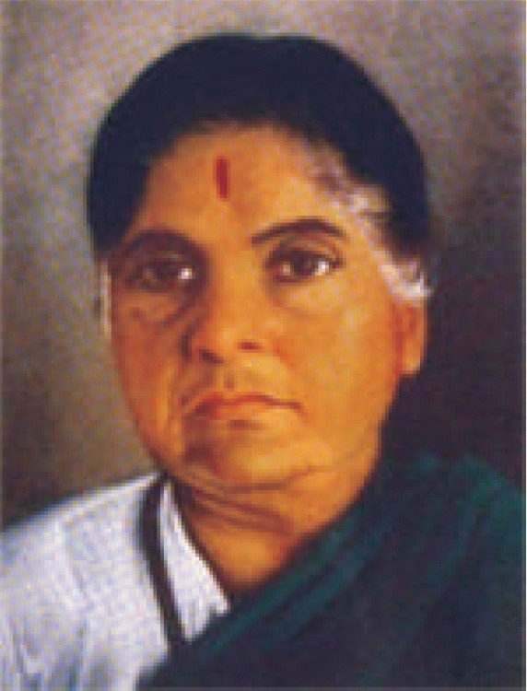

The need to establish the Family Courts was first emphasized by late Smt Durga Bai Deshmukh after her visit to China in the year 1953, where she had the opportunity to study the working of Family Courts. She discussed the subject with Hon’ble Mr Justice M.C. Chagla of Bombay High Court and also Hon’ble Mr Justice P.B. Gajendragadkar, then the Judge, Bombay High Court. She also discussed the matter of setting up of the Family Courts with the then Prime Minister Pandit Jawahar Lal Nehru. Several women associations, welfare organisations and individuals also mounted pressure for setting-up of the Family Courts to provide a forum for speedy settlement of family related disputes.

The emphasis was on a non-adversarial method of resolving family disputes and promoting conciliation and securing speedy settlement of dispute relating to marriage and family affairs.

## Role of Lawyers and Counselors in Family Courts

The Family Courts Act restricts the role of lawyers and increases the role of counselors in the dispute resolution to encourage mutually amicable settlements. This is peculiar as well as contrary to the practices of other courts, which commonly employ the English legal method of practice called the adversarial system of adjudication.

In the adversarial system of adjudication, the judge plays the role of a neutral arbiter and decides based on the merits of the case presented to him/her by the lawyers of the opposing parties.

The Family Courts Act limits the role of the lawyers as legal experts or **‘amicus curiae’** whom the courts may consult for opinion. The Act does away with lawyers with the hope to prevent excessive litigation costs, corruption, manipulative and subversive tactics, extended and bitter court battles and refusal to settle or compromise, and so on.

However, critics have argued that lawyers are necessary to help clients with complex cases and court procedures in which the counselors may not have that kind of expertise. Moreover, there has been no mechanism created to ensure the availability of ‘amicus curiae’ or ‘legal experts’ for the constant needs of courts. Accordingly, family courts have routinely allowed lawyers to represent clients.

As described earlier, the Family Courts Act has given the counselors high preference over lawyers in the family courts in order to promote efforts for settlement between the parties. However, in practice the role of counselors is mere superficial.

Majority of the States do not adequately integrate the requirement of counselors with the legal practice of family courts; the role of the counselors is limited to the task of ascertaining if the dispute can be reconciled, and even this not beyond the preliminary stage and not in the actual trial of the case.

The role of counselors in court practice is a new idea and neither the judges nor the lawyers are oriented to this concept. There exists a wide disparity among states with respect to the process adopted to appoint the counselors, their qualifications and remunerations, their role, and the counseling techniques employed. While some states have used non-governmental organizations as counselors, others have used trained personnel, individual volunteers, as well as lawyers.

## Role of Counselors and Gender Issues

There are a few states such as Maharashtra, where counselors play a considerable role in promoting negotiations and settlements. Women groups contend that counselors should be trained with gender- sensitivity as the neutral stands of counselors usually ends up being anti-women, influenced by long standing patriarchal biases against women.

The women groups have demanded clearly defined frameworks for gender justice in the practice of the family courts, especially with respect to the roles of counselors in order to avoid gender biases in the process of fulfilling the statute mandate of ‘speedy settlement’ and ‘protect and preserve’ the family.

**UNIT V**

UNIT IV

UNIT III

UNIT II

UNIT I

For example, in order to accomplish the mandate of ‘reconciliation’, some counselors coerce women to reconcile and return to the spousal home disregarding women’s human dignity, physical safety and economic rights.

In other instances, where women have been physically abused and thrown out of their matrimonial homes and have demanded maintenance (under section 125 of the Criminal Procedure Code), the counselors and lawyers have regularly and successfully sought reconciliation, which is argued to be a legal trick that undermines women’s claim to maintenance. Section 125 of the Code of Criminal Procedure is a safeguard that makes maintenance mandatory for neglected children and women.

Likewise, family issues are nuanced and have legal complexities; gender-sensitivity may help counselors to not merely take neutral positions but consider the unequal power relationships between men and women in reconciliation and settlement processes.

One of the major criticisms by the women groups, about the Family Courts Act and the family justice system as a whole, is that the conceptual basis of ‘gender justice’, the prime objective of the women’s movement, is left out. Instead, the Family Courts Act focuses on ‘preservation of the family’ through conciliation and in a speedy manner. Women’s groups have always maintained that ‘preservation of family’ is not synonymous with ‘gender justice’ or ‘rights of women’.

## Marriage and Divorce

#### Marriage

Marriage is defined as a social and legal union between a man and a woman; through this institution the spouses create kinship. Kinship is a system of social organization between people who are related by blood, marriage, or adoption. Marriage is a social union because both the spouses are entitled to each other’s company and conjugal rights, which are mutual rights and privileges between two individuals that arise from the state of being married. These rights and privileges include affection, companionship, co-habitation, joint property rights, and sexual relations.

If either of the spouses detaches herself or himself from the social and emotional companionship of her/his spouse without reasonable cause (i.e., sound judgment, which is just, fair and rational) then the aggrieved party can approach the court for relief. In such cases, the court may direct the accused spouse to return with the other spouse to their matrimonial home, which is called as restitution of conjugal rights.

Marriage is also a legal union as certain legal consequences follow after marriage; for example: parties get the status of husband and wife; legitimacy is conferred on children who are born after marriage; and it confers rights of maintenance and inheritance of property on husband and wife.

The majority of marriages are based on monogamy, i.e. a union between one woman and one man. Some societies have also allowed polygamous marriages, which is generally referred to multiple spouses or multiple marriages that include either multiple husbands or multiple wives. Whether monogamous or polygamous, the marriage system does not emerge in vacuum. These different forms of marriage serve a purpose. The practice of polygyny (or multiple wives) was often a strategy for increasing the population size. It also ensured that all women in the society were taken care of when men were in short numbers. Similarly, polyandry (or multiple husbands) is associated with shortage of women (sometimes due to female infanticide and poverty).

Most societies also define marriage rules with respect to endogamy and exogamy. Endogamy is about marriage to a person within one’s own group. Such group may be based on caste (a Brahmin will marry a Brahmin; a Kshatriya will marry a Kshatriya and so on), class (social categories based on economic and educational status), ethnic group (socially defined category based on common culture or nationality), or a religious group or even a village.

**UNIT V**

UNIT IV

UNIT III

UNIT II

UNIT I

Exogamy is a rule that requires an individual to marry outside the tribe, family, clan, or other social unit. It is especially with regard to descent groups on the basis of descent from a common ancestor or ancestress. The group can consist of children of the same father/mother, of grandchildren of the same grandmother/father, great-grandchildren of the same great-grandparent etc., or of the descendants of these persons.

Accordingly, in exogamy, certain degree of social or relationship distance must exist; else exogamic taboo is attached to such marriages that take place within close social or relationship proximity.

As stated in the introduction of this section, different laws of marriage govern people belonging to different religions. For example, the Hindu Marriage Act, 1955, governs a Hindu marriage; the Parsi Marriage and Divorce Act of 1936 govern the marriage between Parsis; and the Christian Marriage Act, 1872, governs the Christian marriage. Muslims do not have any codified law for marriage; they are governed by their religious texts.

###### Conditions of a Valid Marriage

For a valid marriage, certain conditions are to be fulfilled by the parties to the marriage. These conditions may vary from religion to religion.

*Firstly, there is a rule of monogamy among Hindus, Parsis, and Christians;* in that, they can marry only once. Their first marriage must be dissolved if they want to marry again. The dissolution of marriage can take place either by divorce (i.e., dissolution of marriage by the court) or by death of other spouse. However, Muslim law permits ‘polygamy’, where a Muslim man can have four wives.

*Secondly, no religious ceremony is required to constitute a valid marriage under the Muslim law.* The offer and acceptance to marry is often required of a Muslim couple. But this is not so among the other religious groups like, Hindus, Parsis, or Christians. If any Hindu marriage has been solemnized without the performance of customary rites on ceremonies prevailing in the community of either of the parties, such marriage is legally void. Hindus follow the ceremony of ‘Saptapadi’ or taking of seven steps before a sacred fire. Sikhs solemnize their marriage by ‘Anandkaraj’ ceremony where Lavan or the four hymns of Laav are performed during the four nuptial rounds. Parsi marriage must be solemnized in accordance with a ceremony called ‘Ashirwad’; this ceremony binds the couple in matrimony spiritually. Both the bride and the groom promise to remain faithful to each other and to not be led astray by any external temptations.

For Christians in India, certain people are recognized as authorities under the Christian law who can perform the marriage; else the marriage is void. These include persons who have received episcopal ordination (consecration or installation by authority); any Clergyman of the Church of Scotland; any Minister (or priest) of Religion licensed under this Act to solemnize marriages. Such persons grant certificates of marriage to the Christian couples.

*Thirdly, different religions prescribe different age for marriage*. For example, Hindu, Christian and Parsi law prescribe age of 18 years for girls and 21 years for boys; Muslim law mentions age of puberty, which is generally attained at 15 years of age.

*Fourthly, a person cannot marry anyone who belongs to his or her close relations.* All the religions recognize that parties should not be within the prohibited degrees of consanguinity (prohibition of marrying certain blood relations) or affinity (prohibition of marrying certain persons with

whom relationship has arisen by marriage). For example, a person cannot marry his or her brother or sister.

**UNIT V**

UNIT IV

UNIT III

UNIT II

UNIT I

*Lastly, a person must be of sound mind at the time of marriage.* The sound mind refers to the ability of individuals to understand the nature of marriage, and responsibilities towards their spouses once they get married.

|  |  |  |  |  |  |
| --- | --- | --- | --- | --- | --- |
| **Criteria** | **Hindu** | **Muslim** | **Christian** | **Parsi** | **Sikh** |
| Age | Girls - 18 years Boys - 21 years | Age of  puberty-15 years | Girls - 18 years Boys- 21 years | Girls - 18 years Boys- 21 years | Girls - 18 years Boys- 21 years |
| Monogamy | Essential | Polygamy upto 4 wives is allowed. Polyandry is not allowed | Essential | Essential | Essential |
| Prohibited relationships | Sapinda Relationships, Consanguinity And Affinity | Consanguinity and affinity based | Consanguinity  and affinity | Consanguinity  and affinity | Consanguinity  and affinity |
| Sound mind-when a person can judge the consequences of his/her act | Both parties | Both parties | Both parties | Both parties | Both parties |
| Religious ceremonies | Saptpadi (seven steps around the fire) | Civil contract- offer, acceptance and consideration (husband  pays a sum of money-mehr/ dower; in return wife promises to follow the husband) | Priest- certificate of marriage | Aashirwad ceremony | 4 laav |

#### Concept of Void and Voidable Marriage

When all the conditions prescribed by the Personal laws, as discussed above, are fulfilled and there is no legal impediment, the marriage is considered as valid. A party may contravene any of the above-mentioned conditions. In such case, different status would be ascribed to the marriage

i.e. void or voidable marriage. Such status of void or voidable marriage is dependent upon the nature of conditions so violated.

A voidable marriage is a perfectly valid marriage as long as it is not annulled (set aside) by any court of law. Only the aggrieved party to the marriage can file the petition for annulment. The court can annul the voidable marriage by passing a decree of nullity.

A void marriage is no marriage.

The word ‘marriage’ describes that the two persons have undergone the ceremonies of marriage; the ceremonies being a pre-requisite to a valid marriage.

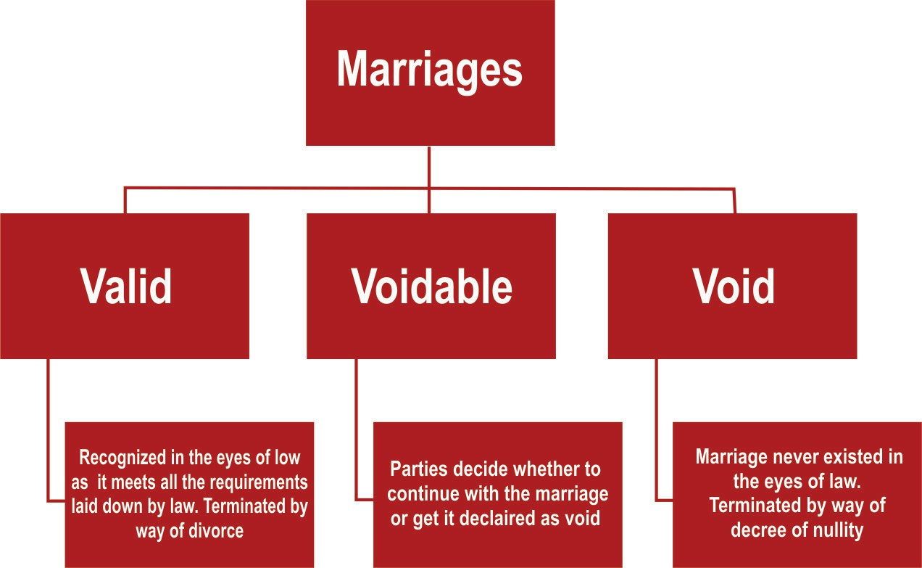

**UNIT V**

UNIT IV

UNIT III

UNIT II

UNIT I

The Hindu Marriage Act, 1955 makes the distinction between void and voidable marriage. It provides *three grounds for void marriage*:

First, marriage with any person falling within sapinda relationship (if one is a lineal descendant of the other person as far as third generation in the line of ascent through mother and fifth generation in the line of ascent through father including the persons whose relationship is being tested) is void. Blood relations are covered under it; for example, a person cannot marry his maternal or paternal uncle’s daughter.

*Second,* one cannot marry with any person falling within the ambit of prohibited relationship (one cannot marry persons with whom relationship has arisen by marriage). For example, there cannot be marriage between uncle and niece or aunt and nephew. The concept of prohibited relationship is wider than sapinda relationship as it covers relationship by blood as well as by marriage.

*Lastly,* if any Hindu re-marries during the lifetime of his or her spouse then the second marriage is void.

The Hindu Marriage Act also provides *four grounds for voidable marriages*.

*Firstly,* if marriage cannot be consummated due to impotency of one spouse, then, other spouse can get it annulled. Here, impotency does not mean barrenness or sterility (inability to have child) rather it is failure to have sexual intercourse.

*Secondly,* when the consent for marriage is obtained by force or fraud, then the aggrieved party can get the marriage annulled.

*Thirdly,* the pre-marriage pregnancy of wife (when the wife is pregnant before marriage by some person other than the husband) is another ground for voidable marriage. But husband must be ignorant of this fact at the time of marriage.

*Lastly,* unsoundness of mind is also a ground for voidable marriage.

###### Muslim Law

Under Muslim law, void marriage is known as ‘Batil’ marriage. The term ‘nullity’ (non-existence) is applicable to void marriage as marriage does not exist from the very beginning and court

merely passes a declaration as to its nullity.

**UNIT V**

UNIT IV

UNIT III

UNIT II

UNIT I

*There is no concept of voidable marriage under Muslim law* rather they recognize concept of irregular (Fasid) marriages. Irregular marriage is that, which can become valid if the defect is cured. For example, marriage with fifth wife is irregular and can be regularized if any of the earlier four wives either dies or obtains divorce from the husband. Irregular marriages are recognized only by the Sunnis and not by the Shia sect among the Muslims. The concept of void marriage is also recognized under the Muslim family law.

Marriage is void on grounds of polyandry, consanguinity, affinity and fosterage.

*Polyandry* means that a married woman cannot contract a second marriage during the subsistence of the first marriage.

*Consanguinity* means prohibition of marrying certain blood relations. For example, a Muslim cannot marry his mother, grandmother, daughter, granddaughter, paternal and maternal uncles and aunts etc.

*Affinity* means prohibition of marrying certain persons with whom relationship has arisen by marriage. For example, a Muslim cannot marry wife’s mother or grandmother, wife’s daughter (from another husband) or granddaughter if his marriage with wife is consummated.

*Fosterage* means when a woman, other than the mother of the child, has suckled a child under the age of two years, the woman becomes the foster mother of the child. A man cannot marry his foster-mother or her daughter, or his foster sister.

###### Christian Law

The Indian Divorce Act, 1869, governs Christians. It also provides for nullity of marriage. But *the Act does not distinguish between void and voidable marriage*. It only states that marriage may be declared as null and void on certain grounds.

First, aggrieved party can get the decree of nullity on ground of impotency of other spouse at the time of marriage.

Secondly, decree of nullity can be obtained if parties are within the prohibited degrees of consanguinity or affinity.

Thirdly, marriage may be revoked if the former husband or wife of either party was living at the time of marriage.

Lastly, it may be annulled if either party was of unsound mind at the time of marriage.

###### Parsi Law

Parsees do not recognize this distinction between void and voidable marriage. Under the Parsi Marriage and Divorce Act, 1936, declaration as to nullity of the marriage can be obtained in one situation where consummation of marriage is impossible due to natural causes.

#### Divorce

###### Theories of Divorce

Marriage is a social institution. There is a social interest in its protection and preservation. But sometimes it is not possible for the parties to continue with their marriage. As a consequence, concept of divorce came into being.

***Divorce is the termination of a marital union***. It results in the cessation of matrimonial tie between husband and wife. The status of husband and wife ceases after divorce. The concept of

divorce has evolved in the form of different theories. Situations like adultery (sexual intercourse outside wedlock ), cruelty, and desertion (when one spouse leaves the other spouse of never coming back) affects the very foundation of marriage. The divorce on these grounds merely enables the other party to put to an end to the form from which substance has already been destroyed.

**UNIT V**

UNIT IV

UNIT III

UNIT II

UNIT I

Divorce is regarded as a mode of punishing the guilty party who had rendered him or her unworthy of consortium. This gave rise to the **guilt or offence theory of divorce**. According to this theory, a marriage can be dissolved only if one of the parties to marriage has, after its solemnization, committed some matrimonial offence. The offence must be one that is recognized as a ground of divorce.

The ***guilt theory*** on the one hand implies that there is a ***guilty party,*** i.e. a party who has committed matrimonial offence and on the other ***an innocent party*** who is a victim.

Later on insanity was added as a ground of divorce. Insanity did not fit in within the framework of guilty or matrimonial offence theory, as the party suffering from insanity could hardly be called a guilty party. This led to ***renaming of the guilty theory*** as ***fault theory***. If one of the parties has some fault in him or her, marriage could be dissolved, ***whether that fault is his or her conscious act or providential***.

Another theory is the theory of ***divorce by mutual consent***, which originated due to the loopholes in the fault theory of divorce. The biggest drawback of the fault theory has been the presumption that there is one innocent party and one guilty party. Sometimes, husband and wife are not able to live together and there is no fault of either of them. In that case both of them are left with no remedy. Thus, a new theory had to be evolved where marriage could be dissolved by mutual consent of both the husband and the wife where they are not able to live together. Divorce by mutual consent means that the law recognizes the situation where parties can also obtain divorce by mutual consent. But mutual consent alone will not automatically terminate the relationship. It is essential to obtain a decree of the court.

For example, under the Hindu Marriage Act, 1955, parties must live separately for a period of one year or more before filing a joint petition. Then, after filing of petition, there will be a **cooling off** period for six months during which the court will not examine the petition. Thereafter, the parties have to file a joint motion to initiate the divorce proceedings.

In the landmark case of *Amardeep Singh v. Harveen Kaur*, the Supreme Court stated that it is not compulsory to wait for a cooling off period of 6 months as proposed under Section 13 B (2) of the Hindu Marriage Act.

Even the Parsi Marriage and Divorce Act, 1936 provides this ground. But there is no requirement of filing of joint petition under it.

The concept of divorce by mutual consent is also recognized under Muslim law in the form of Khula (redemption) and *Mubarat* (mutual release). In *Mubarat*, both the parties mutually decide to release each other from marital bond. In Khula, offer is from the wife’s side and she has to pay consideration (voluntarily giving away something of monetary value in exchange for a promise) to the husband in lieu of acceptance.

The next theory is the theory of ***ir-retrievable breakdown of marriage***. Divorce by mutual consent requires the consent of both the parties, and if one of the parties withholds his or her consent, divorce can never be obtained. Therefore, with the passage of time there arose a necessity for another ground that gave birth to this new theory of ir-retrievable breakdown of marriage. The basic postulate of ‘breakdown theory’ is that, if a marriage has broken down without possibility of repair (or irretrievably) then it should be dissolved without looking at the fault of either of the party.

In 1964, the Archbishop of Canterbury appointed a Committee under the Chairmanship of Dr. Mortimer Bishop of Exeter to look into the matter. The Mortimer Committee in its report recommended that the ‘breakdown of marriage’ should be the sole ground of divorce replacing all the fault grounds of divorce. The Committee defined such breakdown of marriage as such failure in the matrimonial relationship, or such circumstances adverse to the relationship that offers no reasonable probability of comfort and support.

**UNIT V**

UNIT IV

UNIT III

UNIT II

UNIT I

The Matrimonial Causes Act, 1959 of the Commonwealth of Australia, provides that, if a decree of restitution of conjugal rights is not complied with for a period of one year, then either party may seek divorce.

Further, a divorce could also be obtained on the ground that the parties have not resumed cohabitation for a period of one year or more after a decree of judicial separation.

The Parsi Marriage and Divorce Act, 1936; Hindu Marriage Act 1955 and Special Marriage Act 1954 also has this ground.

In 1960’s an agitation started to reform English law of divorce. This agitation produced a rapid response in India, which led to 1964 amendment in the Hindu Marriage Act, 1955. It tried to introduce the ‘breakdown principle’ along the lines of Australian Matrimonial Causes Act, 1959.

However, ***this ground in its entirety has not been specifically included in the Hindu Marriage Act, 1955*** but Supreme Court has, in the case of *Naveen Kohili v. Neelu Kohli*, 2006, strongly recommended that ir-retrievable breakdown of marriage should be made a ground for divorce. The Indian parliament has introduced Marriage Laws Amendment Bill, 2010 with the aim of making ir-retrievable breakdown of marriage as a ground for divorce in the Hindu Marriage Act, 1955.

###### Grounds for Divorce

Different laws of divorce govern people belonging to different religions. The Hindu Marriage Act, 1955, governs divorce among Hindus. The Parsi Marriage and Divorce Act, 1936 governs the divorce among Parsis. The Indian Divorce Act, 1869, governs divorce among Christians. Muslims do not have a codified law for marriage and divorce; they are governed by their religious texts.

Decree of court is required for dissolution of marriage by divorce. But Muslims are an exception to this rule. In Muslim law, husband enjoys special privilege in the area of divorce. He can divorce his wife at his will without citing any reason. Earlier, the Muslim wife had no corresponding right of divorce. It is only after passing of Dissolution of Muslim Marriage Act, 1939 that wife has been conferred right to obtain divorce.

The Hindu Marriage Act, 1955 governs Hindus in matters of marriage and divorce. Both husband and wife are entitled to file petition for dissolution of marriage. This petition can be filed on grounds of adultery (sexual intercourse outside wedlock), cruelty (conduct of such a nature that it is not possible for the aggrieved party to live with the spouse who has committed that act), desertion (physical separation as well as intention to leave the matrimonial home permanently on the part of deserter), unsoundness of mind (mental disorder of such a kind that it is not possible for the petitioner to live with the respondent) and so on.

Parsis as well as Christians recognize adultery, cruelty, desertion and unsoundness of mind as grounds of divorce. The Indian Divorce Act, 1869 governs Christians in matters of divorce. Under this Act, husband can file petition of divorce only on the ground of adultery on the part of wife, whereas wife can file petition on the above-mentioned grounds. If husband is guilty of rape or sodomy or bestiality, then wife can file petition for divorce. This remedy is available to Hindu,

Parsi and Christian wife.

#### Matrimonial Rights and Obligations

**UNIT V**

UNIT IV

UNIT III

UNIT II

UNIT I

Marriage confers on husband and wife certain marital rights and obligations like conjugal rights, rights of maintenance and inheritance. These are discussed below.

###### Conjugal Rights

Marriage confers conjugal rights on the parties. These are the rights and privileges arising from the marital relation, especially the mutual rights of companionship, aid, and sexual relations. The basis of this right is ‘consortium’, which means an association or alliance, or a legal right of one spouse to have comradeship and support with the other.

Parties get right of cohabitation. ‘Cohabitation’ means the act or state of dwelling together, or in the same place with one another. The living together of a man and woman is supposed to be the quintessence sexual relationship. It means an emotional and physical intimate relationship, which includes a common living place known as ‘matrimonial home’.

###### Right of Maintenance

A man, who marries, takes on an obligation to support his wife out of his earnings or other income in a style, commensurate with his total income. This obligation remains in force for the duration of the marriage and sometimes longer, even if the wife has an adequate income of her own. Earlier, there used to be division of work between husband and wife. Husband used to earn livelihood and his duty was to maintain and protect the wife. Wife’s duty was to live under roof and protection of the husband.

Under Hindu Law, the wife has an absolute right to claim maintenance from her husband. Her right to maintenance is codified in the Hindu Adoptions and Maintenance Act, 1956. In assessing the amount of maintenance, the Court takes into account various factors, like financial position and liabilities of the husband.

There does not exist such parallel right for the husband. But, if any matrimonial dispute is brought before the Court, then the Hindu Marriage Act, 1955 provides that either husband or wife who has insufficient means can claim maintenance pendent lite (maintenance during pendency of the proceedings) as well as permanent alimony (maintenance at the time of final disposal of the case), which is different from litigation expenses.

In fixing the quantum of permanent alimony, the Court will determine what is just, bearing in mind the ability of husband to pay, wife’s own assets and conduct of the parties. The order will remain in force as long as wife remains chaste and unmarried.

The Parsi Marriage and Divorce Act, 1936 also recognizes the right of husband as well as of the wife to claim maintenance pendent lite as well as permanent alimony. The parameter for granting the maintenance is same as in the case of Hindus.

Under the Muslim Law, the Muslim Women (Protection of Rights on Divorce) Act, 1986 protects rights of Muslim women who have been divorced by or have obtained divorce from their husbands. Failure on the part of the husband to pay maintenance to wife entitles her to obtain divorce from the husband.

The Indian Divorce Act, 1869 governs maintenance rights of a Christian wife. This Act does not apply to any of the above-mentioned categories i.e. Hindus, Muslims and Parsis. The provisions of this Act are the same as those under the Parsi law and the same considerations are applied in granting maintenance, both alimony pendent lite and permanent alimony.

###### Right of Inheritance

When one person dies without making a will, his property devolves (passes on) under the

law of succession. When two persons get married, they get mutual rights of inheritance. Different laws of succession govern persons belonging to different religions. Under the Undivided Hindu family, if a male or female dies without making a will, then the property is distributed as per rules of succession prescribed in the Hindu Succession Act, 1956. Under the Act, both husband and wife are included in the category of most preferred heirs. Both of them can make a will of his or her separate properties and can give them to anyone. But, the ancestral property has to be disposed off according to the Hindu Succession Act, 1956.

**UNIT V**

UNIT IV

UNIT III

UNIT II

UNIT I

Under Muslim law, in the case of death of wife, the share of husband is 1/4th of the property when there is a son or child of a son; but when there is no such child then husband is entitled to 1/2 of the estate of wife. In case of the death of the husband, the share of the wife is 1/8th when there are children; but if there are no children, then her share increases to 1/4th. Under the Muslim law, there is a restriction that a Muslim cannot dispose of by a will more than 1/3rd of his property.

###### Matrimonial Property

Property and gifts received at or about the time of marriage belongs jointly to the husband and wife. But, there are certain properties belonging exclusively to each one of them. For example, there is a concept of ‘stridhan’ in the Hindu law. Any gifts given to wife by her parents and in-laws exclusively belongs to her. She deals with it the way she likes.

Concept of ‘dower’ under Muslim law is another example of such property, which belongs exclusively to the wife. Dower is a sum of money or property that the wife is entitled to receive from the husband in consideration of marriage. In fact, it would be more correct to say that dower is an obligation imposed upon the husband as a mark of respect for the wife.

#### The Prohibition of Child Marriage Act, 2006

Minor is a person who has not completed the age of 18 years under the Indian Majority Act, 1875. With respect to the age of marriage, the Hindu Marriage Act, 1955, the Parsi Marriage and Divorce Act, 1936 and the Christian Marriage Act, 1872 has prescribed the age of 18 years for girls and 21 years for boys.

In India, child marriages (marriage which takes place before a girl attains the age of 18 years, and 21 years in case of boys) were prevalent. When the Hindu Marriage Act, 1955 was drafted, it did not affect the validity of child marriages. Only some minor penalties (15 days simple imprisonment or fine which may extend to 1000 rupees) were imposed; else, large number of marriages would fall under category of void or voidable marriages.

The Prohibition of Child Marriage Act, 2006 has changed the position in this regard. It has made child marriage voidable. Rigorous imprisonment of 2 years or fine, which may extend up to one lakh rupees, may be imposed in case of contravention of any provision of this Act. But even now, child marriage is valid.

The Prohibition of Child Marriage (Amendment) Bill, 2021 proposes to increase the marriageable age of girls from 18 to 21 years to bring parity in the marriageable age of the girls and boys. The Bill adds that the provisions of the Act shall have an overriding effect over any other law, custom, usage or practice governing the parties to the marriage.

## Exercises

**UNIT V**

UNIT IV

UNIT III

UNIT II

UNIT I

Based on your understanding, answer the following questions: Q-1 Give one point of difference between the following –

1. Exogamy and endogamy
2. Void and voidable marriage
3. Monogamy and polygamy
4. Marriage and divorce Q-2 Write brief notes on-
5. Fosterage
6. Significance of Article 44
7. Role of Lawyers and Counselors in Family Courts
8. Gender inequality in Hindu Family Law
9. Objectives of Family Court Q-3 Answer the following questions-
10. Give any two examples of gender inequality in the Islamic family law.
11. Explain the grounds for voidable marriage provided in the Hindu Marriage Act.
12. What is divorce? What are the various grounds for divorce?
13. What are the conditions for a valid marriage? Q-4 Identify the marital right and explain-
14. The obligation of a man to support his wife out of his income
15. Devolution of property after the death of spouse in Hindu and Muslim laws

**UNIT V**

UNIT IV

UNIT III

UNIT II

UNIT I



CHAPTER

2

**Child Rights**

## Contents

1. Child Rights
2. Right to Education
3. Right to Health
4. Right to Shelter
5. Child Labour
6. Sexual Abuse
7. Juvenile Justice
8. Exercises

## Learning Outcomes

After the completion of this chapter, the students will be able to:

* + Explain the meaning of child
  + Explain various rights available to a child
  + Critically evaluate child sexual abuse
  + Summarise the importance of Juvenile laws

## Child Rights

Etymologically, the term ‘child’ is derived from the Latin word ‘*infans*’, which means the one who does not speak. According to the Convention on the Rights of the Child of 1989, *a child is any human being below the age of eighteen years, unless under the law applicable to the child, majority is attained earlier*. In India, a person is deemed to be a major on attaining the age of 18 years under the Indian Majority Act, 1875. The law, policy, and practice of child welfare has undergone a significant change from a historical perspective.

Earlier, there was the concept of authority and control where the father had absolute rights over his children. After this, the welfare principle was reflected in the dominant ideology of the family. The Indian traditional view of welfare is based on *daya*, *dana*, *dakshina*, *bhiksha*, *ahimsa*, and *tyaga*. It was believed that welfare of children depended upon these values. It was only during the twentieth century that the concept of children’s right emerged. This shift in focus from the ‘welfare’ to the ‘rights’ approach is significant.

The rights approach is primarily concerned with issues of social justice, non-discrimination, equity, and empowerment. The rights perspective is embodied in the United Nations Convention on the

Rights of the Child 1989, which is a landmark in international human rights legislation. India ratified the Convention on the Rights of the Child in December, 1992. This convention gives all those basic human rights to children that will enable them to achieve their full potential. These include civil, economic, social, cultural, and political rights. The civil rights include protection from torture and maltreatment. Making of special rules governing the circumstances under which children may be deprived of their liberty also constitutes part of civil rights. The economic rights include the right to ensure proper development and protection from exploitation at work. The social rights include the right to the highest attainable standard of health services, protection from sexual exploitation and the regulation of adoption. Right to education is included in cultural rights.

**UNIT V**

UNIT IV

UNIT III

UNIT II

UNIT I

## Right to Education

Education is the transmission of the values and accumulated knowledge of a society. It helps children in knowing their culture, moulding their behaviour in the ways of adulthood and directing them towards their eventual role in society. Right to education is one of the fundamental rights in the Constitution of India under Article 21 A (inserted by 86th constitutional amendment). It provides that the state shall provide free and compulsory education to all children between the age of six to fourteen years (6-14 years). The state also has to promote the educational and economic interests of the weaker sections of the society, and, in particular of the Scheduled Castes and the Scheduled Tribes. The mandatory duty of the state to make effective provisions for securing the right to education is subject to its economic capacity and development. Moreover, a fundamental duty has been imposed on the parent or guardian to provide opportunities for education to his child or ward between the age of six to fourteen years (6-14 years) under Article 51 A sub clause (k) (inserted by 86th constitutional amendment).

The Right of Children to Free and Compulsory Education Act was passed by the Parliament in 2009. Some of the salient features of the Act are as given here. The Act ensures that children get education irrespective of their economic condition. It provides for free and compulsory education to all children in the age group of six to fourteen years (6 -14 years).

The financial burden for the implementation is to be shared by state and the central government on basis of the **Sarva Shiksha Abhiyan program** of the central government. It also provides for 25% reservation for economically disadvantaged communities in all private and minority schools. The private schools have to face penalty for violating any provision of this Act.

## Right to Health

Health is a state of complete physical, mental, and social well-being. It is not merely the absence of disease or infirmity. The enjoyment of the highest attainable standard of health is one of the fundamental rights of every human being without distinction of race, religion, and political belief, economic or social condition. Healthy development of the child is one of the basic needs and the ability to live harmoniously in a changing environment is essential for such development. The extension to all people of the benefits of medical, psychological and related knowledge is essential for the most comprehensive attainment of health.

**UNIT V**

UNIT IV

UNIT III

UNIT II

UNIT I

|  |  |
| --- | --- |
| RIGHT TO HEALTH – JUDICIAL CONTRIBUTION | The World Health Organization (WHO) is a specialized agency of the United Nations that is concerned with international public health |
| Consumer Education and Research Centre v. Union of India, (1995): Right to health and medical care is a fundamental right under Article 21 read with Articles 39(c), 41 and 43 of the Constitution.  Paschim Banga Khet Mazdoor Samity v. State of West Bengal, (1996): Article 21 imposes an obligation on the State to safeguard the right to life of every person. Preservation of human life is, thus, of paramount importance. |  |

A constitutional duty has been imposed on the state to ensure that the health and strength of workers, men, and women, and the tender age of children are not abused. It has to ensure that children are given opportunities and facilities to develop in a healthy manner and in conditions of freedom and dignity. Moreover, their childhood will be protected against exploitation. The health of infant and mother has to be protected by maternity benefit. The primary duty of the state is to improve public health; secure justice and humane conditions for work; extension of sickness, old age, disablement and maternity benefits are also contemplated. Further, the state’s duty includes prohibition of consumption of intoxicating drinking and drugs that are injurious to health. A mandatory duty has been imposed on the state to protect and impose a pollution free environment for the good health of its citizens.

## Right to Shelter

Right to shelter includes adequate living space, safe structure, clean and hygienic surroundings, sufficient light, pure air and water, electricity, sanitation and other civic amenities like roads. It is a place where a person has opportunities to grow physically, mentally, intellectually and spiritually. Thus it includes the entire infrastructure necessary to enable an individual to live and develop as a human being.

These components are discussed by the Supreme Court in the case of ***Chameli Singh v. State of U.P.***, (1996). **In *Shantistar Builders v. Narayan Khimalal Totame***, (1990) the Supreme Court held that the right to life would take within its sweep the right to food, the right to clothing, the right to decent environment and a reasonable accommodation to live in. There is a difference between the need of an animal and a human being for shelter. For the animal, it is the bare protection of the body whereas for a human being it has to be a suitable accommodation, which would allow him to grow in every aspect i.e. physical, mental and intellectual. Thus, right to shelter has become an integral part of the right to life.

## Child Labour

Child Labour means labour by the child i.e. when the child is made to work. There are a number of factors to determine whether a particular kind of work can be called as ‘child labour’ or not. These factors include a child’s age, nature and hours of work, and the conditions under which such work is performed etc. Labour that jeopardises the physical, mental or moral well-being of a child is known as ‘hazardous work’. Such labour deprives children of their childhood, potential and dignity.

The International Labour Organization (ILO) was founded in 1919. It was the first specialized agency of the United Nations to deal with the labour issue. ILO started the International Programme on the

Elimination of Child Labour (IPEC) in 1992. Its main objective is progressive elimination of child labour.

**UNIT V**

UNIT IV

UNIT III

UNIT II

UNIT I

The Constitution of India has provided the right against exploitation as a fundamental right. A child who is below the age of 14 years cannot be employed in any factory or mine or engage in any other hazardous employment (Article 24). A duty has been imposed on the state to ensure that tender age of children is not abused. The state has to ensure that these children are not forced by economic necessity to enter into any occupation unsuited to them.

The Child Labour (Prohibition and Regulation) Act was enacted in 1986. The objectives of this Act are: banning the employment of children, who have not completed their fourteenth year, in specified occupations and processes; laying down procedures to decide modifications to the schedule of banned occupations or processes; and regulating the conditions of work of children in employment where they are not prohibited from working.

A National Policy on Child Labour was formulated in 1987. This policy provides for strict enforcement of Child Labour Laws. The focus under this policy is on the General Developmental Programs on child labour. It provides for starting of projects in the areas having high concentration of child labour. In pursuance to this policy, the National Child Labour Project (NCLP) scheme was launched in 1988. The Scheme envisages running of special schools for children withdrawn from work.

In 2006, legislature has also taken steps towards the total elimination of child labour; it brought child domestic workers up to 14 years of age working in hotels, *dhabas*, eateries, and in the entertainment industry within the purview of the Child Labour (Prohibition and Regulation) Act, 1986.

## Sexual Abuse

Child Sexual Abuse involves any sexual activity with a child. Sexual abuse is inappropriate sexual behaviour with a child. It could be interaction between a child and an adult or older child, in which child is used for the sexual stimulation of the Perpetrator (wrong doer). It includes fondling a child’s genitals, making the child fondle the perpetrator (wrong doer) genitals, intercourse, incest, rape, sodomy, exhibitionism and sexual exploitation. Perpetrator uses deception, threats or other coercive methods to engage the child and maintain their silence.

A person under the age of 18 years may also commit sexual abuse. There is significant disparity in age, development, or size, rendering the victim (i.e., child) incapable of giving consent. Child sexual abuse is broad enough to include extra-familial (outside a family) abuse as well as inter-familial (within family) abuse.

An Act has been passed by the Parliament in 2012 to deal with this problem - the Protection of Children from Sexual Offences Act, 2012 ..(POCSO Act, 2012). This Act protects children from offences of penetrative sexual assault (penetration of penis or any object or part of body into the vagina, mouth, urethra or anus of child), sexual assault (touching vagina, penis, anus or breast of child with sexual intent or making a child to do so), sexual harassment (uttering words, making sounds or gesture or exhibiting any body part or making a child to do so), and use of child for pornographic purposes (using a child in any form of media for the purposes of sexual gratification).

Education programs for children are created to create awareness among children. These programs focus on two main goals: primary prevention (preventing the abuse from occurring), and detection (encouraging children to report past and current abuse). The parents play an important role in empowering their children to protect themselves. Accordingly, the prevention of child sexual abuse begins with social awareness, plus the recognition that expertise, energy, and money are needed to alleviate (mitigate) the conditions that produce child sexual abuse.

School based sex education for children is appealing because it has the potential to reach large

number of young people. Parental competency programs target at risk parents (poor, young, single) and at risk children with the goal of providing training and social support before any abuse can occur.

**UNIT V**

UNIT IV

UNIT III

UNIT II

UNIT I

## Juvenile Justice

The word ‘juvenile’ has originated from the Latin word ‘Juvenilis’, which means ‘of or belonging to youth’. Juvenile justice is the area of criminal law applicable to persons who are not old (mature) enough to be held responsible for criminal acts. A child is born innocent. The environmental factors that have stirred criminal tendencies in the child should be held responsible. The removal of these factors might turn the juvenile into a person of stature and excellence.

#### History of Juvenile Justice System in India

The primary legal framework of juvenile justice law in India was the **Juvenile Justice Act 1986**, which provided protection, treatment and rehabilitation of children and delinquent juveniles and for the adjudication of certain matters related to the disposition of delinquent juveniles.

The General Assembly of the United Nations adopted a Convention on the Rights of Child on 20th November 1989. This convention seeks to protect the best interest of juvenile offenders. The Convention states that to protect the social reintegration of juveniles, there shall be no judicial proceedings and court trials against them. The Convention led the Indian Legislation to repeal the Juvenile Justice Act, 1986 and to make a new law. Thus, Indian Legislation came up with a new Act which was called The Juvenile Justice (Care and Protection of Children) Act, 2000.

The Juvenile Justice (Care and Protection of Children) Act, 2000 was amended twice – first in the 2006 and later in 2011. The amendments were made to address the gap and loopholes in the implementation. The increasing number of cases of juvenile crimes in recent years and frightful incident of ***Delhi Gang Rape Case, Mukesh & Anr v. State for Nct of Delhi & Ors (2017)*** triggered major changes in the criminal justice system of India. The Juvenile Justice (Care and Protection of Children) Act, 2000 was replaced soon by ***The Juvenile Justice (Care and Protection) Act, 2015.***

The Juvenile Justice (Care and Protection of Children) Act, 2015 is the primary legal framework for juvenile justice in India. It has brought within its ambit ‘children in need of care and protection’ and ‘children in conflict with law’. **A ‘child in need of care and protection’** means a child who is found without any home and ostensible means of subsistence. It includes a child who is mentally or physically challenged or suffering from terminal or incurable diseases with no one to look after him or her. It also embraces those children who are likely to be grossly abused, tortured or exploited for the purpose of sex or other illegal acts. It includes children having parents who are unfit to exercise control over them. It also incorporates children who do not have parents and no one is willing to take care of them. It also includes a child who is found vulnerable and is likely to be inducted into drug abuse or trafficking; or is likely to be abused for unconscionable gains; or a victim of any armed conflict, civil commotion or natural calamity. A child who is found begging or is a child living on the streets or a working child has also been included in this category.

A **‘child in conflict with law’** means a juvenile (person who has not attained the age of 18 years) who is alleged to have committed an offence (violation or breach of law) and has not completed eighteenth year of age as on the date of commission of such offence.

This Act also provides for proper care, protection and treatment to juveniles by catering to their developmental needs. It has adopted a child-friendly approach in the adjudication and disposition of matters in the best interest of children. It also aims at ultimate rehabilitation through various institutions established under this enactment. It has tried to lay down a uniform framework for juvenile justice in the country.

*The Supreme Court in the case of* ***Sheela Barse v. Secretary, Children’s Aid Society*** *held that children should not be made to stay in observation homes for too long, and as long as they are there, they should be kept occupied. The occupations should be congenial and intended to bring about adaptability in life, self-confidence, and development of human values.*

**UNIT V**

UNIT IV

UNIT III

UNIT II

UNIT I

*In the case of* ***Sanjay Suri v. Delhi Administration****, a news report described the ill treatment meted out to minors in the Tihar Jail in Delhi in connivance with the jail staff. The writers of this report then moved the Supreme Court seeking relief on behalf of the child prisoners. The Court appointed the district judge to make an inquiry and give report to the court. His report disclosed that adult prisoners subjected children to sexual assault. They feared that if their names were disclosed, they would be victimized. The court passed several orders based on the report. Some juvenile undertrial prisoners were ordered to be released immediately. Some convicted minors were freed on parole (conditional release of a prisoner) for one month. The judgment stressed the need to generate a sense of humanism in jail administration.*

*******Salient features of the* ***The Juvenile Justice (Care and Protection) Act, 2015:***

* 1. *The Juvenile Justice Act divided the crimes into three different categories i.e. petty offences, serious offences and heinous offences.*
  2. *Juvenile Justice Boards are constituted in every district to deal with children in conflict with law. The board comprises of a metropolitan judge and judicial magistrate with two social workers.*
  3. *Excluding the offence of heinous crimes, for all other cases, the juvenile will get institutional care for a maximum of three years by the Juvenile Justice Board.*
  4. *If a minor between the age of 16-18 years is accused of committing a heinous crime(Whether a crime is heinous or not is determined by the Juvenile Justice Board on a case to case basis), then under the amended law, the minor can be tried as an adult.*

## Exercises

Based on your understanding, answer the following questions:

* 1. The United Nations convention on the Rights of Child gives all basic rights to a child that will enable them to achieve their full potential. Explain the cultural and social rights available to a child.
  2. What is the status of education as a right? How did it acquire this status?
  3. Is there any legislation in India dealing with child labour? Name the relevant legislation. Aditi hired a 12 year old girl to help her with the domestic household chores. Can she be prosecuted for child labour? Explain giving legal reasons.

**UNIT V**

UNIT IV

UNIT III

UNIT II

UNIT I

CHAPTER

3

**Adoption**

## Contents

1. Adoption
2. Minor custody and Guardianship
3. Exercises



## Learning Outcomes

After the completion of this chapter, the students will be able to:

* Explain Adoption
* Contrast between the laws of guardianship under various religions
* Differentiate between the types of guardians

Did you know that Steven Paul Jobs was born on February 24, 1955, to Abdul fattah Jandali and Joanne Schieble, and was adopted by Paul and Clara Jobs?

## Adoption

#### What is Adoption?

***Adoption is the act of establishing a person as parent to one who is not in fact or in law his child.*** It is the means by which a legal relationship is established between the parent and child who are not so related biologically. It is also defined as a process by which people take a child who was not born to them and raise him or her as a member of their family.

Earlier, the objective of adoption was mainly to secure performance of funeral rites and to preserve the continuance of one’s lineage.

#### Statutes governing Adoption

###### The Hindu Adoption and Maintenance Act, 1956

In India, the only statute governing adoption is the **Hindu Adoption and Maintenance Act, 1956**. Its ambit is confined only to Hindus.

The law codifies the legal process of adopting children by a Hindu adult and the legal obligations to provide maintenance to the various family members.

###### Law on adoption for other religions/ communities:

There is no law on adoption for Christians, Parsis, and Muslims. A person belonging to these communities has to get himself appointed as guardian under the Guardians and Wards Act, 1890. This Act applies to all communities and castes.

The court will take into consideration the personal law of the minor while appointing or declaring a person as guardian under the Guardians and Wards Act, 1890. Once a person is appointed or declared as a guardian, he has to abide by the provisions of the Guardians and Wards Act, 1890.

**UNIT V**

UNIT IV

UNIT III

UNIT II

UNIT I

## Minor Custody and Guardianship

#### Who is a Minor?

Minor is a person who has not completed the age of 18 years under the Indian Majority Act,

1875.

#### Who is a Guardian?

A Guardian is a person who has rights and duties with respect to the care and control of a minor’s

person in relation to body or property (estate or wealth of minor).

These rights of guardian include the right to determine the child’s upbringing in regard to religion, education, and other matters such as the disposal of properties and so on. A guardian is vested with the duty to act for the welfare of the minor. The welfare of the child is paramount consideration for the court in matters pertaining to custody and guardianship of the child.

In matters of custody and guardianship every community has its own laws.

#### The Guardians and Wards Act, 1890

This is a non-religious and universally applicable law regarding the issues relating to guardianship

of a child in India.

The Guardians and Wards Act, 1890 was passed during the British period. This Act has authorized the court to appoint guardian for a minor child. The child may belong to any community.

#### The Hindu Minority and Guardianship Act, 1956

The Hindu Minority and Guardianship Act was enacted in 1956. This Act has codified the law

relating to custody and guardianship of children belonging to the Hindu community. Guardian includes the following:

v a natural guardian

v a guardian appointed by the will of the minor’s father or mother

v a guardian appointed or declared by a court

#### De-jure and De-facto guardians

A guardian can be de-jure (authority vested by law) or de-facto (exercising power without being legally established).

###### Types of De-jure guardians

De-jure guardians can be of three types, they are:

* + - Natural guardians (by birth): Generally, father and mother are recognized as natural guardians of the child
    - Testamentary guardians: Guardians appointed by will
    - Certificated guardians: Guardians appointed by the court under the Guardians and Wards Act, 1890 are known as Certificated guardians

#### Natural Guardian

**UNIT V**

UNIT IV

UNIT III

UNIT II

UNIT I

Natural Guardian of a Hindu minor: Section 6 of Hindu Minority and Guardianship Act, 1956 provides that the natural guardian of a Hindu minor boy or unmarried girl in respect of the minor’s person as well as in respect of the minor’s property is the father, and only after him, the mother. The mother is entitled to guardianship ‘after’ the father. Here, the term ‘after’ means ‘in the absence of’. Ordinarily, the custody of a minor child who is below the age of five years is given to the mother.

Thus, a functional guardian (person who is looking after the welfare of the child and actually taking care of him) will be given responsibility of the guardianship. It is immaterial whether that person is a father or mother. The paramount consideration is the welfare of the child.

###### Position under Muslim Law

Muslims do not recognize mother as a guardian, whether natural or otherwise. But she has the **‘right of hizanat’**, which is the right of the mother to have custody of the child during early childhood.

A guardian appointed by ‘will’ is known as a testamentary guardian. Under the Hindu Minority and Guardianship Act, 1956, both the parents can appoint a testamentary guardian for the child.

###### Position under Muslim Law

But it is not so among Muslims. In Muslim law, only father has power to appoint a testamentary guardian. The mother has no such power.

## Exercises

Based on your understanding, answer the following questions:

* 1. The Act that codified the law relating to custody and guardianship of children belonging to the

Hindu community is known as:

* + 1. The Guardians and Wards Act, 1890
    2. The Hindu Minority and Guardianship Act, 1956
    3. The Hindu Adoption and Maintenance Act, 1956
    4. The Hindu Marriage and Divorce Act
  1. Which of the following communities has a law on Adoption?
     1. Christians
     2. Parsis
     3. Hindus
     4. Muslims
  2. Anisha’s (a minor) father appointed Anisha’s aunt as her guardian in his Will under the Hindu Minority and Guardianship Act, 1956. Anisha’s aunt is a:
     1. Testamentary Guardian
     2. Natural Guardian
     3. De facto Guardian
     4. Certificated Guardian
  3. Shanaya is a five year old Muslim girl. Her parents are separated. Which parent will get custody of the child and why?
  4. Anuj is the son of Neeta and Neelesh Pandey. The couple separated and both are eager to seek

the custody of Anuj. Who will be Anujs guardian under Hindu law? Explain the position of both

**UNIT V**

UNIT IV

UNIT III

UNIT II

UNIT I

the mother and father.

* 1. Angad, a minor sikh was staying in Delhi with his parents who were involved in a bitter battle over his custody. Explain with relevant provisions as to who will get his custody?



**UNIT V**

UNIT IV

UNIT III

UNIT II

UNIT I



**Property, Succession**

**and Inheritance**

CHAPTER

4

## Contents

1. Concept of Property: Joint Family Property and Separate Property
2. Inheritance and Succession
3. Intestate Succession
4. Rules relating to Intestate Succession
5. Testamentary Succession
6. Exercises

## Learning Outcomes

After the completion of this chapter, the students will be able to:

* + Explain the concept of property, succession and inheritance
  + Differentiate between types of succession
  + Apply the rules regarding intestate succession in different religions
  + Draft a sample Will

## Concept of Property: Joint Family Property and Separate Property

The term property is derived from the Latin term ‘propertietat’ and the French equivalent ‘proprious’ which means a thing owned.

#### Types of Property

There are two kinds of property:

* 1. Joint family property- Property acquired by joint funds of the family is known as joint family property. All the needs of the family are fulfilled from it.
  2. Self-acquired property - Property acquired by self-exertion or labour is known as self-acquired property. Thus, it includes property by one’s own learning.

#### What is Learning?

**Gains of Learning Act, 1930:** It defines ‘learning’ as education whether elementary, technical, scientific, and special or general.

It defines ‘training’ as every kind of training, which is usually intended to enable a person to pursue any trade, industry, profession or vocation in life.

## Inheritance and Succession

**UNIT V**

UNIT IV

UNIT III

UNIT II

UNIT I

#### What is Inheritance?

Inheritance is one of the means of acquisition of property. Inheritance means the right of an heir (to succeed to property on the death of an ancestor) by way of succession. Different laws of succession govern persons belonging to different religions.

After the death of the owner, all rights belonging to the deceased with regard to the property are divisible into two classes, namely:

1. Inheritable rights, and
2. Un-inheritable rights

Inheritable rights: A right is inheritable if it survives its owner. It remains functional even after the death of the person to whom it belongs and devolves on his/her legal representative. For instance, proprietary rights (rights attached to property) like debts are inheritable rights.



Un-inheritable rights: A right is not inheritable if it dies with the person. For instance, personal rights (rights associated with the person) are not inheritable as they extinguish with the death of the deceased.

#### What is Succession?

Succession is **the process in which property is transferred upon someone’s death.** It is also used to refer to the estate a person leaves behind at death.

There are two ways of succession i.e. *intestate succession and testamentary succession.*

#### Who is an Heir?

The persons on whom the property devolves are called the heirs of the deceased. A person who is entitled to inherit property after the death of the intestate is known as heir.

#### Who is a Testator?

*Testator* is a person who has made a legally valid will before death.

#### What is a Will?

A legal declaration of a person’s wish regarding the disposal of his or her property or estate after death.

On 9 March 2018, the Supreme Court of India made a landmark judgment permitting passive euthanasia under strict guidelines in the country.

**UNIT V**

UNIT IV

UNIT III

UNIT II

UNIT I

Supreme Court of India legalised passive euthanasia by means of withdrawal of life support to patients in a permanent vegetative state. Passive euthanasia allows withdrawal of medical treatment with the intention to expedite the death of a terminally-ill patient.

In the landmark verdict, the Supreme Court also ruled that in specific circumstances, a person has the right to decide against artificial life support by creating a living will. The Supreme Court has attached strict conditions for executing a living will that was made by a person in his normal state of health and mind.

The Supreme Court declared the right to die with dignity as a fundamental right within the ambit of the right to live with dignity. It held that the right to life and liberty under Article 21 of the Constitution of India also includes the right to die peacefully and with dignity.

The judgment was delivered on a PIL filed by NGO Common Cause for an individual’s right to make a living will document for passive euthanasia. However, the debate to legalise passive euthanasia got triggered in a 2011 Supreme Court judgment in the case of Mumbai nurse Aruna Shanbaug, who was in a permanent vegetative state for more than 40 years.

#### Testamentary Succession

When a person disposes off his property by making a will, it is known as testamentary succession. A person can make a will only of his/her separate property. *Testamentary succession* is governed by the Indian Succession Act, 1925.

In testamentary succession, the law empowers a person to determine, during his lifetime, the disposition of the property that he leaves behind him after his death. The law respects the will of the deceased and secures its enforcement (to compel observance and obedience to that will). A person who determines the disposition of his property in this way is said to have made a will.

## Intestate Succession

A person who dies without making a will is known as intestate and succession to his property is known as intestate succession.

In Intestate Succession, the property devolves according to the law or custom by which the deceased is governed.

If a Hindu dies intestate i.e. without making a will, then, both separate property as well as joint family property passes on to his heirs in accordance with the Hindu Succession Act, 1956.

Under Hindu law, a son had a birthright in joint family property. The Hindu Succession (Amendment) Act, 2005 was enacted to remove gender discriminatory provisions in the Hindu Succession Act, 1956. Now, under the Hindu Succession (Amendment) Act, 2005, daughters have inheritance rights equal to those of sons from properties of their fathers, grandfathers and great grandfathers.

#### Muslim Law

Muslims do not have any codified law for intestate succession. They are governed by rules contained in religious texts. They do not make any distinction between ancestral and self acquired property. The right of an heir comes into existence on the death of the ancestor.

#### Other Religions

The Indian Succession Act, 1925, governs intestate succession of Christians and Parsis. Every religion has its own rules of Intestate succession, but there are certain concepts that are common to all religions.

For example, A person who is entitled to inherit property after the death of the intestate is known as

**UNIT V**

UNIT IV

UNIT III

UNIT II

UNIT I

an Heir. These heirs could be of three types, i.e., Ascendants, Descendants, and Collaterals.

#### Heirs - Ascendants, Descendants, and Collaterals

Ascendants are the ancestors of a person both on the paternal and maternal side. The immediate ascendants are father and mother. It includes father (F), Mother (M), paternal grandfather (FF), paternal grandmother (FM), maternal grandfather (MF), maternal grandmother (MM), etc. There is no limit to degrees of ascent.

Descendants mean the offspring of a person. The immediate descendants of a person are his or her sons and daughters. It includes son (S), daughter (D), grandson (SS), granddaughter (SD), great grandson (SSS), great granddaughter (SSD), etc. There is no limit to degrees of descent.

Collaterals are descendants in parallel lines, i.e., from a common ancestor or ancestress. For instance, brothers, sisters, and their children how low so ever, paternal and maternal uncles and aunts and their children how low so ever are all collaterals. These heirs can relate to each other by full blood, half blood or uterine blood.

#### Relation by full blood, half blood and uterine blood

**Relation by full blood:** Two persons are related to each other by full blood when they have the same father and same mother.

**Relation by half blood:** Two persons are related to each other by half blood when they have the same father but different mothers.

**Relation by uterine blood:** Two persons are related to each other by uterine blood when they have the same mother but different fathers.

The rules pertaining to intestate succession are more or less similar in all the communities whereby first preference is given to the husband or wife of the deceased and their lineal descendants. In their absence, the preference is given to collaterals that are close to the deceased. In their absence, property goes to remote agnatic heirs and then to cognatic heirs.

However, every religion has adopted a different way of determining the disposition of property.

## Rules Relating to Intestate Succession

#### Rules of intestate succession of a Hindu Male:

Heirs belonging to a Hindu male are classified into four categories i.e. class I, class II, agnates and cognates.

* + Class I heirs are the most preferred heirs and include mother, wife, son as well as daughter and

their descendants upto the third generation.

* + Class II heirs include father, brother as well as sister and their children, maternal and paternal

uncles and aunts, maternal and paternal grandfather and grandmother etc. Class II heirs will inherit property only in absence of Class I heirs*.*

* + If there are no heirs belonging to Class I or Class II then property goes to agnates.

###### Who are Agnates?

When two persons are related by blood or adoption wholly through males, they are called

agnates. For example:

The son of a great grandson (son, grandson, great grandson being dead) P ⇨ S ⇨ SS ⇨ SSS ⇨ SSSS1

**UNIT V**

UNIT IV

UNIT III

UNIT II

UNIT I

In the above diagram, S is son of P, SS is son of S and grandson of P, SSS is son of SS and great grandson of P, SSSS1 is son of SSS and great great grandson of P. Here, SSSS1 is agnate to P as he is tracing relation wholly through males i.e. his father (SSS), grandfather (SS), and great grandfather (S). No female has intervened in-between.

In case, all the above-mentioned heirs i.e. Class I, Class II and agnates are absent then property will go to cognates.

###### Who are Cognates?

When two persons are related by blood or adoption but not wholly through males, they are

called cognates.

###### For example:

P ⇨ F ⇨ FM ⇨ FMF1

Father of paternal grandmother i.e. FMF1 is a cognate as female (father’s mother) has intervened in between. In the above diagram, F is father of P, FM is mother of F and paternal grandmother of P, FMF1 is father of FM. Here, FMF1 is cognate to P as a female has intervened in between, i.e., father’s mother (FM).

#### Rules of intestate succession of a Hindu Female

If a female Hindu dies intestate then heirs are divided into five categories. The heirs in earlier categories are preferred over the heirs in later categories.

* + The first category includes husband, son, daughter and children of a pre- deceased son and

daughter.

* + The second category includes heirs of the husband.
  + Father and mother fall under the third category.
  + Heirs of father and mother are covered under fourth and fifth category respectively.

#### Rules of intestate succession among Muslims

There is no codified law for Muslims in the area of succession. They are governed by their religious texts.

###### Rules of intestate succession among Sunni Muslims

Among Sunnis, heirs are divided into three categories i.e.

* + Sharers (Quranic heirs),
  + Residuaries (agnatic heirs), and
  + Distant kindred (uterine heirs)

Sharers are the most preferred heirs. First of all, sharers are allotted their Quranic shares. If something is left behind after allotting shares to them, then, it goes to residuaries. If their shares exhaust the entire estate, then sharers exclude residuaries and distant kindred. The distant kindred are not entitled to succeed so long as there is any heir belonging to the class of sharers or residuaries. But there is one case in which distant kindred will inherit with the sharer: when there

is only one sharer i.e. the wife or husband of the deceased and no other sharer or residuary exist.

**UNIT V**

UNIT IV

UNIT III

UNIT II

UNIT I

###### Rules of intestate succession among Shia Muslims

Among Shias, heirs are divided into two categories i.e.

* + - Heirs by consanguinity and
    - Heirs by marriage i.e. husband and wife

###### Heirs by consanguinity

Heirs by consanguinity are further subdivided into three classes:

* + - Class I includes parents and children.
    - Class II includes grandparents, brothers and sisters, and their descendants etc.
    - Class III includes paternal and maternal uncles and aunts of the deceased, and of his parents,

grandparents etc.

Among the heirs by consanguinity, the first group excludes the second and the second group excludes the third. The claimants in both the categories i.e. heirs by consanguinity and heirs by marriage succeed together, if there are heirs of both the categories.

#### Rules of intestate succession under the Indian Succession Act, 1925

* + The Indian Succession Act, 1925 is a central legislation and is applicable to every person, unless they are governed by any law particularly applicable to them. This Act is not applicable to Hindus and Muslims. Christians and Parsis are governed by this Act.

Rules of intestate succession among Christians under the Indian Succession Act, 1925:

* + Among Christians, the first preference is given to the spouse of the deceased and his lineal descendants i.e. children, grandchildren, great grandchildren or their remoter lineal descendants.
  + When there are no lineal descendants then property passes on to the spouse of the deceased and those who are kindred (consanguinity is the connection or relation of persons descended from the same stock or common ancestor) to him.
  + If there are no lineal descendants or one who is kindred to him, then the entire property goes

to his or her spouse.

* + In the absence of such a spouse, property passes on to lineal descendants or to those who

are kindred to him.

###### Rule of Escheat

A rule of escheat is applicable in all the communities. If no heir is present then property goes to the Government by this rule.

## Testamentary Succession

**UNIT V**

UNIT IV

UNIT III

UNIT II

UNIT I

#### Testamentary Succession under Muslim Law

An executor under Mohammedan law is called a wasi, derived from ‘wasiyyat’, which means a will. A Muslim who is of sound mind and who is not a minor, may make a valid will.

No particular form is required to make a valid will. Any unequivocal expression of a testamentary nature will suffice. It may be made either verbally or in writing. Any property which is capable of being transferred and which exists at the time of the testator’s death, may be disposed off by a will. Needless to say, property that belongs to another cannot be bequeathed by a will.

A Muslim can dispose off only one third of his property, which is left after the payment of his funeral expenses and his debts. The balance two thirds of the property goes to the heirs of the deceased.

#### Testamentary succession among Hindus, Parsis and Christians

The rules relating to testamentary succession among Hindus, Parsis and Christians are contained in the Indian Succession Act, 1925. This Act does not deal with substantive law, such as what property may be transferred or what estates and interest may be created.

The Indian Succession Act, 1925 primarily deals with formalities related to the following matters:

* Execution (Validation of a legal document by the performance of all necessary formalities)
* Revocation (to recall, withdraw, or reverse the will)
* Revival (restoration to use, acceptance, activity, or vigor after a period of obscurity)
* Interpretation (an explanation or conceptualization) of wills
* The grant of Probate (the process of legally establishing the validity of a will before a judicial authority) and other legal representations, powers and duties of the Executors (a person who is appointed by a testator to execute the testator’s will.)

*Administrators* are persons authorized to manage an estate, especially when the owner has died

intestate or without having appointed executors.

However, it is a secular law that is applicable to each and every community in matters of testamentary succession.



**UNIT V**

UNIT IV

UNIT III

UNIT II

UNIT I

**SAMPLE WILL**

1. I d/s/o resident of aged years hereby write my final will and testament. Any wills written previously are hereby revoked under the laws of India. I am writing this will freely and under no duress. I am of sound mental and physical health and in a position to comprehend what I write in this will. I am married to and we have two children namely aged 20 years and aged 25 years.
2. As of today, I own the following which I would like to bequeath by the virtue of this will.
   * One 4 BHK flat located at with area 1500 sq. feet bought on 24th November 2008 for Rs. 75 lacs;
   * Cash amounting to Rs. 10 lacs in fixed deposit at bank;
   * 1 Honda city car bought in the year 2015;
   * 1 fortuner car bought in the year 2018;
   * Gold jewellery weighing approximately 300 grams lying in SBI locker located at

.; and

* + 1000 TATA power share certificates amounting to Rs. 10 lacs.

1. All the assets owned by me are self-acquired properties. No one else has any right, title, interest, claim or demand whatsoever on these assets or properties. I have full right, absolute power and complete authority on these assets, or in any other property which may be substituted in their place or places which may be Acquired or received by me hereafter.
2. It is my wish and desire that after my death all my assets as mentioned above, will devolve upon my wife who shall then become the sole and absolute owner thereof to the exclusion of my other legal heirs. However, in the event, my wife predeceases me then all my assets will devolve upon my children equally, absolutely and forever to the exclusion of any other legal heir.
3. That all my loans and liabilities including but not limited to taxes, penalties, cess, charges etc. of whatsoever nature whether existing or created after my death shall be repaid and discharged by my wife or my children as the case may be out of my aforementioned assets.
4. I have made this will in full consciousness without any pressure, coercion, undue influence, mistake of any kind and with bonafide intent to avoid any dispute, misunderstanding or litigation that may arise between my legal heirs after my death.
5. I have carefully read and understood the contents of this will and the same is being signed by me in the presence of two responsible persons who will be the attesting witnesses.

In witness whereof I have this to be my last will and set my hand on this day of in the presence of the under mentioned witnesses each of whom have simultaneously signed in my presence and in the presence of each other.

WITNESSES:

1.

2. TESTATOR

Name: Signature:

## Exercises

**UNIT V**

UNIT IV

UNIT III

UNIT II

UNIT I

Based on your understanding, answer the following questions:

* 1. X, a hindu male, dies leaving behind a farm house that he purchased out of his own earnings and a flat that he acquired from his father. The heirs left behind after him included his mother, wife, brother and two sons. He bequeathed the house and farm house by way of a will in favour of his younger son and nothing for his elder son. Answer the following:
     1. Identify the two types of properties and the mode of disposing off both the types.
     2. Is the above Will valid? If not, distribute the property of X amongst his heirs giving all the

applicable rules.

* 1. What do you mean by inheritance? Differentiate between inheritable and uninheritable rights

with relevant examples.

* 1. Differentiate between Testamentary and Intestate Succession.
  2. A dies without an heir. She has left behind substantial property that is self acquired through her

own learning. By what rule will her property be disposed of and who will acquire the property?

* 1. You are a practicing lawyer who is an expert in creating wills. Draft a Will for your client who is a Senior Vice President in a Company. She is married with two daughters. She owns a house in a posh locality in South Delhi, has share holdings, jewellery and fixed deposits and money in the savings account. She has two cars. She also has an old help who has been working for her for the past 25 years. She wants to divide her property equally between her husband and children. She also wants to ensure that she provides for some amount to her old help in her will.

**UNIT V**

UNIT IV

UNIT III

UNIT II

UNIT I



**Prevention of**

**Violence against Women**

CHAPTER

5

## Contents

1. What is Domestic abuse/violence?
2. International Legal Framework
3. Laws in India on Prevention of Violence against Women
4. Exercises

## Learning Outcomes

After the completion of this chapter, the students will be able to:

* Understand the concept of violence against women
* Trace the evolution of laws on violence against women in India
* Critically evaluate the laws for protection of women in India

## What is domestic abuse/violence?

Domestic abuse, also called ‘domestic violence’, can be defined as a pattern of behavior in any

domestic relationship that is used to gain or maintain power and control over another.

Abuse is physical, sexual, emotional, economic or psychological actions or threats of actions that influence another person. This includes any behavior that frighten, intimidate, terrorize, manipulate, hurt, humiliate, blame, injure, or wound someone. Domestic abuse can happen to anyone of any race, age, sexual orientation, religion, or gender. It can occur within a range of relationships including couples who are married, living together or dating. Domestic violence affects people of all socio economic background and education level.

Domestic violence is largely forbidden in the Western countries. However, in many countries domestic violence is either legally recognized or socially acceptable. For example, the United Arab Emirates’ laws allow the man the use of limited physical means to discipline his wife and children. Domestic violence is also a socially acceptable practice, including by women themselves, in many developing countries like Jordan, Guinea, Zambia, Sierra Leone, Laos, and Ethiopia.

## International Legal Framework

The concern for ‘violence against women’ including violence in intimate relationships, has significantly existed in international discourses and legal frameworks. The Convention on the Elimination of All Forms of Discrimination against Women, 1979 (CEDAW) is a United Nations treaty that defines what constitutes discrimination against women and sets up an agenda for national action to end such discrimination. CEDAW is often referred to as the international bill of rights for women and has 99 countries, including India, as signatories who have committed themselves to undertake

various measures to end discrimination against women in all forms. In 1992, the CEDAW Committee recommended that any form of discrimination or violation of women’s rights amounts to violence and that the State is responsible for such violence committed both by state as well as private individuals.

**UNIT V**

UNIT IV

UNIT III

UNIT II

UNIT I

The UN Declaration on Elimination of Violence against Women was adopted in 1993 and defines ‘violence against women”. It is defined as *any gender-based violence acts that result in, or are likely to result in, physical, sexual or psychological harm or suffering to women.* The violence acts include threats of such actions as well as coercion or arbitrary deprivation of liberty. These acts may occur either in public or in private life. Such violence might happen within the family and includes battering, sexual abuse of female children in the household, dowry-related violence, marital rape, female genital mutilation and other traditional practices harmful to women, non-spousal violence, and violence related to exploitation. They may also occur outside the family in the general community and such violence may include rape, sexual abuse, sexual harassment and intimidation at work, in educational institutions and elsewhere, trafficking in women, and forced prostitution.

When violence is committed or overlooked by the state it also amounts to ‘violence against women’. India is a party to the Declaration on Elimination of Violence against Women. In 1996, the UN Commission on Human Rights created the UN Model Legislation on Domestic Violence with the objective of serving as a drafting guide for comprehensive legislation on domestic violence at States levels.



It defines **domestic violence** as: *all acts of gender-based physical, psychological and sexual abuse by a family member against women in the family, ranging from simple assaults to aggravated physical battery, kidnapping, threats, intimidation, coercion, stalking, humiliating verbal abuse, forcible or unlawful entry, arson, destruction of property, sexual violence, marital rape, dowry or bride-price related violence, female genital mutilation, violence related to exploitation through prostitution, violence against household workers and attempts to commit such acts.*

## Laws in India on Prevention of Violence against Women

#### Protection of Women from Domestic Violence Act (PWDVA), 2005

* + - Prior to 2005, the concept of ‘domestic violence’ was not recognized under the Indian law as a special category.
    - In 2005, the Indian Parliament adopted the Protection of Women from Domestic Violence Act (PWDVA) with the objective of providing effective protection to the women who are victims of violence occurring within the family or anyway connected with the family sphere.
    - The idea of ‘domestic violence’ was borrowed mostly from the international legal framework. India is party to both the Convention on the Elimination of All Forms of Discrimination against Women, 1979 (CEDAW) as well as the UN Declaration on Elimination of Violence

against Women, 1993, and the PWDVA conforms with the UN Model Legislation on

**UNIT V**

UNIT IV

UNIT III

UNIT II

UNIT I

Domestic Violence.

* + - * The adoption of PWDVA addresses two important concerns;

Firstly, the family law reforms of the 1980s like the Family Courts Act, focus more on the need to ‘preserve the family’ at all costs. Hence, it does not emphasize on ending violence against women in the private sphere. PWDVA helps to address violence occurring in the private sphere.

Secondly, before 2005, domestic violence against women was considered ‘cruelty’ and was punishable under the criminal law and they formed grounds for divorce under the family laws. However, there was no comprehensive law providing civil remedies for domestic violence for women, like, monetary reliefs or compensation as well as other services that aid women who are sufferers of domestic violence.

* + - * **PWDVA adopts a comprehensive definition of domestic violence and includes physical abuse as well as other forms of violence within the family that is manifested and affects the woman. The definition is provided in Section 3 of the Act and reads as: *any act, omission or commission or conduct of the respondent shall constitute domestic violence in case it …*
        1. harms or injures or endangers the health, safety, life, limb or well-being, whether mental or physical, of the aggrieved person or tends to do so and includes causing physical abuse, sexual abuse, verbal and emotional abuse and economic abuse; or
        2. harasses, harms, injures or endangers the aggrieved person with a view to coerce her or any other person related to her to meet any unlawful demand for any dowry or other property or valuable security; or
        3. has the effect of threatening the aggrieved person or any person related to her by any conduct mentioned in clause (a) or clause (b); or
        4. otherwise injures or causes harm, whether physical or mental, to the aggrieved person.
      * PWDVA recognizes how domestic violence affects women at multiple levels and provides various support services to women to help deal with the situation. They are:

v Mandatory assistance by medical facilities and shelter homes

v Provision for legal aid

v Counseling on the direction of the court

v Protection Officers and Service Providers to maintain a list and facilitate access

The salient features of **PWDVA** are as follows:

1. The PWDVA is a civil law except Sec-31 & 33 where criminal proceedings are involved. Its primary objective is to provide compensation as well as support to the woman. This is contrary to criminal law, which intends to primarily punish the perpetrators. Enforcing criminal laws depend on the State, the police, and the prosecution lawyer. As a civil law, PWDVA is victim- driven; she has direct access to the court. The rights and reliefs under PWDVA can only be initiated with the consent of the woman.
2. PWDVA describes ‘domestic relationships’ broadly to include, wives, mothers,sisters, daughters, and live in partners. All of these all are provided protection by the PWDVA.
3. The protection under the PWDVA is not limited to the matrimonial home but covers

‘shared householder’ to include mothers, sisters and daughters as well.

1. PWDVA provides for ‘Stop Violence’ orders that offer emergency reliefs to stop violence immediately. PWDVA is an additional law and allows women to enforce other laws, such as the divorce laws as well.

**UNIT V**

UNIT IV

UNIT III

UNIT II

UNIT I

1. For the effective implementation of this law, PWDVA offers both access to justice as well as access to support systems. It provides for Protection Officers to operate as a nexus between the court and the woman to ensure accessibility to the justice system. These protection officers are usually women. Their role includes assisting women in filing for applications seeking various reliefs, assisting the magistrate in discharge of his functions, making women aware about their right to get free legal aid and providing women shelter homes, medical services etc.
2. PWDVA also envisages Service Providers, i.e. non- governmental organizations who voluntarily register under the Act, to deliver her with essential support she might require, such as shelter and medical facilities. Service Providers are crucial, as women often would feel more comfortable approaching an NGO rather than the police or state authorities.
3. PWDVA stipulates for the ‘single window clearance system’ to aid women in accessing the justice system. This allows woman to use PWDVA to enforce other civil reliefs under other laws as well, such as the criminal law. For example, she can use one PWDVA suit to enforce her right to not be dispossessed when a divorce petition is pending (Section 498 A of the Indian Penal Code). This helps her avoid filing of multiple of suits in various forums.
4. PWDVA provides that the magistrate may, at any stage of the proceedings of the case, direct either one or both the parties to the suit to undertake counseling with any member of the service provider who holds the required qualification and experience of counseling. Women groups are critical to the counseling provision as it is often seen as a tool for preserving marriage and placing the woman back in the violent situation.
5. PWDVA puts responsibility on the Central and State Governments for training and sensitization of the general public as well as the state authorities including the judiciary.

In the matters of violence against women, international legal standards, discussed in the earlier paragraphs, have played inspirational role for the Indian stakeholders including the judiciary, the lawmakers, as well as the numerous women groups. PWDVA itself has drawn heavily on those international legal standards. However, even prior to the enactment of the PWDVA, the Indian judiciary has relied on the international legal framework to draw inspiration in deciding and providing civil remedies to cases concerning violence against women.

#### Sexual Harassment of Women at Workplace : Prevention, Prohibition, and Redressal

###### Protection of Women from Sexual Harassment Act, 2013 (POSH Act)

POSH Act was enacted with the objective of making workplaces safer for women by preventing, prohibiting and redressing acts of sexual harassment against them in the workplace. The law was made effective in the whole of India on December 9, 2013, by the Ministry for Women and Child Development.

###### History of the POSH Act:

* + - *Many women’s rights groups and non-governmental organizations demanding action against sexual harassment towards women at the work place, filed a case,* ***Vishakha and others***

***v. State of Rajasthan and others****, in the Supreme Court in the interest of women’s protection as a public interest litigation or social action litigation. The origin of this case dates back to 1992. Then, a low-caste woman in her 50s, Bhanwari Devi, who worked as a social or grass roots worker with the Rajasthan Government’s women development project, was gang raped by a group of upper-caste men because she tried to stop the devious practice of child marriage. The trial court acquitted (set free of charge of offense) the accused offenders stating also that upper-caste men could not have raped a low-caste woman, and also because all, including the village authorities, doctors, and the police rejected her allegation. Then, in the absence of any Indian law dealing specifically with violence against women, the Supreme Court referred to the UN Convention on the Elimination of All forms of Discrimination against Women and delivered a set of standards, also called the* ***Vishakha guidelines****, which included the following:*

**UNIT V**

UNIT IV

UNIT III

UNIT II

UNIT I

* + - * It is the onus of the employer to include a rule in the company code of conduct for preventing

sexual harassment.

* + - * Organizations must establish complaint committees that are headed by women.
      * Initiate disciplinary actions against offenders and safeguard the interests of the victim.
      * Female employees shall be made aware of their rights.

For the very first time, the Supreme Court recognized obvious legislative insufficiency and recognised sexual harassment at workplace as a violation of human rights. According to the Vishakha judgment, until a legal structure on the topic is formulated and adopted, the Vishakha Guidelines established by Article 32 of the Constitution will have the force of law and must be obeyed by organizations in both the commercial and public sectors.

The Sexual Harassment of Women at Workplace (Prevention, Prohibition, and Redressal) Act of 2013 is based on Vishakha guidelines and aims to create a mechanism for redressal of Sexual Harassment complaints at workplace.

## Exercises

Based on your understanding, answer the following questions:

* 1. Provide answers briefly for the following-
     1. What is CEDAW?
     2. What is PWDVA? State the support services provided to women under PWDVA.
     3. What guidelines were issued by the Supreme Court in Vishakha & others v. State of Rajasthan?
     4. Trace the evolution of POSH Act, 2013 in India.
  2. The concern for ‘violence against women’ including violence in intimate relationships has significantly existed in international discourse and legal frameworks.
     1. Which United Nations treaty defines Violence against women?
     2. How had Indian Parliament reacted to the rising cases of domestic violence?
     3. State a few salient features of the Act.
  3. You are a legal studies teacher in a school. You have been asked to conduct a session relating to sexual harassment at workplace. In the session you have to make teachers and staff aware about the laws relating to sexual harassment and various guidelines passed by the Parliament to protect women against violence for prevention of the same citing relevant judgments and acts.

Write an article or create a presentation covering all the points/ issues in the session relating to sexual harassment at workplace.

